April 2020

Dear Valued Partners,

The COVID-19 (corona) pandemic has created a truly unprecedented situation which affects us all. Our hearts go out to anyone who has been impacted by the virus, either directly or indirectly.

As we are in the midst of uncertainty facing this pandemic, we hope we could help you assist in servicing your needs in distance learning for the upcoming school year 2020-2021. We have always speculated about the dramatic change technology will bring to education. Now, at a time of great uncertainty, schools can show how technology will secure our children’s future through distance education, and the use of Learning Management System (LMS) such as our **TekTeach LMS**.

TekTeach LMS is a distance education platform that enables the teachers to create learning experiences of students wherever they are: at home, in school, or wherever they need to be.

TekTeach allows:

* Access to subscribed TechFactors Courseware which are complete learning resources required to study a subject.
* TechFactors Courseware provides gamified assessments to keep students engaged. Interactive exercises help students to navigate skill-based components. More importantly, students submit evidences of learning from performance tasks.
* Students will benefit from online guidance of teachers from TekTeach
* Teachers can provide their own content like quizzes, lectures, etc., or curated reference materials from other sources.

**To know more about TekTeach LMS, please see our advertorial presentation that is attached to this letter**. As a technology-based learning company, TechFactors can help schools implement distance education with TekTeach, today. With over 600 partner schools nationwide and around 600,000 student subscriptions to various TechFactors Coursewares, the school is assured of a strong partnership with TechFactors.

To make learning a great experience, TechFactors Curriculum Consultants support schools in charting a technology-enabled 21st century school environment. Please anticipate a call from TechFactors Curriculum Consultants, soon. You can also email inquiries to inquiry@techfactors.com.

Thank you and Stay Safe!

**Implementing Distance Education with TekTeach**

**What is TekTeach LMS?**

Tekteach LMS is a Learning Management System (LMS) developed by techFactors Inc. (TFI) to enhance delivery of e-learning content of TFI courseware and facilitate course creation for different subjects through an online learning platform.

**How does TekTeach works?**

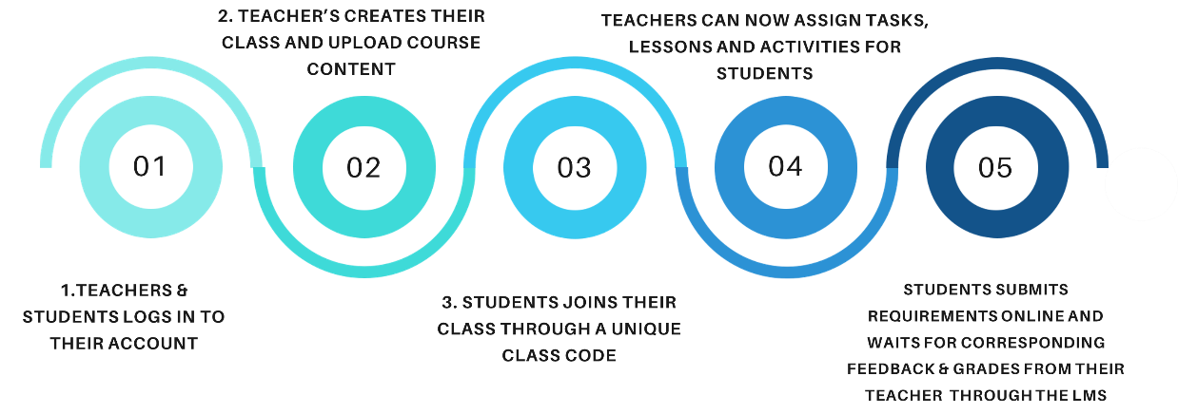

**Our TekTeach Offering**

* A responsive online platform for:
  + Conducting classes (synchronous & asynchronous)
  + Creating assessments
  + Managing learning resources
* Complete Access to your subscribed TechFactors courseware
* Comprehensive Training for Successful LMS implementation
  + Technical Systems Training – know how to utilize TekTeach system functionalities
  + Instructional Design Training- Learn how develop lesson plans that is fit for online learning
* Infrastructure Support (optional)
* Easy and effective implementation program to make digital learning fun and enjoyable.