**Arts Lecture**

**Principles of Design**

Repetition

Lines, shapes, and colors could be repeated for artistic purposes.

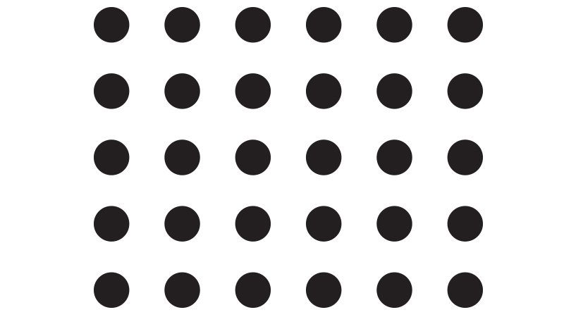

Contrast

When artists arrange opposite elements like small or large shapes, light or dark colors, and smooth or rough textures.



Rhythm

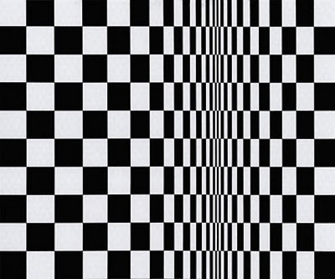When there is repetition of lines, shapes, and colors, there is rhythm. Rhythm also shows a sense of movement.