**A PROJECT DESIGN OF**

“**DETACHABLE WOODEN SHOE ORGANIZER”**

A Thesis in

**IE 524 DESIGN PROJECT**

Presented to the

Faculty of the Industrial Engineering Department

Cebu Technological University

Main Campus: R. Palma St., Cebu City

In Partial Fulfillment

Of the Requirements for the Degree of

**BACHELOR OF SCIENCE IN INDUSTRIAL ENGINEERING**

By

Abacajan, Nelliza C.

Tampus, Georgie S.

May 2020

# **APPROVAL SHEET**

# **ABSTRACT**

The proponents of this study have come up with an innovative and creative design of a product, the Detachable Wooden Shoe Organizer. This product is not the typical and traditional designed shoe racks that is seen and displayed at homes. This product is way more efficient with its multiple layers and levels which a several number of shoes can be put on. Along with this, this product is also designed to be detachable, which means its leaf (layer) can be detached from whenever it is decided to be used. User can decide whether to insert or attach the other layer or not. The detachable leaf is also designed to create more layers to be used for organizing the shoes. The product can also be wall mounted or folded into two. However, this product is relatively expensive but the proponents guarantee the customers that its quality and features is satisfying and will justify the price.

# **ACKNOWLEDGMENTS**

The researcher hopes to express their profound gratitude and sincerest appreciation to the following whose valuable assistance made this study a reality

First and foremost, the highest honor and acknowledgement we give to our Almighty Father, who bestowed us wisdom and guidance along the journey of this research. Without Him, it wouldn’t be possible for us to complete this research, and so, we give deepest thanks and gratefulness to Him.

Our sincere thanks also to our Product Design thesis instructor, Engr. Philip John S. Borromeo for his patience and guidance to us throughout this study. And also, big thanks to the professors and instructors of Cebu Technological University- Main Campus Industrial Engineering Department.

An appreciation of thanks and gratitude also we give to the employee Anest Furniture in Mandaue who made our product for us and accommodating our requests and questions while we were there to gather knowledge about our customized product.

We also give thanks to those people who have helped a lot and who have encouraged us mentally, emotionally, physically and spiritually to go still in this study. We are much filled with gratitude knowing that your support is with us and also, to our friends, classmates, batch mates, who continued also to do their own works but still giving out some supports for us.

More importantly, our most sincere thankfulness and gratitude we give to our family and parents, who supported us in many aspects. Without them, not a single word of this study would be done if in the first place, they have not sent us to a university. With their most little supports up to the biggest helps and supports, we also give them back our hardest efforts for this study. And so, we express our joy and love towards them for everything.

# **DEDICATION**

This study is heartily dedicated to the people who show their full support, love and guidance from the beginning of the research until the completion of the research. To our families, friends and classmates whom we’ve shared bonds and moments with, we dedicated and offer this study to them.

Most of all, we highly dedicate this study to the Lord Almighty, for He is the one who made everything of this study possible and we acknowledge that we are nothing apart from Him. That we cannot do anything good and complete without His guidance and provision to us.

# **TABLE OF CONTENTS**

**ACKNOWLEDGMENTS** 2

**DEDICATIONS** 3

**TABLE OF CONTENTS** 3

**LIST OF FIGURES** 3

**LIST OF TABLES** 3

**INTRODUCTION** 4

**PURPOSE OF THE STUDY** 4

**SIGNIFICANCE OF THE STUDY** 5

**METHODOLOGY** 7

**CHAPTER 1** 9

**THE PRODUCT** 9

**1.1** **FEATURES OF THE PRODUCT** 9

**1.2 PHYSICAL CHARACTERISTICS** 10

**1.3 USES OF THE PRODUCT** 11

**1.4 PICTORIAL VIEW OF THE PRODUCT** 12

**1.4.1 Assembly Drawing** 12

**1.4.2 Exploded Drawing** 14

**1.5 APPROXIMATE WEIGHT OF THE PRODUCT** 15

**1.6 SOURCES OF RAW MATERIALS** 15

**CHAPTER II** 17

**Method of Production** 17

**2.2 Assembly Process Chart** 24

**2.2.1 Precedence Table** 30

**2.2.2 Network Diagram – Breakdown of Major Activities** 30

**2.3 Operation Time** 31

**2.4 Cycle Time** 32

**2.5 Manufacturing Lead Time** 34

**2.6 Number of Workstations** 36

**2.6.1 Grouping of Workstations** 36

**2.6.2 Design of Workstation** 38

**2.7 Idle Time of the Line** 45

**2.8 Efficiency of the Line** 46

**2.9 Number of Workers** 46

**2.10 Number of Workers** 46

**2.10.1 Recommended Qualification of Workers** 48

**2.11 Rate of Workers** 52

**2.11.1 Method of Rating Worker’s Efficiency** 53

**2.12 Equipment and Tools Needed** 56

**2.13 Principles of Motion Economy** 57

**2.14 Anthropometric Data** 59

**2.15 Layout of the Production Area** 61

**CHAPTER 3** 65

**MATERIALS REQUIREMENT** 65

**3. 1 Product Structure Tree** 65

**3.1.1 Summary of Product Structure Tree** 67

**3.2 Specifications of the Materials** 68

**3.3 Parts List** 69

**3.4 Bill of Materials** 70

**CHAPTER IV** 72

**INVENTORY CONTROL** 72

**4.1 Economic Order Quantity (EOQ)** 77

**4.2 Reordering Point** 79

**4.3 Safety Stock** 80

**4.4 Summary of EOQ/ROP/SS** 81

**4.5 Number of Orders per Year** 82

**4.6 Length of the Order Cycle** 83

**CHAPTER V** 84

**UNIT COST AND UNIT PRICE** 84

**5.1 Cost of Direct Materials** 84

**5.2 Cost of Direct Labor** 85

**5.3 Overhead Cost** 87

**5.4 Unit Cost** 95

**5.5 Unit Price** 95

**5.6 Discussion of the Value of Money** 96

**BENEFITS AND INCENTIVE SCHEME** 97

**6.1 As Mandated by the Law** 97

**6.2 Discretion of the Company** 102

**CHAPTER VII** 103

**QUALITY CONTROL** 103

**7.1 Attributes of the Product Requiring Control** 103

**7.2 Variables of the Product Requiring Control** 104

**7.3 Suggested Practical Method of Controlling Attributes** 104

**7.4 Suggested Practical Method of Controlling Variable** 106

**7.5 Inspection along the Line** 106

**7.6 Statistical Method of Controlling Quality** 107

**7.6.1 Suggested Tool to Control Attributes** 108

**7.6.2 Suggested Tool to Control Variables** 113

**7.7 Suggested Policy regarding Rework** 115

**7.8 Qualification of Personnel in Charge of Quality Control** 116

**7.9 Organizational Structure of Quality Control Section/Department** 117

**CHAPTER 8** 118

**MATERIAL HANDLING** 118

**8.1 Principles of Material Handling** 118

**8.3 Total Distance between Workstations** 122

**8.4 Recommended MHE’s to move the materials** 123

**CHAPTER 9** 124

**MAINTENANCE OF FACILITIES** 124

**9.1 Maintenance of Production Facilities** 124

**9.1.1 Preventive Maintenance** 124

**9.1.2 Maintenance of Material Handling Equipment** 127

**9.1.3 Total Preventive Maintenance** 128

**9.2 Maintenance of Non-Production Facilities** 129

**9.2.1 The Building** 129

**9.2.2 The Drainage System** 131

**9.2.3 The Electrical System** 133

**9.2.4 Personnel in Charge of Maintenance Work** 134

**10.1 Measures against Occurrence of Accidents in the Plant** 135

**Personal Protective Equipment** 137

**Implementation of 5S in the Company** 143

**Provision of Emergency Equipment** 144

**Proper Signage** 145

**Good Working environment** 147

**10.2 Measures in Securing the Plant Bad Elements of Society** 148

**Benefits and incentives scheme** 149

**10.3 Recommended Policies regarding Health of the Workers** 149

**Health and Safety Policy** 150

**10.4 Medical and Dental Services** 151

**10.5 Food Services** 153

**CHAPTER XI** 155

**PLANT LAYOUT** 155

**11.1 Space Requirements** 155

**11.2 Non- Production Functional Areas** 156

**11.3 Production Functional Area** 157

**11.4 Space Relationship Diagram** 158

**11.5 Space Allocation** 160

**11.5.1 Non-production Area** 160

**11.5.2 Production Areas** 162

**11.6 Total Area of the Sections of Plant** 163

**11.7 Preliminary Layout – Dimensionless Block Diagram** 164

**11.8 Final Layout** 165

**11.9 Plant Location** 166

**11.10 Percent of Lot Occupancy** 169

**CHAPTER XII** 171

**COST OF DEVELOPMENT** 171

**12.1 Cost of Land** 171

**12.2 Cost of Renovation** 171

**12.3 Cost of Equipment** 174

**12.4 Total Cost of Development** 178

**Chapter XIII** 179

**ORGANIZATIONAL STRUCTURE OF THE PLANT** 179

**13.1 Organizational Chart** 179

**13.1.1 Function of Organizational Positions** 180

**Chapter XIV** 189

**Conclusion and Recommendations** 189

**Conclusions** 189

**Recommendations** 190

**BIBLIOGRAPHY** 191

**APPENDIX** 191

**CURRICULUM VITAE** 191

# **LIST OF FIGURES**

**Figure 1.** Flow of the Research Process 16

**Figure 2**. Wall Mounted Assembly Drawing (Without Leaf ) 21

**Figure 3**. Wall Mounted Assembly Drawing (With Leaf) 21

**Figure 4** .Front View Assembly Drawing (Without Leaf) 22

**Figure 5**. Side View Assembly Drawing (With Leaf) 22

**Figure 6** . Bottom View Assembly Drawing (With Leaves/holder) 23

**Figure 7**. Leaf Isometric View 23

**Figure 8**. Leaf Isometric View 23

**Figure 9**. Leaf Side View 24

**Figure 10**. Leaf Front View 24

**Figure 11**. Bracket Front View 24

**Figure 12.** Bracket Side View 24

**Figure 13**. Exploded Drawing 25

**Figure 14.** Process Flow Chart of Major Activities 31

**Figure 15.**  Measuring and Tracing Assembly Process Chart 35

**Figure 16.** Cutting Assembly Process Chart 36

**Figure 17**. Assembly Process Chart 37

**Figure 18.** Sanding and Polishing Assembly Process Chart 38

**Figure 19**. Mixing Assembly Process Chart 39

**Figure 20**. Painting Assembly Process Chart 40

**Figure 21.** Network Diagram 41

**Figure 22.** Operation Time of the Product 42

**Figure 23.** Value Stream Map of the Production 46

**Figure 24.** Reach envelopes of users 49

**Figure 25.** Heavier Work Standing Position 50

**Figure 26.** Workstation for Measuring, Cutting, Assembling 51

**Figure 27**.Workstation for Sanding 52

**Figure 28**. Workstation for Polishing 53

**Figure 29**. Workstation for Mixing, Painting, Inspecting, Packaging 54

**Figure 30**. Worker’s Evaluation Sheet 66

**Figure 31**. Layout of the Production Area 74

**Figure 32**. Dimension on the Layout of the Production Area 75

**Figure 33.** Product Structure Tree 77

**Figure 34.** X-Bar Control Chart Sample 125

**Figure 35.** Process Control Chart 125

**Figure 36.** Organizational Structure of Quality Control Section/Department 128

**Figure 37**. Material Handling Principles 129

**Figure 38**. Measured Distance Between Workstations 132

**Figure 39.** Maintenance card for tools and equipment 138

**Figure 40***.* Material handling equipment card 139

**Figure 41**. Sample Weekly TPM Card 140

**Figure 42.** Safety Procedure of Hand Grinders 149

**Figure 43**. Safety Procedure of Belt Sander 149

**Figure 44.** Safety Procedure of Table Saw 150

**Figure 45.** Signage around the Plant 157

**Figure 46.** Space Relationship Diagram 171

**Figure 47.** Dimensionless Block Diagram 175

**Figure 48.** Final Plant Layout 176

**Figure 49.** Plant Location Option 1 178

**Figure 50**. Plant Location Option 2 179

**Figure 51.** Plant Location Option 3 180

**Figure 52**. Organizational Chart 190

# **LIST OF TABLES**

# **INTRODUCTION**

Organizing objects is vital for the utilization of available resources. Along with establishing a sense of structure and order, an organized state promotes better efficiency. Just like other objects, shoes need to be organized.

Organizing shoes in an accessible and tidy fashion is desirable to save space and disclose shoes for easy selection when donning specific attire. No outfit is complete without matching shoes. As a result, many shoes are procured by people and often left in disarray when not in use. Shoes require space for storage, and a way to organize shoes in a space-saving, aesthetically pleasing manner is warranted **Invalid source specified.**. The demand of shoe organizer products is very much evident as the market is flooded with all kinds of shoe storage solutions; e.g. basic shoe rack, shoe cabinet, over-the-door shoe rack, shoe rack bench and automated shoe carousel **Invalid source specified.**.

Keeping your shoes organized doesn’t just keep them from being in a good condition but also makes your life easier and gives you lesser hassle as users won’t take much more time in finding and getting the best pair of shoes.

# **PURPOSE OF THE STUDY**

In today's environment, there is no executive task more vital and demanding than the sustained management of innovation and change**Invalid source specified.**. With the present ease of obtaining knowledge, customer awareness has grown tremendously and industries can no longer rely on pass laurels and afford to think that anything it produces will be accepted by the consumers. Consumers are much more aware on the importance of a space saving and ergonomically sound product design **Invalid source specified.**. Thus, this study aspires to provide a newer sight and design of a shoe rack which has specific features that alleviates it from other typical shoe rack products (e.g., flexible/ adjustable height, multifunction, etc.).

With the present ease of obtaining

knowledge, customer awareness has grown

tremendously and industries can no longer rely

on pass laurels and afford to think that anything

it produces will be accepted by the consumers.

Consumers are much more aware on the

importance of an ergonomically sound product

design

The purpose of this study upon succeeding the design product absolutely depends on the acceptance on the market. In this case, the product will undergo basic design process which involves testing its functionality and revising the said prototype until it will come up with a reliable and viable design to be determined. One objective of the study is to come up with ideal and realistic production system that could be suitable of making and producing Multiple Shoe Organizer. The production systems include the production flow, assembly design process, required personnel, time utilization, line efficiency and space requirements which primarily affect the organization’s progress.

# **SIGNIFICANCE OF THE STUDY**

The following are the beneficiaries of the study.

*THE INDIVIDUAL*

The individual sector will benefit from the study since it provides an own thought in creating prototype (design product) out from wood that they could generate income.

*RESEARCHERS*

This study will have a profound benefit to the researchers since the product does not only help in terms of its economic and environmental aspects but this study will serve as a great accomplishment to them.

*FUTURE RESEARCHERS*

This study will serve as a basis for those who are going to conduct a study regarding woods and furniture especially shoe racks or shoe organizer. This will enable them to get an idea and a glimpse on the wood industry.

# **METHODOLOGY**

**Flow of the Research Process**

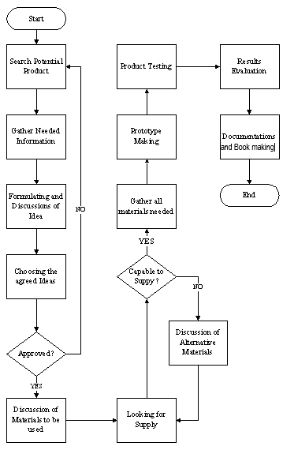

**Figure 1.** Flow of the Research Process

The methodologies of this study explore the actual situation in an industrial setting. The proponents of the study carefully deliberated the parts, processes and even the number of operation and workstation up to the unit costing. Furthermore, this study involves the whole assembly process on making this product such as: cutting, assembling and painting with built-in inspection in every process.

# **CHAPTER 1**

## **THE PRODUCT**

## **FEATURES OF THE PRODUCT**

|  |  |
| --- | --- |
| **FEATURES** | **DESCRIPTION** |
| Detachable leaf | This shoe rack has leaves or layers that are detachable and each leaf can be detached from whenever it is decided to be used. User can decide whether to insert or attach the other layer or not.  The detachable leaf is also designed to create more layers to be used for organizing the shoes. |
| Wall Mounted | This product is designed to be wall mounted to save floor space |
| Multiple Layered | The detachable wooden shoe organizer has 36 layers that could be attached so that many shoes can be accommodated |
| Foldable | The detachable wooden shoe organizer can be folded into half and the height is shortened |
| Transformable | The detachable wooden shoe organizer can be transformed from being a wall mounted product to a standing product by folding the backboard into half, making the topmost shelf as the base. |
| Height Flexibility | Due to the numerous available slots and retractable leaf, the height can be customized to the height of the desired shoes that will be placed in the shoe rack. |

**Table 1.** Features of the Product

## **1.2 PHYSICAL CHARACTERISTICS**

This section presents the additional characteristics that are added in the product. It is the distinctive attribute or aspect of the product.

|  |  |  |
| --- | --- | --- |
| **CHARACTERISTICS** | **DIMENSION** | **DESCRIPTION** |
| Base | 10mmx305mmx254mm | The base serves and functions as the stand/support of the rack |
| Leaf | 5mmx305mmx254mm | The leaf is the one that is inserted to and detached from the slots, thus, it can be used as a layer or holder for the shoes |
| Piano Hinge | 254mm | Piano hinge is used and is specifically responsible for the folding feature of the shoe rack |
| Slot |  | This is the slot where the leaf is inserted to create a layer or holder for the shoes |
| Screw | 6mmx32mm | The screw is a piece of metal used to penetrate and fasten the hinge |
| Pin Nail | 20mm | Pin nails are thin pins that leave a tiny hole which minimizes the need for wood filler |

**Table 2**. Physical Characteristics of the Product

## **1.3 USES OF THE PRODUCT**

**Table 3**. Uses of the Product

|  |  |
| --- | --- |
| **USES** | **DESCRIPTION** |
| Shoe Organizer | This product is mainly used for organizing your shoes or other footwear |
| Multi-purpose Organizer | This product can also be used as an organizer for anything that you want to organize. This product can also be used as an organizer for your books, clothes, and others which can be put on each of the layers. The layers can also be retracted to have a bigger space and distance so that longer and larger products can be organized on it such as box, even boots, and others. |

## **1.4 PICTORIAL VIEW OF THE PRODUCT**

### **1.4.1 Assembly Drawing**

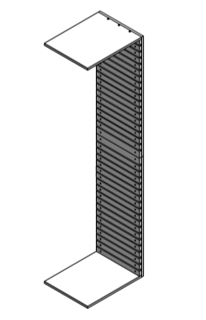

**Figure 2**. Wall Mounted Assembly Drawing (Without Leaf )

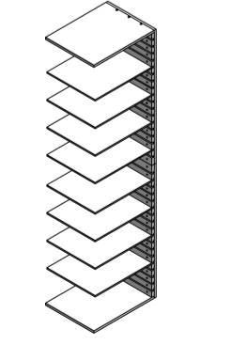

**Figure 3**. Wall Mounted Assembly Drawing (With Leaf)

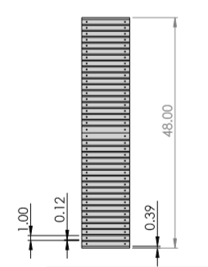

**Figure 4** .Front View Assembly Drawing (Without Leaf)

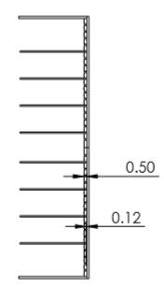

**Figure 5**. Side View Assembly Drawing (With Leaf)

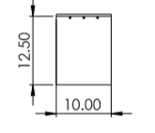

**Figure 6** . Bottom View Assembly Drawing (With Leaves/holder)

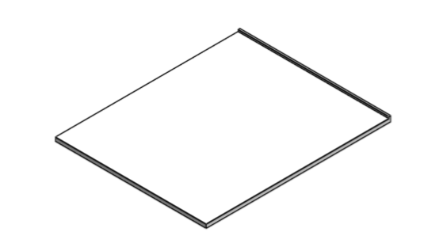

**Figure 7**. Leaf Isometric View

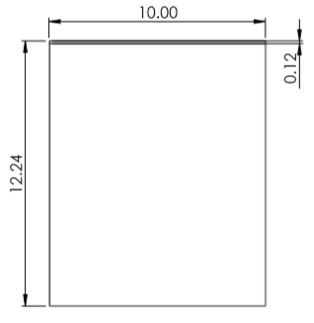

**Figure 8**. Leaf Isometric View

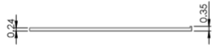

**Figure 9**. Leaf Side View

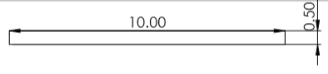

**Figure 10**. Leaf Front View

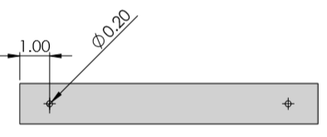

**Figure 11**. Bracket Front View

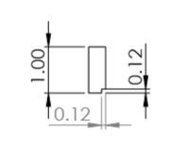

**Figure 12.** Bracket Side View

### **1.4.2 Exploded Drawing**

Provided in this section is the exploded drawing of the product which will let the proponents and readers view the details or parts of it.

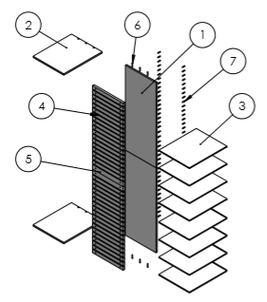

**Figure 13**. Exploded Drawing

## **1.5 APPROXIMATE WEIGHT OF THE PRODUCT**

The estimated weight of product can be seen in this section.

**Table 4.** Approximate Weight of the Product

|  |  |
| --- | --- |
|  | **WEIGHT** |
| Without leaves (all leaves are detached) | 2 kilograms |
| With leaves (all leaves are inserted) | 2.36 kilograms |

## **1.6 SOURCES OF RAW MATERIALS**

In procuring the raw materials needed in the production of the detachable wooden shoe organizer, the business should have partners in supplying the materials.

**Table 5**. Sources of Raw Materials

|  |  |  |
| --- | --- | --- |
| **Material** | **Supplier** | **Address** |
| Lawaan Wood | Cebu Universal Lumber Co., Inc. | Lopez Jaena St., Tipolo, Mandaue City |
| Ply Wood | Cebu Universal Lumber Co., Inc. | Lopez Jaena St., Tipolo, Mandaue City |
| Nails | Mandaue Cebu Tradecenter, Inc. | Mandaue City, Cebu |
| Piano Hinge | Mandaue Cebu Trade Center, Inc. | Mandaue City, Cebu |
| Screw | Mandaue Cebu Tradecenter, Inc. | Mandaue City, Cebu |
| Wood Glue | Mandaue Cebu Tradecenter, Inc. | Mandaue City, Cebu |
| Pin Nails | Mandaue Cebu Tradecenter, Inc. | Mandaue City, Cebu |
| Paint | Mandaue Cebu Tradecenter, Inc. | Mandaue City, Cebu |
| Wood Stain | Mandaue Cebu Tradecenter, Inc. | Mandaue City, Cebu |
| Mirotone Topcoat | Mandaue Cebu Tradecenter, Inc. | Mandaue City, Cebu |
| Sanding Paper | Mandaue Cebu Tradecenter, Inc. | Mandaue City, Cebu |
| •         100 (grano) |
| •         180 (grano) |
| •         240 (grano) |

# **CHAPTER 2**

## **Method of Production**

Production methods may fall into four (4) categories: project, batch, mass and continuous production. The table below shows the classification of the product to produce in every method of production.

**Table 6.** Method of Production

|  |  |  |  |  |
| --- | --- | --- | --- | --- |
| **PRODUCTION SYSTEM** | **TYPE OF PRODUCTION PROCESS** | | | |
| **PROJECT** | **BATCH** | **MASS** | **CONTINUOUS** |
|
| **Type of Product** | Unique | Made - to - Order (Customized) | Made - to - Stock | Commodity |
|
| **Primary type of work** | Specialized Contracts | Fabrication | Assembly | Mixing, Treating, Refining |
|
| **No. of different Products** | Infinite Variety | Many, Varied | Few | Very Few |
|
| **Type of Customer** | One at a time | Few Individual Customers | Mass Market | Mass Market |
|
| **Demand Volume** | Very Low | Low to Medium | High | Very High |
|
| **Product and Demand** | Infrequent | Fluctuates | Stable | Very Stable |
|
| **Equipment** | Varied | General Purpose | Special Purpose | Highly Automated |
|
| **Worker Skills** | Expert Craft Person | Wide Range Skills | Limited Range of Skill | Equipment Motors |
|
| **TOTAL** | **0** | **5** | **3** | **0** |

As shown in the table above, the Detachable Wooden Shoe Organizer is a batch production. This type of product is made to order or is customized by only few individual customers and its demand fluctuates.

Furthermore, the production of the Detachable Wooden Shoe Organizer undergoes: Measuring and Tracing, Cutting, Gluing and Assembly, Sanding, Polishing, Mixing and Painting. Additionally, the description of each major processes is discussed by the following:

**Measuring and Tracing-** The raw materials such as the plywoods and the piano hinge that are needed to be cut are to be measured and traced first using the necessary measuring tools and a scriber to create a delicate mark or pattern for the easiness of cutting afterwards.

**Cutting-** After measuring and tracing the materials, these will then be moved to the cutting station where it will be cut precisely and delicately using a grinder there.

**Gluing and Assembly-** After cutting the desired length for the materials, it will be attached and assembles using glue, piano hinge, screw and pin nails.

**Sanding-** Once done assembling, the product will then be processed to create a smooth surface through sanding using 100 and 180 grit of sandpaper.

**Polishing-** Once the surface of the product are smoothen it will then be polished using 240 grit of sandpaper to shine the product.

**Mixing-** This is the process wherein the paints are mixed to create the desired color of the product for the aesthetics.

**Painting-** Applying paint to the product.

**Inspection and Packaging-** The final phase of the product making before it will be shipped to the customers. This process mainly involves testing the product based on its quality and functionality. On the other hand, after ensuring the quality of the product, it will be then undergo a packaging.

To illustrate the major processes, Figure 15 shows the process flow of manufacturing the Detachable Wooden Shoe Organizer.



**Figure 14.** Process Flow Chart of Major Activities

**2.2 Process Assembly Chart**

**Table 7**. Meynard’s Operations Sequence Technique

|  |  |  |  |
| --- | --- | --- | --- |
| **OPERATION** | **CODE** | **PROCESSES** | **STANDARD TIME** |
| **Measuring and Tracing** | A1 | Get the 1/2 Plywood for the base and put in the table | 5.8 |
| A2 | Get the scriber and tape measure and trace the needed length for the base | 45.16 |
| A3 | Get the 1/2 Plywood for the backboard and put in the table | 6.52 |
| A4 | Get the scriber and trace the needed length for the backboard | 50.53 |
| A5 | Get the 1/4 Plywood for the leaf and put in the table | 19.78 |
| A6 | Get the scriber and trace the needed length for the leaf | 117.99 |
| A7 | Get the Plywood for the leaf stopper and put in the table | 11.46 |
| A8 | Get the scriber and trace the needed length for the leaf stopper | 33.23 |
| A9 | Get the Solid Wood for the bracket and put in the table | 43.66 |
| A10 | Get the scriber and trace the needed length for the bracket | 129.77 |
| A11 | Trace the part of the leaf stopper | 48.93 |
| **Cutting** | B1 | Get the traced Plywood | 7.29 |
| B2 | Set up the cutting machine | 87.78 |
| B3 | Cut the traced plywood for the base | 59.08 |
| B4 | Put Aside | 7.25 |
| B5 | Cut the traced plywood for the backboard | 52.52 |
| B6 | Put Aside | 11.77 |
| B7 | Cut the traced plywood for the leaf | 628.79 |
| B8 | Put Aside | 130.42 |
| B9 | Cut the traced plywood for the leaf stopper | 422.88 |
| B10 | Put Aside | 101.14 |
| B11 | Cut the traced Solid Wood for the bracket | 1107.17 |
| B12 | Put Aside | 100.27 |
| B13 | Cut the Piano Hinge into 10 inches | 21.77 |
| B14 | Put Aside | 4.96 |
| **Gluing and Assembly** | C1 | Get the leaf | 60.54 |
| C2 | Get the leaf stopper | 49.65 |
| C3 | Glue the leaf stopper to the leaf | 219.32 |
| C4 | Get the bracket | 66.57 |
| C5 | Get the backboard | 3.84 |
| C6 | Glue the bracket to the backboard | 709.84 |
| C7 | Pin the nails of the bracket to the backboard | 510.69 |
| C8 | Get the base | 8.51 |
| C9 | Get the backboard | 12.53 |
| C10 | Glue the base to the backboard | 69.76 |
| C11 | Attach the base to the backboard using philip screw | 712.83 |
| C12 | Attach the 2 backboard together using piano hinge | 247 |
| **Sanding** | D1 | Sand the product using 100 grint sandpaper | 2153.2 |
| D2 | Sand the product using 180 grint sandpaper | 2307.42 |
| **Polish** | E1 | Final sanding using 240 grint sandapaper | 4426.79 |
| **Mix** | F1 | Get 3 colors of paint to mix | 12.55 |
| F2 | Open can of 1st color | 15.49 |
| F3 | open can of 2nd color | 18.54 |
| F4 | Open can of 3rd color | 14.66 |
| F5 | Get container for paint mixing | 4.21 |
| F6 | Pour ample amount of 1st color to the container | 18.44 |
| F7 | Put aside can of 1st color | 4.23 |
| F8 | Pour ample amount of 2nd color to the container | 16.82 |
| F9 | Put aside can of 2nd color | 5.8 |
| F10 | Pour ample amount of 3rd color to the container | 18.84 |
| F11 | Put aside can of 3rd color | 3.46 |
| F12 | Mix the 3 colors together in a can using mixing paddles | 213.94 |
| **Painting** | G1 | Apply stain paint | 352.8 |
| G2 | Drying | 550 |
| G3 | Apply the desired color of paint | 635.04 |
| G4 | Drying | 420 |
| G5 | Apply Topcoat | 1525.89 |
| G6 | Drying | 1500 |
| **Inspection and Packaging** | H1 | Inspection and Packaging | 721.41 |

This phase shows the graphical representation on the sequencing of the steps included in a process, considering the transformation of the raw material to the desired output. The assembly process chart will be a useful tool in examining the process in detail and in identifying the possible areas for improvement of the process. The assembly process chart is ideal in having a generalized view of the processes with the list of all major materials and components, subassembly and assembly operations and even inspections.

## **2.2 Assembly Process Chart**

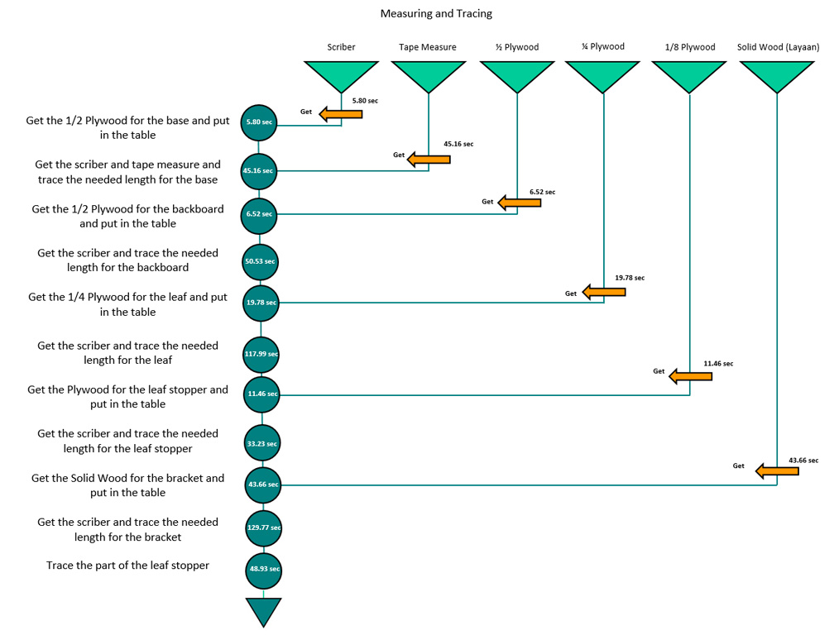

**Figure 15.**  Measuring and Tracing Assembly Process Chart

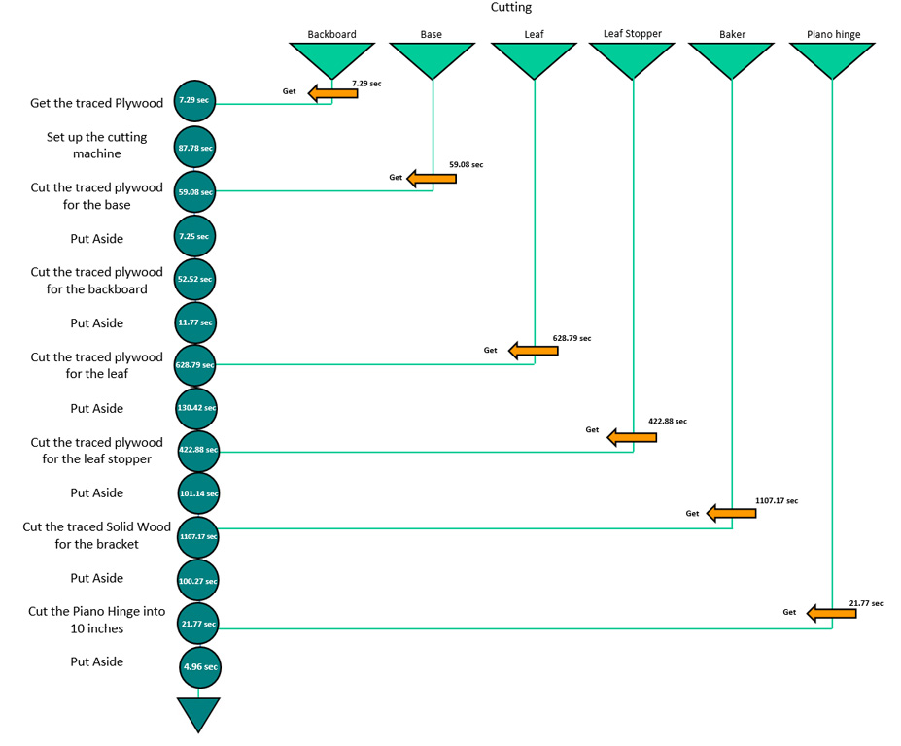

**Figure 16.** Cutting Assembly Process Chart

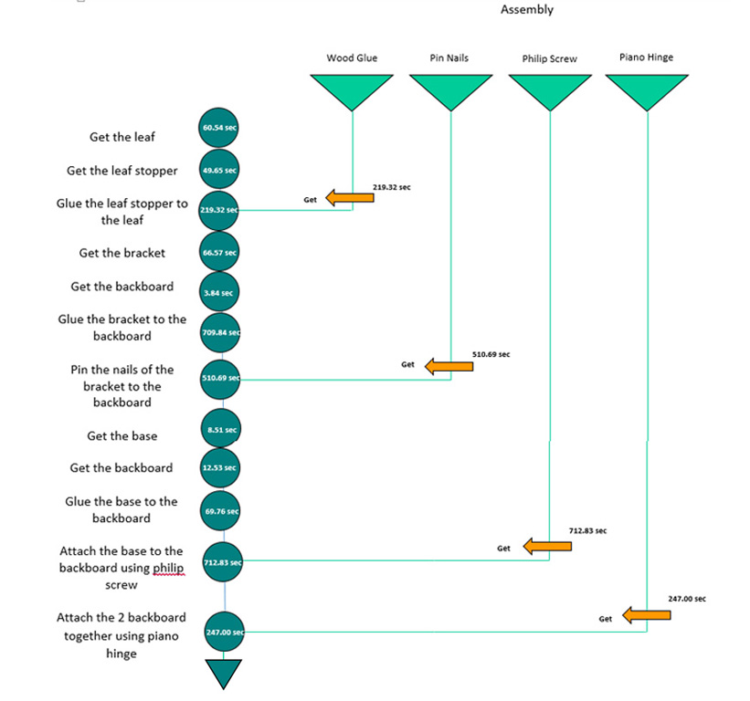

**Figure 17**. Assembly Process Chart

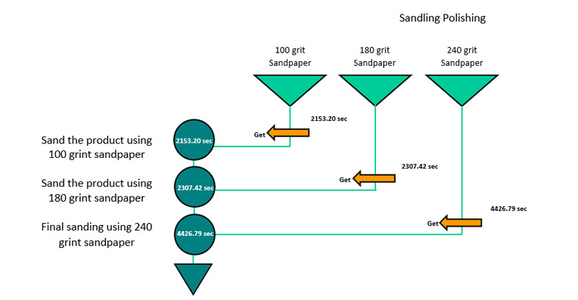

**Figure 18.** Sanding and Polishing Assembly Process Chart

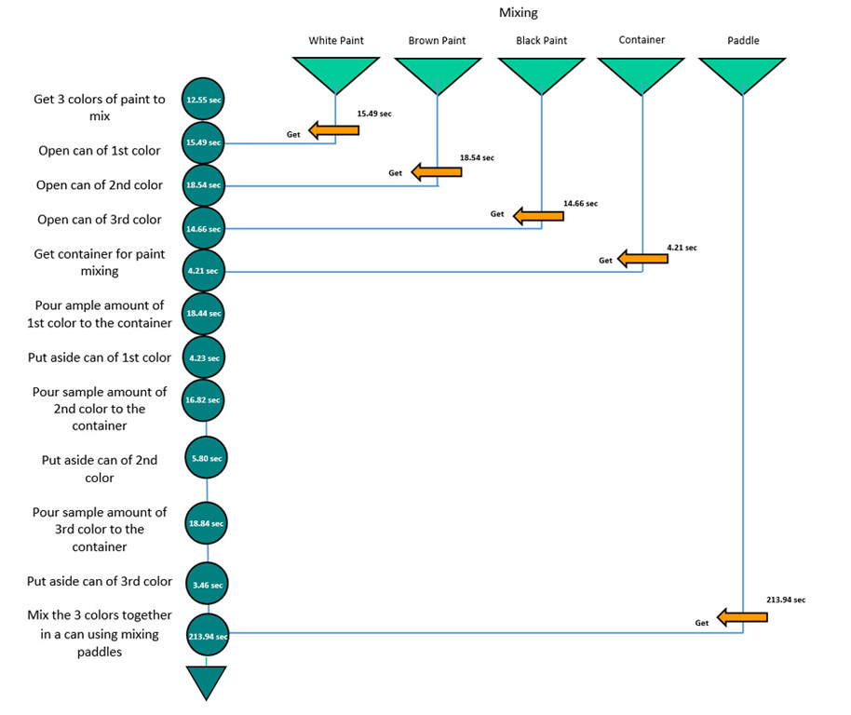

**Figure 19**. Mixing Assembly Process Chart

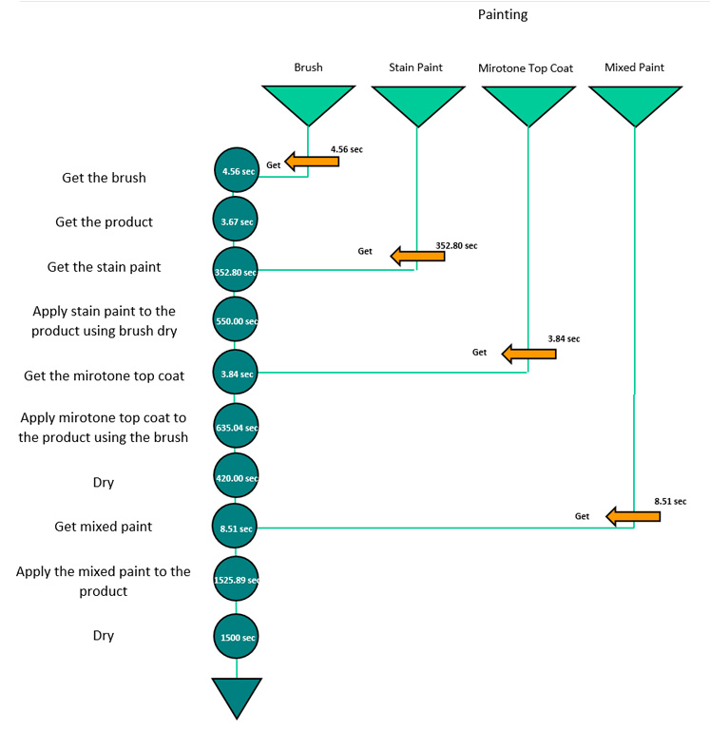

**Figure 20**. Painting Assembly Process Chart

### **2.2.1 Precedence Table**

The Precedence Table shows how the product has been processed along with its corresponding time duration. This shows the predecessors required for each activity in making the product.

**Table 8**. Precedence Table

|  |  |  |  |
| --- | --- | --- | --- |
| **PRECEDENCE TABLE** | | | |
| **ACTIVITY** | **OPERATIONS** | **PREDECESSORS** | **TIME (min.)** |
| **A** | Measuring and Tracing | - | 8.5 |
| **B** | Cutting | A | 45.7 |
| **C** | Assembling | B | 44.5 |
| **D** | Sanding | C | 74.3 |
| **E** | Polishing | D | 73.8 |
| **F** | Mixing | E | 5.8 |
| **G** | Painting | F | 83.1 |
| **H** | Inspection and Cutting | G | 12.0 |

### **2.2.2 Network Diagram – Breakdown of Major Activities**

The Network diagram represents the different sequential activities which is primarily composed of nodes and arrows.



**Figure 21.** Network Diagram

## **2.3 Operation Time**

The product’s operating time refers to the time consumed in producing one unit of product. It also presents the time consumed in every process. The operation time yielded is calculated as the summation of the time of the workstations.

|  |  |
| --- | --- |
| **OPERATIONS** | **TIME (min.)** |
| Measuring and Tracing | 8.55 |
| Cutting | 45.72 |
| Assembling | 44.52 |
| Sanding | 74.34 |
| Polishing | 73.78 |
| Mixing | 5.78 |
| Painting | 83.06 |
| Inspection and Cutting | 12.02 |
| **TOTAL** | **347.78** |

**Figure 22.** Operation Time of the Product

The table above shows that the total operating time of producing one unit of the Detachable Wooden Shoe Organizer is 347.78 minutes.

## **2.4 Cycle Time**

**Table 9.** Summary of Time-Motion Analysis

|  |  |  |  |
| --- | --- | --- | --- |
| **OPERATIONS** | **STANDARD TIME (min.)** | **AVERAGE TIME SPEND TIME (min.)** | **CYCLE TIME (min.)** |
| Measuring and Tracing | 6.18 | 2.37 | 8.55 |
| Cutting | 33.01 | 12.71 | 45.72 |
| Assembling | 31.63 | 12.88 | 44.52 |
| Sanding | 52.27 | 22.08 | 74.34 |
| Polishing | 51.87 | 21.91 | 73.78 |
| Mixing | 4.22 | 1.56 | 5.78 |
| Painting | 69.63 | 13.43 | 83.06 |
| Inspection and Packaging | 8.52 | 3.50 | 12.02 |
| **TOTAL** | **257.334** | **90.44** | **347.78** |

To maximize the efficiency and utilization rate and to reduce the idle time of the production, the bottleneck or the task that have the slowest cycle time in the production should be eliminated or at least paced up by splitting or sharing the said task. Ergo, each workstation should operate at its minimum allowable cycle time.

**Table 10.** Production Efficiency and Utilization Rate Maximization

|  |  |  |  |  |  |
| --- | --- | --- | --- | --- | --- |
| **OPERATION** | **CYCLE TIME PER OPERATOR (min.)** | **NUMBER OF OPERATORS** | **PIECES PER HOUR** | **PIECES PER DAY** | **WIP** |
| **Measuring and Tracing** | 98.78 | 1.00 | 0.61 | 4.56 | 0 |
| **Cutting** |
| **Gluing and Assembly** |
| **Sanding** | 74.34 | 1.00 | 0.81 | 6.05 | 2 |
| **Polish** | 73.78 | 1.00 | 0.81 | 6.10 | 2 |
| **Mix** | 100.87 | 1.00 | 0.59 | 4.46 | 0 |
| **Painting** |
| **Inspection and Packaging** |

The table above shows the number of operators for each process and as to how the processes are batched, hence allowing each process to have the same takt time (i.e., 6172.2 mins.). On the other hand, the production will operate at its best efficiency and highest utilization rate. It also shows the needed number of piece per hour at each process, piece per month and the work-in-process (WIP) per processes. Furthermore, to compute for the desired or proposed throughput rate (e.g., output per day or per month), the proponents utilize the following formula:

$$Throughput Rate= \frac{1}{Takt Time}$$

$$Throughput Rate= \frac{1}{100.87 minutes/unit}$$

$$Throughput Rate= 0. 0099 unit/minute$$

$$Throughput Rate= 0.59 units/hour$$

Throughput rate is the output rate that a process or a task is expected to produce over a period of time. On the other hand, the proponents can now compute the desired or proposed output per day and per month as calculated in the following formula:

Output Per Day = Daily Available Operating Time in Hours x Throughput Rate

Output Per Day = 7.5 hours x 0.59 units/hour

𝐎𝐮𝐭𝐩𝐮𝐭 𝐏𝐞𝐫 𝐃𝐚𝐲 = **4.46 ≈ 4** 𝐮𝐧𝐢𝐭𝐬

In determining the desired output per month, the proponents have determined first the number of working days per month for a 6-working days a week according to the Department of Labor and Employment (DOLE) – Region VII, Central Visayas. Thus, the proponents considered the following metrics:

**Table 11.** Number of Operating Days

|  |  |
| --- | --- |
| Number of Days for Year 2020 | 366 |
| Less: Number of Regular Holidays in a Year | 11 |
| Less: Number of Special Holidays in a Year | 9 |
| Less: Number of Sundays in a Year | 53 |
| Total Number of Operating Days | 293 |
| Average Number of Operating Days per Month | 24.42 ≈ 24 days |

Output per month = Average Operating Days per Month * Output per Day

Output per month = 24 working days per month * 4.46 units per day

**Output per month = 107.07 ≈ 107 output per month**

## **2.5 Manufacturing Lead Time**

The manufacturing lead time refers to the total time required to manufacture an item from the storage of raw materials until the storage of finished good.

**Figure 23.** Value Stream Map of the Production

## **2.6 Number of Workstations**

Workstation is the assigned location for an employee to perform his or her job, and which is equipped with all the required tools and facilities. In solving the number of workstations or sub-workstations, the proponents used the formula:

$$Number of Workstations= \frac{Sum of Operation Cycle Time}{Takt Time}$$

$$Number of Workstations= \frac{347.78 minutes}{100.87 minutes}$$

$$Number of Workstations= 3.45 ≈ 4$$

As computed above, the needed number of workstations is 4. This corresponds to the total number of operators shown in Table 26 (i.e., 4 operators). It means that each workstation only need 1 operator.

### **2.6.1 Grouping of Workstations**

This section shows the grouping of the computed 39 workstations. To do so, the proponents perform a line balancing to each operation with a primary layout heuristic of 30 the longest task time and in case there is a tie, the most following tasks should be the heuristic to follow, as shown in Table 2.8. Line balancing refers to the assigning of tasks/operations to a series of workstations so that each workstation has no more than can be done in the allowable cycle time (i.e., cycle time per operator), and so that the unassigned (i.e., idle) time across all workstations is minimized. Furthermore, for the precedence diagram that is needed in performing the line balancing, the proponents just used the network diagram showed in Table 2.2 for brevity.

**Table 12**. Precedence Table for Line Balancing

|  |  |  |  |  |  |
| --- | --- | --- | --- | --- | --- |
| **ACTIVITY** | **OPERATION/PROCESS** | **PREDECESSOR** | **CYCLE TIME PER PROCESS (min.)** | **OPERATION CYCLE TIME (min)** | **NUMBER OF OPERATORS** |
| A | Measuring and Tracing | - | 8.5 | 98.78 | 1 |
| B | Cutting | A | 45.7 |
| C | Assembling | B | 44.5 |
| D | Sanding | C | 74.3 | 74.34 | 1 |
| E | Polishing | D | 73.8 | 73.78 | 1 |
| F | Mixing | E | 5.8 | 100.87 | 1 |
| G | Painting | F | 83.1 |
| H | Inspection and Cutting | G | 12.0 |

**Table 13**. Production Line Balancing

|  |  |  |  |  |  |
| --- | --- | --- | --- | --- | --- |
| **WORKSTATION** | **OPERATOR** | **TIME REMAINING (min.)** | **TASK ELIGIBLE** | **OPERATION ASSIGNED** | **IDLE TIME (sec.)** |
| I | 1 | 100.87 | A | A | - |
|  |  | 92.32 | A | A | - |
|  |  | 46.60 | B | B | - |
|  |  | 2.09 | C | - | 2.09 |
| II | 2 | 100.9 | D | D | - |
|  |  | 26.5 | D | - | 26.5 |
| III | 3 | 100.9 | E | E | - |
|  |  | 27.09 | E | - | 27.09 |
| IV | 4 | 100.87 | F | F | - |
|  |  | 95.09 | G | G | - |
|  |  | 12.02 | H | H | - |
|  |  | 0.0 | - | - | 0 |

### **2.6.2 Design of Workstation**

A workstation designed for the anthropometry, tasks and cognitive abilities of the user is essential in realizing the intended capability and safety of operational systems. Workspaces should take account of reach envelopes of users.

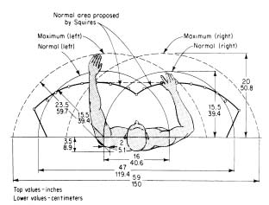

**Figure 24.** Reach envelopes of users

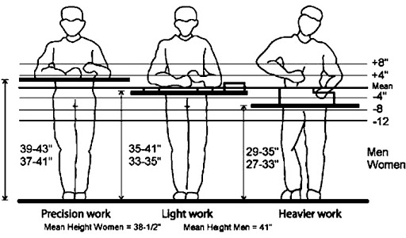

**Figure 25.** Heavier Work Standing Position

The Figure above is an example of a man working in a standing position and working in a heavy work. With this, the researchers of this study have benchmarked this position since the load of the work of this production is a heavy one which involves woods since it is a furniture production.

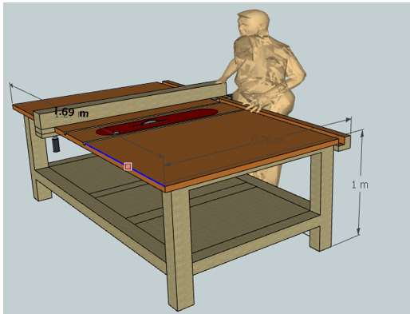

**Figure 26.** Workstation for Measuring, Cutting, Assembling

In measuring, cutting and assembling, the worker will be in standing position since the worker will be using a grinder or a sawing table that would enable him to easily cut the woods better in that position and the operator can also measure the parts accordingly.

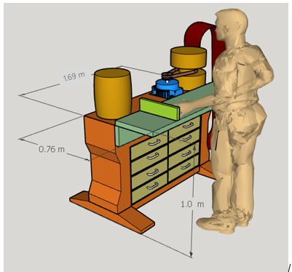

**Figure 27**.Workstation for Sanding



**Figure 28**. Workstation for Polishing

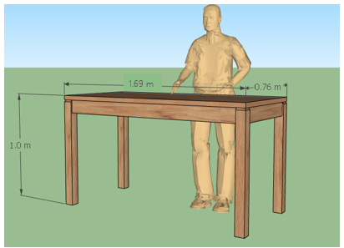

**Figure 29**. Workstation for Mixing, Painting, Inspecting, Packaging

**ANTHROPOMETRIC DATA**

STANDING

|  |  |  |  |  |  |  |  |  |  |  |
| --- | --- | --- | --- | --- | --- | --- | --- | --- | --- | --- |
| **Measurement** | **Male** | | | | | **Female** | | | | |
| **Mean** | **Median** | **Standard Deviation** | | | **Mean** | | **Median** | **Standard Deviation** | |
| Standing height | 167.01 | 167.00 | | 8.03 | 153.90 | | 155.00 | | | 82.28 |
| Eye height | 155.01 | 155.00 | | 6.92 | 143.05 | | 143.00 | | | 6.15 |
| Shoulder height | 137.45 | 137.00 | | 6.07 | 127.71 | | 127.00 | | | 5.80 |
| Shoulder width | 44.67 | 44.00 | | 7.33 | 40.24 | | 40.00 | | | 8.29 |
| Shoulder elbow length | 33.05 | 33.00 | | 3.98 | 31.39 | | 31.00 | | | 10.28 |
| Length of upper arm | 25.99 | 26.00 | | 4.54 | 24.92 | | 25.00 | | | 8.38 |
| Length of lower arm | 25.83 | 25.00 | | 4.42 | 24.16 | | 24.00 | | | 4.18 |
| Forearm hand length | 44.06 | 44.00 | | 4.13 | 40.47 | | 41.00 | | | 5.39 |
| Length of arm and hand | 72.60 | 73.00 | | 6.35 | 66.04 | | 67.00 | | | 5.77 |
| Elbow height | 104.41 | 104.00 | | 6.72 | 96.28 | | 97.00 | | | 7.39 |
| Knuckle height | 72.51 | 73.00 | | 5.80 | 67.77 | | 68.00 | | | 6.33 |
| Chest height | 123.36 | 123.00 | | 7.23 | 111.28 | | 112.00 | | | 10.50 |
| Chest breadth | 36.35 | 35.50 | | 6.18 | 32.63 | | 31.00 | | | 7.22 |
| Waist height | 97.32 | 98.00 | | 8.43 | 95.47 | | 96.00 | | | 6.09 |
| Waist hip length | 10.11 | 9.00 | | 6.44 | 10.19 | | 9.00 | | | 6.32 |
| Hip width | 43.50 | 44.00 | | 8.33 | 43.38 | | 44.00 | | | 7.10 |
| Hip height | 87.66 | 89.00 | | 8.57 | 85.34 | | 86.00 | | | 9.01 |
| Knee height | 49.73 | 50.00 | | 5.99 | 45.88 | | 46.00 | | | 3.09 |
| Popliteal height | 46.35 | 47.00 | | 3.00 | 42.05 | | 42.00 | | | 4.02 |
| Upper reach | 193.40 | 190.00 | | 10.80 | 190.19 | | 191.00 | | | 10.28 |
| Overhead fingertip reach | 212.08 | 213.00 | | 9.10 | 196.46 | | 196.00 | | | 8.91 |
| Arm span | 167.92 | 169.00 | | 9.15 | 153.18 | | 153.00 | | | 8.53 |

SITTING

|  |  |  |  |  |  |  |
| --- | --- | --- | --- | --- | --- | --- |
| **Measurement** | **Male** | | | **Female** | | |
| **Mean** | **Median** | **Standard deviation** | **Mean** | **Median** | **Standard deviation** |
| Sitting height | 84.84 | 85.00 | 5.81 | 79.92 | 80.00 | 4.50 |
| Eye height | 73.36 | 73.00 | 3.83 | 68.38 | 69.00 | 4.85 |
| Elbow Height | 22.23 | 22.00 | 4.21 | 21.89 | 22.00 | 4.09 |
| Waist height, sittings | 19.44 | 19.00 | 6.15 | 22.41 | 22.00 | 3.21 |
| Hip height | 13.28 | 13.00 | 4.06 | 15.29 | 15.00 | 6.71 |
| Hip breadth, sitting | 35.60 | 35.00 | 4.06 | 36.39 | 36.00 | 4.83 |
| Thigh clearance height | 13.49 | 13.00 | 4.45 | 12.82 | 12.00 | 6.97 |
| Buttock popliteal height | 46.40 | 46.00 | 3.73 | 45.14 | 45.00 | 3.69 |
| Knee height, sitting | 50.03 | 50.00 | 3.99 | 46.98 | 47.00 | 4.43 |
| Popliteal height | 43.33 | 43.00 | 2.57 | 40.34 | 40.50 | 2.90 |
| Buttock width | 48.45 | 48.00 | 7.40 | 47.66 | 48.25 | 6.85 |
| Length of upper leg | 36.80 | 36.00 | 6.12 | 35.96 | 36.00 | 5.25 |
| Length of lower leg and foot | 45.27 | 46.00 | 4.53 | 42.14 | 42.50 | 4.31 |
| Thumb tip reach | 71.30 | 72.00 | 7.12 | 65.44 | 66.00 | 7.63 |
| Overhead fingertip reach, sitting | 127.92 | 128.00 | 7.81 | 116.87 | 117.00 | 9.77 |

## **2.7 Idle Time of the Line**

Idle time refers to unused time of the workstations associated with waiting.

**Table 14.** Summary of Production Line Balancing

|  |  |  |  |  |
| --- | --- | --- | --- | --- |
| **ACTIVITY** | **OPERATION** | **WORKSTATION ASSIGNMENT** | **NUMBER OF OPERATORS** | **TOTAL IDLE TIME (min.)** |
| A | Measuring and Tracing | I | 1 | 2.09 |
| B | Cutting |
| C | Assembling |
| D | Sanding | II | 1 | 26.53 |
| E | Polishing | III | 1 | 27.09 |
| F | Mixing | IV | 1 | 0 |
| G | Painting |
| H | Inspection and Packaging |
|  |  |  | **TOTAL** | **55.70** |

$$Percentage of Idle Time= \frac{Idle Time per Cycle}{Number of Workstations x Takt Time } x 100$$

$$Percentage of Idle Time= \frac{75.70 mins.}{4 x 100.87 mins.} x 100$$

$$Percentage of Idle Time= 12.38\% ≈ 12\%$$

## **2.8 Efficiency of the Line**

Efficiency defines how the lines do tasks successfully without wasting time and energy. This may have calculated as:

$$Efficiency of the Line=100\%-Idle Time Percentage$$

$$Efficiency of the Line=100\%-12.38\%$$

$$Efficiency of the Line=87.62\%$$

## **2.9 Number of Workers**

This section shows the number of works in the production area and the number of administrative workers.

**Table 15**. Number of Production Workers

|  |  |
| --- | --- |
| **POSITION** | **HEADCOUNT** |
| Measuring and Tracing In-charge | 1 |
| Cutting-In-Charge |
| Assembling-In-Charge |
| Sanding-In-Charge | 1 |
| Polisher | 1 |
| Mixer | 1 |
| Painter |
| Inspector |
| **Total Number of Workers** | **4** |

## **2.10 Number of Workers**

This phase shows the computed number of workers needed for the operations to sustain. This phase also shows the number of production and administrative workers presented in tables.

Number of Operators, N

$$N=R × \sum{AM}$$

Where:

$R$ = desired rate of production

$AM$ = allowed standard minutes per operation

$$R= \frac{Proposed Output per Day}{Total Available Time per Day}$$

Proposed Output per Day 4 units

Total Available Time per Day 7.5 hours

= 450minutes

$$R= \frac{4 units}{450 minutes}$$

$$R=0.0089/minute$$

$$N=R × \sum{AM}$$

$N=0.0089 ×418.81 minutes$

$$N=4 workers$$

**Table 16.** Number of Workers

|  |  |  |
| --- | --- | --- |
| WORKSTATION | PROCESS | NUMBER OF WORKERS |
| **A** | **Measuring-Tracing-Cutting-Assembling** | **1** |
| **B** | **Sanding** | **1** |
| **C** | **Polishing** | **1** |
| **D** | **Mixing-Painting-Inspecting-Packaging** | **1** |
| **Total # of Workers** | | **4** |

### **2.10.1 Recommended Qualification of Workers**

This phase presents the different job qualification and specification of the production workers. It includes their job summary, duties and responsibilities and job specification.

|  |  |
| --- | --- |
| JOB DESCRIPTION | |
| Job Title: | Measuring-Tracing-Cutting and Assembling in Charge |
| Department: | Production |
| Reports to: | Production Manager |
| Job Overview  He/she is responsible for measuring the woods and trace it for cutting. He then will assemble the woods parts that are cut. For assembling, this includes also assembling and attaching the hinge to the body and other materials.  Wood is the main material for the production of the Detachable Wooden Shoe Organizer. | |
| Responsibilities and Duties   * Perform the task assigned to him/her by the production head * Clean his/her work station as well as the equipment and materials he/she used | |
| Qualifications   * Male * 18 years old and above * At least High School Graduate * Able to work as part of a team * Can work in a standard performance | |

**Table 17**. Measuring-Tracing-Cutting and Assembling In Charge-Job Description

**Table 18.** Sanding In Charge-Job Description

|  |  |
| --- | --- |
| **JOB DESCRIPTION** | |
| **Job Title:** | Sanding in Charge |
| **Department:** | Production |
| **Reports to:** | Production Manager |
| **Job Overview**  He He/she will perform the sanding operation of the product. | |
| **Responsibilities and Duties**   * Perform the task assigned to him/her by the production head * Clean his/her work station as well as the equipment and materials he/she used | |
| **Qualifications**   * Male * 18 years old and above * At least High School Graduate * Able to work as part of a team | |

**Table 19**. Polishing In Charge-Job Description

|  |  |
| --- | --- |
| JOB DESCRIPTION | |
| **Job Title:** | Polishing in Charge |
| **Department:** | Production |
| **Reports to:** | Production Manager |
| **Job Overview**  He/she is responsible for polishing the assembled wood by making it shine and putting a substance on the surface of the furniture in order to make it clean. | |
| **Responsibilities and Duties**   * Perform the task assigned to him/her by the production head * Clean his/her work station as well as the equipment and materials he/she used | |
| **Qualifications**   * Male * 18 years old and above * At least High School Graduate * Able to work as part of a team | |

**Table 20.** Painting In Charge-Job Description

|  |  |
| --- | --- |
| JOB DESCRIPTION | |
| **Job Title:** | Mixing-Painting-Inspecting-Packaging in Charge |
| **Department:** | Production |
| **Reports to:** | Production Manager |
| **Job Overview**  He/she is responsible for mixing the paint to produce the desired color. After mixing, he then will paint the product. He is also assigned for the inspection and packaging of the product. | |
| **Responsibilities and Duties**   * Perform the task assigned to him/her by the production head * Clean his/her work station as well as the equipment and materials he/she used | |
| **Qualifications**   * Male * 18 years old and above * At least High School Graduate * Able to work as part of a team | |

## **2.11 Rate of Workers**

According to DOLE, National Wages and Productivity Commission, the workers’ salaries are rated accordingly.

**Table 21.** Rate of Workers

|  |  |  |  |
| --- | --- | --- | --- |
| **POSITION** | **NUMBER OF WORKERS** | **RATE PER DAY** | **RATE PER MONTH** |
| Measuring- Tracing-Cutting -Assembling in Charge | 1 | Php404 | Php9696 |
| Sanding in Charge | 1 | Php404 | Php9696 |
| Polishing in Charge | 1 | Php404 | Php9696 |
| Mixing-Painting-Inspecting-Packaging in Charge | 1 | Php404 | Php9696 |

### **2.11.1 Method of Rating Worker’s Efficiency**

Worker’s efficiency is the degree how well the laborers carry out their responsibility day by day. It is significant that the laborers perform effective work to deliver quality item.

**Table 22.** Criteria of Evaluation

|  |  |
| --- | --- |
| **CRITERIA OF EVALUATION** | |
| **Attendance** | It measures how dedicated the workers to perform their job. It also measures how the workers fit for his job. The number of absences is the unit to measure the rate of the workers in attending his work |
| **Tardiness** | It is another measure on how dedicated the workers to their job. It measures how workers responsible in meeting the required arrival time for work. It is very important factors in evaluating the worker’s efficiency because it will describe the worker’s way of work. Number of late arrival will be the unit of measure of the tardiness regardless of how long he/she came late |
| **Effectivity** | It measures the effectiveness of the workers in performing their job. It will be measure according to the ratio of the worker’s actual output over expected output. |
| **Worker’s Performance** | It measures how well the workers do his job. It will be measure based on the worker’s bad output/performance per mon |

**Table 23.** Rating Scheme

|  |  |  |  |  |
| --- | --- | --- | --- | --- |
| **RATING** | **RATING SCHEME** | | | |
| **ATTENDANCE** | **TARDINESS** | **EFFECTIVITY** | **WORK PERFORMANCE** |
| **1** | 4 and above absences per month | 4 and above number of late arrivals per month | 60% and below effectivity rate | 4 and above bad outputs per month |
| **2** | 3 absences per month | 4 late arrivals per month | 61% - 70% effectivity rate | 3 bad outputs per month |
| **3** | 2 absences per month | 2 late arrivals per month | 71% - 80% effectivity rate | 2 bad outputs per month |
| **4** | 1 absences per month | 1 late arrival per month | 81% - 90% effectivity rate | 1 bad output per month |
| **5** | No absence | No late arrival per month | 91% - 100% | No bad output per month |
|

The table above shows the rating scheme in evaluating the efficiency of the worker.

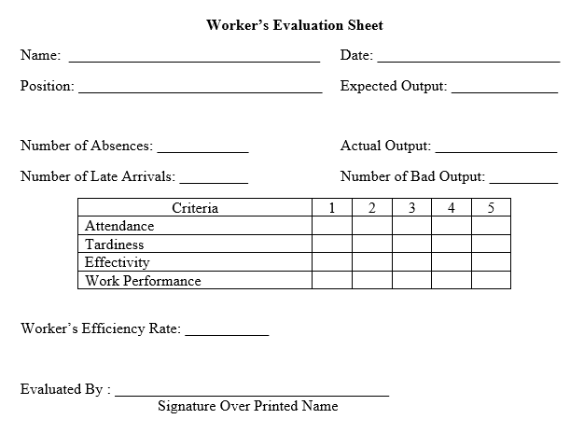

**Figure 30**. Worker’s Evaluation Sheet

The figure above shows the worker’s evaluation sheet. It includes the actual record of the worker as well as the rating of the worker. The worker’s efficiency will be the average rating of the workers.

$${Worker}^{'}s Efficiency Rate= \frac{Sum of Rating}{4} x 100$$

## **2.12 Equipment and Tools Needed**

**Table 24**. Tools and Equipment

|  |  |  |
| --- | --- | --- |
| **TOOLS AND EQUIPMENT** | **IMAGE** | **FUNCTION** |
| Philip’s Screw Driver |  | This tool is used to attach the screw |
| Pin Nail Gunner |  | This tool is used to shoot an ultrathin kind of pin |
| Grinder |  | This is used for cutting the woods in a faster and easier way |
| Paint Brush  (1”) |  | This size of paint brush is used for gluing the bracket part of the furniture |
| Paint Brush  (2 1/2 “) |  | This size of paint brush is used for painting and coating the finished good or the finished furniture |
| Measuring Tape |  | Measurement device used to measure the required dimensions of the product |

## **2.13 Principles of Motion Economy**

**Table 25.** Measuring and Tracing Principles of Motion Economy

|  |  |  |
| --- | --- | --- |
| **MEASURING & TRACING** | | |
| **Use of Human Body** | **Arrangement of Workplace** | **Design of Tools and Equipment** |
| To perform the measuring and tracing process, the operator should use his hand, wrist, forearm, arm and shoulder to achieve work satisfaction. | The equipment to be used for measuring such as the measuring tape should be placed in the workstation of the assigned worker and should be reachable. The storage bins are provided in the measuring area. For a better performance of the operator, the area is given good illumination | In measuring the wood parts, the tools are placed next to the operator or within the workstation so he can easily manipulate them |

**Table 26**. Cutting Principles of Motion Economy

|  |  |  |
| --- | --- | --- |
| **CUTTING** | | |
| **Use of Human Body** | **Arrangement of Workplace** | **Design of Tools and Equipment** |
| To perform the cutting process, the operator should use his hand, wrist, forearm, arm and shoulder to achieve work satisfaction. | The materials used in the cutting process are properly located in the workstation of the operator | In cutting the wood, the tools used are positioned near the operator so the operator can easily for them to maneuver. |

**Table 27**. Assembling Principles of Motion Economy

|  |  |  |
| --- | --- | --- |
| **ASSEMBLING** | | |
| **Use of Human Body** | **Arrangement of Workplace** | **Design of Tools and Equipment** |
| To perform the assembling process, the worker must use his hand, wrist, shoulder and arm. | The wood parts, raw materials are properly located in the workstation of the operator. The storage bins are provided in the assembly area. For a better performance of the operator, the area is given good illumination | The materials (bracket, wood glue, brush) used are positioned near the operator so the operator can easily for them to maneuver. |

**Table 28**. Sanding and Polishing Principles of Motion Economy

|  |  |  |
| --- | --- | --- |
| **SANDING and POLISHING** | | |
| **Use of Human Body** | **Arrangement of Workplace** | **Design of Tools and Equipment** |
| To perform polishing, the operator should use his hand, wrist, forearm, arm and shoulder to perform the process satisfactorily. Smooth continuous curved motions will make the polishing easier.  For sanding, smooth motions should also be applied. | The materials used in the sanding and polishing process are properly located in the workstation of the operator. | The materials used are positioned near the operator so the operator can easily for them to maneuver. |

**Table 29**. Mixing and Painting Principles of Motion Economy

|  |  |  |
| --- | --- | --- |
| **MIXING and PAINTING** | | |
| **Use of Human Body** | **Arrangement of Workplace** | **Design of Tools and Equipment** |
| To perform painting using paint and paintbrush, the operator should use his hand, wrist, forearm, arm and shoulder to perform the process satisfactorily. Smooth continuous curved motions will make the painting easier. | The materials used in the mixing and painting are properly located in the workstation of the operator. | The materials used are positioned near the operator so the operator can easily for them to maneuver. |

**Table 30**. Inspection and Packaging Principles of Motion Economy

|  |  |  |
| --- | --- | --- |
| **INSPECTION AND PACKAGING** | | |
| **Use of Human Body** | **Arrangement of Workplace** | **Design of Tools and Equipment** |
| To perform inspection, assigned worker should use his vision to visually check the product, hands, arm, forearm are also used to physically inspect the product. As per Packaging, the assigned worker should use his arm, forearm, wrist and shoulder and upper to efficiently conduct the process. | The materials used in the inspection and packaging are properly located in the workstation of the operator. | The materials used are positioned near the operator so the operator can easily for them to maneuver. |

## **2.14 Anthropometric Data**

Anthropometry alludes to the estimation of the human person. It includes the efficient estimation of the physical properties of the human body, fundamentally dimensional descriptors of body size and shape. The accompanying tables of anthropometric estimations of standing and sitting in the 50th percentile appeared beneath are utilized to decide the standard sizes and measurements of every workstation for each procedure obliging the normal estimations of Filipino laborers and influence them to do their work securely and easily.

**Table 31**. Standing Anthropometric Data

|  |  |  |  |  |  |  |
| --- | --- | --- | --- | --- | --- | --- |
| **MEASUREMENT** | **MALE** | | | **FEMALE** | | |
| **Mean** | **Median** | **Standard Deviation** | **Mean** | **Median** | **Standard Deviation** |
| Standing height | 167.01 | 167 | 8.03 | 153.9 | 155 | 82.28 |
| Eye height | 155.01 | 155 | 6.92 | 143.05 | 143 | 6.15 |
| Shoulder height | 137.45 | 137 | 6.07 | 127.71 | 127 | 5.8 |
| Shoulder width | 44.67 | 44 | 7.33 | 40.24 | 40 | 8.29 |
| Shoulder elbow length | 33.05 | 33 | 3.98 | 31.39 | 31 | 10.28 |
| Length of upper arm | 25.99 | 26 | 4.54 | 24.92 | 25 | 8.38 |
| Length of lower arm | 25.83 | 25 | 4.42 | 24.16 | 24 | 4.18 |
| Forearm hand length | 44.06 | 44 | 4.13 | 40.47 | 41 | 5.39 |
| Length of arm and hand | 72.6 | 73 | 6.35 | 66.04 | 67 | 5.77 |
| Elbow height | 104.41 | 104 | 6.72 | 96.28 | 97 | 7.39 |
| Knuckle height | 72.51 | 73 | 5.8 | 67.77 | 68 | 6.33 |
| Chest height | 123.36 | 123 | 7.23 | 111.28 | 112 | 10.5 |
| Chest breadth | 36.35 | 35.5 | 6.18 | 32.63 | 31 | 7.22 |
| Waist height | 97.32 | 98 | 8.43 | 95.47 | 96 | 6.09 |
| Waist hip length | 10.11 | 9 | 6.44 | 10.19 | 9 | 6.32 |
| Hip width | 43.5 | 44 | 8.33 | 43.38 | 44 | 7.1 |
| Hip height | 87.66 | 89 | 8.57 | 85.34 | 86 | 9.01 |
| Knee height | 49.73 | 50 | 5.99 | 45.88 | 46 | 3.09 |
| Popliteal height | 46.35 | 47 | 3 | 42.05 | 42 | 4.02 |
| Upper reach | 193.4 | 190 | 10.8 | 190.19 | 191 | 10.28 |
| Overhead fingertip reach | 212.08 | 213 | 9.1 | 196.46 | 196 | 8.91 |
| Arm span | 167.92 | 169 | 9.15 | 153.18 | 153 | 8.53 |

**Table 32.** Sitting Anthropometric Data

|  |  |  |  |  |  |  |
| --- | --- | --- | --- | --- | --- | --- |
| **MEASUREMENT** | **MALE** | | | **FEMALE** | | |
| **Mean** | **Median** | **Standard deviation** | **Mean** | **Median** | **Standard deviation** |
| Sitting height | 84.84 | 85 | 5.81 | 79.92 | 80 | 4.5 |
| Eye height | 73.36 | 73 | 3.83 | 68.38 | 69 | 4.85 |
| Elbow Height | 22.23 | 22 | 4.21 | 21.89 | 22 | 4.09 |
| Waist height, sittings | 19.44 | 19 | 6.15 | 22.41 | 22 | 3.21 |
| Hip height | 13.28 | 13 | 4.06 | 15.29 | 15 | 6.71 |
| Hip breadth, sitting | 35.6 | 35 | 4.06 | 36.39 | 36 | 4.83 |
| Thigh clearance height | 13.49 | 13 | 4.45 | 12.82 | 12 | 6.97 |
| Buttock popliteal height | 46.4 | 46 | 3.73 | 45.14 | 45 | 3.69 |
| Knee height, sitting | 50.03 | 50 | 3.99 | 46.98 | 47 | 4.43 |
| Popliteal height | 43.33 | 43 | 2.57 | 40.34 | 40.5 | 2.9 |
| Buttock width | 48.45 | 48 | 7.4 | 47.66 | 48.25 | 6.85 |
| Length of upper leg | 36.8 | 36 | 6.12 | 35.96 | 36 | 5.25 |
| Length of lower leg and foot | 45.27 | 46 | 4.53 | 42.14 | 42.5 | 4.31 |
| Thumb tip reach | 71.3 | 72 | 7.12 | 65.44 | 66 | 7.63 |
| Overhead fingertip reach, sitting | 127.92 | 128 | 7.81 | 116.87 | 117 | 9.77 |

## **2.15 Layout of the Production Area**

The production area refers to the production functional areas which are responsible in transforming raw materials (inputs) into a finished good/product (output). CORELAP (Computerized Relationship Layout Planning) is used to design the layout of the production area.

**Table 33**. Workstation Assignment

|  |  |
| --- | --- |
| **OPERATION** | **Workstation Assignment** |
| **Measuring and Tracing** | I |
| **Cutting** |
| **Assembling** |
| **Sanding** | II |
| **Polishing** | III |
| **Mixing-Painting-Inspection-Packaging** | IV |

**Table 34**. Relationship Diagram of Workstations

|  |  |  |  |  |
| --- | --- | --- | --- | --- |
| WORKSTATION | WORKSTATION RELATIONSHIP | | | |
| **I** | **II** | **III** | **IV** |
| **I** | - | A | A | O |
| **II** | A | - | A | E |
| **III** | A | A | - | A |
| **IV** | O | E | A | - |

Legend:

1. **4; E- 3; O-2; X- 1; U- 0 I- -1**

**Table 35**. Final Placement Sequence of the Workstations

|  |  |  |  |  |  |  |  |  |
| --- | --- | --- | --- | --- | --- | --- | --- | --- |
| **WORKSTATION** | **SUMMARY** | | | | | | **TCR** | **PLACEMENT SEQUENCE** |
|
| **A** | **E** | **O** | **X** | **U** | **I** |
| **I** | 2 | 0 | 1 | 0 | 0 | 0 | 10 | **3** |
| **II** | 2 | 1 | 0 | 0 | 0 | 0 | 11 | **1** |
| **III** | 2 | 1 | 0 | 0 | 0 | 0 | 11 | **2** |
| **IV** | 1 | 1 | 1 | 0 | 0 | 0 | 9 | **4** |

The table above shows how the workstations enter using the CORELAP with II-III-I-IV. With this layout, final layout of the production area can be done.



**Figure 31**. Layout of the Production Area



**Figure 32**. Dimension on the Layout of the Production Area

# **CHAPTER 3**

# **MATERIALS REQUIREMENT**

In this chapter, the process of defining the quantity and the quality of the raw materials needed in the operation or manufacturing of the product assembly is presented and discussed. This provides the elaborative or detailed information of the product**.** This phase shows the leveling of the materials needed to manufacture a product in accordance to its structure tree, specifications and bill of materials.

## **3. 1 Product Structure Tree**

Product Structure Tree is a representation of how a product is form and what the parts are. Also, it shows the subassemblies part and other items that shows the dependent parts ad represents grouping of items. The core of making product structure tree is illustrated by product components and their relationships



**Figure 33.** Product Structure Tree

## **3.1.1 Summary of Product Structure Tree**

|  |  |  |  |
| --- | --- | --- | --- |
| **Level** | **Description** | **Quantity** | **Unit of Measure** |
| 0 | Detachable Wooden Shoe Organizer | 1 | piece |
| 1 | Backboard Assembly | 1 | piece |
| 1 | Bracket Assembly | 38 | Pieces |
| 1 | Leaf | 36 | Pieces |
| 1 | Base | 2 | Pieces |
| 1 | Painting | 0.016 | liter |
| 2 | Plywood | 0.21 | ply |
| 2 | Solid Lauan Wood | 0.25 | Brdft |
| 2 | Plywood | 0.0012 | Ply |
| 2 | Plywood | 0.11 | Ply |
| 2 | Top Coat | 0.5 | Liter |
| 2 | Black Paint | 0.003 | Liter |
| 2 | White Paint | 0.01 | Liter |
| 2 | Brown Paint | 0.003 | liter |
| 2 | Wood Stain | 0.5 | liter |
| 3 | Piano Hinge | 1 | piece |
| 3 | Paint | .016 | liter |
| 3 | Wood Glue | 0.01 | 1 |
| 3 | Paint | .016 | liter |
| 3 | Pin Nails | 72 | pieces |
| 3 | Phillip’s screw | 1 | piece |
| 3 | Wood Glue | 0.01 | liter |

**Table 36**. Summary of Product Structure Tree

## **3.2 Specifications of the Materials**

|  |  |  |  |
| --- | --- | --- | --- |
| **Part Code** | **Parts** | **Description** | **Technical Information** |
| PH | Piano Hinge | 0.8x15 inch, Angle 180 | Purchased |
| PN | Pin Nails | 20 mm Brad Nail | Purchased |
| PS | Philip Screw | 6x1.25mm | Purchased |
| PL | Ply Wood (Leaf) | Marine, 4x8x1/4inch | Purchased |
| PS | Ply Wood (Leaf Stopper) | Ordinary, 4x8x1/8 | Purchased |
| PB | Solid Wood (Bracket) | Lauan, 10x1x1/2 | Purchased |
| PBB | Ply Wood (Back Board) | Marine, 48x96x1/2in | Purchased |
| PBS | Ply Wood (Base) | Marine, 4x8x1/2 | Purchased |
| SI | Sand Paper (Initial) | 100 grit, 3x5inch | Purchased |
| SS | Sand Paper (Semi -Fi) | 180 grit, 3x5inch | Purchased |
| SF | Sand Paper (Final) | 240 grit, 3x5inch | Purchased |
| WG | Wood Adhesive | Aquapac 1 liter | Purchased |
| WF | Wood Filler | Bosny Wood Filler | Purchased |
| BP | Black Permapaint | Boysen Black Permapaint 1L | Purchased |
| BRP | Brown Permapaint | Boysen Brown Permapaint 1L | Purchased |
| WP | White Permapaint | Boysen White Permapaint 1L | Purchased |
| TC | Top Coat | Mirotone Top Coat 1L | Purchased |
| WS | Wood Stain | Wood Stain 450 mL | Purchased |

**Table 37.** Specifications of the Materials

## **3.3 Parts List**

|  |  |  |  |  |  |  |
| --- | --- | --- | --- | --- | --- | --- |
| **Part Code** | **Material** | **Quantity per piece** | **Unit of measure** | **Daily Usage Rate** | **Weekly Usage Rate** | **Monthly Usage Rate** |
| **PH** | Piano Hinge | 0.25 | pc | 1.016 | 6.09 | 146.3 |
| **PN** | Pin Nails | 72 | pc | 288 | 1728 | 41472 |
| **PS** | Philip Screw | 6 | pc | 24 | 144 | 3456 |
| **PL** | Ply Wood (Leaf) | 0.82 | ply | 3.28 | 19.69 | 472.5 |
| **PS** | Ply Wood (Leaf Stopper) | 0.00121 | ply | 0.005 | 0.029 | 0.7 |
| **PB** | Solid Wood (Bracket) | 0.25 | brdft | 1 | 6 | 144 |
| **PBB** | Ply Wood (Back Board) | 0.21 | ply | 0.84 | 5.04 | 120.96 |
| **PBS** | Ply Wood (Base) | 0.11 | ply | 0.44 | 2.64 | 63.36 |
| **SI** | Sand Paper (Initial) | 1 | pc | 4 | 24 | 576 |
| **SS** | Sand Paper (Semi -Fi) | 1 | pc | 4 | 24 | 576 |
| **SF** | Sand Paper (Final) | 1 | pc | 4 | 24 | 576 |
| **WG** | Wood Adhessive | 0.01 | Liter | 0.04 | 0.24 | 5.76 |
| **WF** | Wood Filler | 0.003 | liter | 0.012 | 0.072 | 1.728 |
| **BP** | Black Permapaint | 0.003 | Liter | 0.012 | 0.072 | 1.728 |
| **BRP** | Brown Permapaint | 0.01 | Liter | 0.04 | 0.24 | 5.76 |
| **WP** | White Permapaint | 0.003 | Liter | 0.012 | 0.072 | 1.728 |
| **TC** | Top Coat | 0.5 | Liter | 2 | 12 | 288 |
| **WS** | Wood Stain | 0.5 | Liter | 2 | 12 | 288 |

**Table 38**. Parts List

## **3.4 Bill of Materials**

|  |  |  |  |  |  |  |
| --- | --- | --- | --- | --- | --- | --- |
| **Part Code** | **Parts** | **Description** | **Quantity per piece** | COMMERCIAL | | **Price Per Unit** |
| **Qty.** | **Price** |
| **PH** | Piano Hinge | 39.37 in, Angle 180 | 0.25 | 1 | 200 | 50.8 |
| **PN** | Pin Nails | 20 mm Brad Nail | 72 | 5000 | 150 | 2.16 |
| **PS** | Philip Screw | 6x1.25mm | 6 | 50 | 24 | 2.88 |
| **PL** | Ply Wood (Leaf) | Marine, 48x96x1/4inch | 0.82 | 1 | 420 | 262.5 |
| **PS** | Ply Wood (Leaf Stopper) | Ordinary, 48x96x1/8 inch | 0.001207 | 1 | 240 | 12 |
| **PB** | Solid Wood (Bracket) | Lauan, 10x1x1/2 | 0.25 | 1 | 700 | 175 |
| **PBB** | Ply Wood (Back Board) | Marine, 48x96x1/2in | 0.21 | 1 | 770 | 192.5 |
| **PBS** | Ply Wood (Base) | Marine, 48x96x1/2 | 0.11 | 1 | 770 | 77 |
| **SI** | Sand Paper (Initial) | 100 grit, 3x5inch | 1 | 1 | 2.5 | 2.5 |
| **SS** | Sand Paper (Semi -Fi) | 180 grit, 3x5inch | 1 | 1 | 2.5 | 2.5 |
| **SF** | Sand Paper (Final) | 240 grit, 3x5inch | 1 | 1 | 2.5 | 2.5 |
| **WG** | Wood Adhessive | Aquapac 1 liter | 0.01 | 1 | 1,635 | 16.35 |
| **WF** | Wood Filler | Bosny Wood Filler 400g | 0.003 | 0.4 | 300 | 0.09 |
| **BP** | Black Permapaint | Boysen Black Permapaint 1L | 0.003 | 1 | 207 | 0.621 |
| **BRP** | Brown Permapaint | Boysen Brown Permapaint 1L | 0.01 | 1 | 207 | 2.07 |
| **WP** | White Permapaint | Boysen White Permapaint 1L | 0.003 | 1 | 207 | 0.621 |
| **TC** | Top Coat | Mirotone Top Coat 1L | 0.5 | 1 | 150 | 75 |
| WS | Wood Stain | Wood Stain 450 mL | 0.5 | 0.45 | 40 | 20 |

**Table 39.** Table of Materials

# **CHAPTER 4**

# **INVENTORY CONTROL**

1. **Holding (or carrying) costs-** are those concerned with holding inventories that are not available. Such expenses are one aspect of the total cost of production, along with the cost of buying and the cost of shortages. Holding cost is the product of the unit cost of the material and the holding cost percentage. To calculate the holding cost percentage:

**Holding Cost Percentage $=\frac{Annual Cost of Owning Inventory}{Annual Inventory Value}$**  x Opportunity Cost Capital Percentage

**Opportunity Cost Capital Percentage -** the financial return that a capital could be expected to earn in an alternative investment of equivalent risk.

**Annual Cost of Owning Inventory-** refers to the summation of non-capital costs (e.g., Cost of Space, Storage Facilities & Energy Consumption).

**Cost of Space**

The cost of space is the cost incurred in acquiring the space in storing the inventory. The require space for the inventory is 5 meter by 5 meter which is equal to 20.25 square meter. The rental fee for the space is Php 10,322.34/sq. m per month.

Annual Cost of Space = Rent/Month 𝑥 12 months per year

Annual Cost of Space **=** Php 10,322.34x 12

𝐀𝐧𝐧𝐮𝐚𝐥 𝐂𝐨𝐬𝐭 𝐨𝐟 𝐒𝐩𝐚𝐜𝐞 = 𝐏𝐡𝐩 **123,868.13**

**Cost of Storage Facilities**

Annual Cost of Storage = $\frac{Cost of Facility}{Economic Life}$ x Number of Racks

**Table 40**. Cost of Storage Facilities

|  |  |  |  |  |
| --- | --- | --- | --- | --- |
| MATERIAL | QUANTITY | PRICE | ECONOMIC LIFE | ANNUAL COST OF STORAGE |
| Rack | 2 | ₱1,800.00 | 5 | ₱720.00 |
| Pallet | 5 | ₱300.00 | 1 | ₱1,500.00 |
| **TOTAL** | | | | **₱2,220.00** |

**Cost of Energy Consumption**

The cost of energy consumption is the energy consumed in storing the materials. The area has one (1) 20 watts’ bulb which operates approximately 2 hrs. a day.

**Annual Cost of Energy Consumption =** Power x Operating Hours x Power

Rate x Operating Days/month x 12 months

**=** 0.02 kW x 2 hrs x Php15.4914 x 24 days x12mos.

**Annual Cost of Energy Consumption = Php 178.46**

Thus,

Annual Cost of Owning Inventory = Cost of Space + Cost of Storage + Cost of Energy

Annual Cost of Owning Inventory = Php 123,868.13 + Php 2,200.00 + Php 178.46

**Annual Cost of Owning Inventory = Php 126,246.59**

Annual Inventory Value is the annual value of unsold or unused inventory. The proponent considered that the average inventory value is the cost incurred on the safety stock of the materials since the operation is new and the average inventory cannot be determined.

$$Annual Inventory Value=\frac{Daily Delivery Stock}{Commercial Quantity} x Commercial Price x 288 Days$$

**Table 41** Annual Inventory Value



Therefore,

$$Holding Cost Percentage= \frac{Annual Cost of Owning Inventory}{Annual Inventory Value}+ Opportunity Cost Capital Percentage$$

$$Holding Cost Percentage= \frac{126,246.59}{250,857.19}+ 10\%$$

$$Holding Cost Percentage= 0.533\%+ 10\%$$

$$Holding Cost Percentage= 10.53$$

**Table 42**. Carrying Cost

|  |  |  |  |
| --- | --- | --- | --- |
| **RAW MATERIAL** | **UNIT COST** | **CARRYING COST %** | **CARRYING COST** |
| Piano Hinge | 200 | 10.53% | 21.1 |
| Pin Nails | 150 | 10.53% | 15.8 |
| Philip Screw | 24 | 10.53% | 2.5 |
| Ply Wood (Leaf) | 420 | 10.53% | 44.2 |
| Ply Wood (Leaf Stopper) | 240 | 10.53% | 25.3 |
| Solid Wood (Bracket) | 700 | 10.53% | 73.7 |
| Ply Wood (Back Board) | 770 | 10.53% | 81.1 |
| Ply Wood (Base) | 770 | 10.53% | 81.1 |
| Sand Paper (Initial) | 2.5 | 10.53% | 0.3 |
| Sand Paper (Semi -Fi) | 2.5 | 10.53% | 0.3 |
| Sand Paper (Final) | 2.5 | 10.53% | 0.3 |
| Wood Adhessive | 1,635 | 10.53% | 172.2 |
| Wood Filler | 300 | 10.53% | 31.6 |
| Black Permapaint | 207 | 10.53% | 21.8 |
| Brown Permapaint | 207 | 10.53% | 21.8 |
| White Permapaint | 207 | 10.53% | 21.8 |
| Top Coat | 150 | 10.53% | 15.8 |
| Wood Stain | 40 | 10.53% | 4.2 |

1. **Ordering costs -** are the expenses incurred to create and process an **order** to a supplier. These **costs** are included in the determination of the economic **order** quantity for an inventory item.

**Energy Cost of Ordering**

|  |  |  |  |  |
| --- | --- | --- | --- | --- |
| **Equipment** | **Qty.** | **Usage per Transaction (hr.)** | **Power Rate (Php/kwh)** | **Total cost (Php)** |
| System Unit | 1 | 0.276 | 11.73 | ₱3.24 |
| Monitor | 1 | 0.15 | 11.73 | ₱1.76 |
| Telephone | 1 | 0.2 | 11.73 | ₱2.35 |
| Printer w/ scanner | 1 | 0.1 | 11.73 | ₱1.17 |
| **Total energy Cost** | | | | **₱8.52** |

**Table 43**. Energy Cost of Ordering

Labor Cost of Ordering

Labor Cost of Ordering = (Order Processing Time/Working hours) *x* Labor Cost per Day

|  |  |  |  |  |
| --- | --- | --- | --- | --- |
| **Personnel** | **Working Hours (mins.)** | **Labor Cost per Day (Php)** | **Processing Time/trans. (mins.)** | **Labor Cost (Php)** |
| Production Manager | 450 | 600 | 10 | 13.33 |
| TOTAL LABOR COST | | | | 13.33 per transaction |

**Table 44**. Labor Cost of ordering

## **4.1 Economic Order Quantity (EOQ)**

The following are the assumptions that the proponents considered in formulating the EOQ model for the raw materials:

* Demand for the material is constant and uniform throughout the period
* Lead time (time from ordering to receipt) is constant
* Price per unit of material, ordering or setup cost, and holding cost percentage of 18.13% are constant
* All demands for the material will be satisfied (No back orders are allowed)

The EOQ Formula:

$$EOQ= \sqrt{\frac{2 \left(Annual Demand\right)(Ordering Cost)}{Unit Cost x Holding Cost Percentage}}$$

|  |  |  |  |  |  |  |  |
| --- | --- | --- | --- | --- | --- | --- | --- |
| **Raw Material** | **Unit of measure** | **Usage Rate** | | **Ordering Cost** | **Holding Cost** | | **Economic Order Quantity** |
| Daily | Annually | Unit Cost | Holding Cost |
| Piano Hinge | pc | 1.02 | 292.6 | 71.85 | 200 | 21.1 | 3.16 |
| Pin Nails | pc | 288.00 | 82944 | 71.85 | 150 | 15.8 | 70.93 |
| Philip Screw | pc | 24.00 | 6912 | 71.85 | 24 | 2.5 | 127.97 |
| Ply Wood (Leaf) | ply | 3.28 | 945 | 121.85 | 420 | 44.2 | 3.52 |
| Ply Wood (Leaf Stopper) | ply | 0.00 | 1.4 | 121.85 | 240 | 25.3 | 0.24 |
| Solid Wood (Bracket) | brdft | 1.00 | 288 | 221.85 | 700 | 73.7 | 1.57 |
| Ply Wood (Back Board) | ply | 0.84 | 241.9 | 121.85 | 770 | 81.1 | 0.97 |
| Ply Wood (Base) | ply | 0.44 | 126.7 | 121.85 | 770 | 81.1 | 0.7 |
| Sand Paper (Initial) | pc | 4.00 | 1152 | 71.85 | 2.5 | 0.3 | 501.53 |
| Sand Paper (Semi -Fi) | pc | 4.00 | 1152 | 71.85 | 2.5 | 0.3 | 501.53 |
| Sand Paper (Final) | pc | 4.00 | 1152 | 71.85 | 2.5 | 0.3 | 501.53 |
| Wood Adhessive | Liter | 0.04 | 11.5 | 121.85 | 1,635 | 172.2 | 0.1 |
| Wood Filler | liter | 0.01 | 3.5 | 121.85 | 300 | 31.6 | 0.3 |
| Black Permapaint | Liter | 0.01 | 3.5 | 121.85 | 207 | 21.8 | 0.43 |
| Brown Permapaint | Liter | 0.04 | 11.5 | 121.85 | 207 | 21.8 | 0.79 |
| White Permapaint | Liter | 0.01 | 3.5 | 121.85 | 207 | 21.8 | 0.43 |
| Top Coat | Liter | 2.00 | 576 | 121.85 | 150 | 15.8 | 7.7 |
| Wood Stain | Liter | 2 | 576 | 121.85 | 40 | 4.2 | 28.86 |

**Table 45.** Economic Order Quantity

## **4.2 Reordering Point**

The ROP Formula:

ROP = (Lead Time x Daily Usage Rate) + Safety Stock

|  |  |  |  |  |  |
| --- | --- | --- | --- | --- | --- |
| **Raw Material** | **Unit of measure** | **Daily Usage Rate** | **Lead Time (Days)** | **Safety Stock** | **Reordering Point** |
| Piano Hinge | pc | 1.016 | 1 | 0.083 | 1.10 |
| Pin Nails | pc | 288.000 | 1 | 23.616 | 311.62 |
| Philip Screw | pc | 24.000 | 1 | 1.968 | 25.97 |
| Ply Wood (Leaf) | ply | 3.281 | 2 | 0.381 | 6.94 |
| Ply Wood (Leaf Stopper) | ply | 0.005 | 2 | 0.001 | 0.01 |
| Solid Wood (Bracket) | brdft | 1.000 | 2 | 0.116 | 2.12 |
| Ply Wood (Back Board) | ply | 0.840 | 2 | 0.097 | 1.78 |
| Ply Wood (Base) | ply | 0.440 | 2 | 0.051 | 0.93 |
| Sand Paper (Initial) | pc | 4.000 | 1 | 0.328 | 4.33 |
| Sand Paper (Semi -Fi) | pc | 4.000 | 1 | 0.328 | 4.33 |
| Sand Paper (Final) | pc | 4.000 | 1 | 0.328 | 4.33 |
| Wood Adhessive | Liter | 0.040 | 2 | 0.005 | 0.08 |
| Wood Filler | liter | 0.012 | 1 | 0.001 | 0.01 |
| Black Permapaint | Liter | 0.012 | 1 | 0.001 | 0.01 |
| Brown Permapaint | Liter | 0.040 | 1 | 0.003 | 0.04 |
| White Permapaint | Liter | 0.012 | 1 | 0.001 | 0.01 |
| Top Coat | Liter | 2.000 | 1 | 0.164 | 2.16 |
| Wood Stain | Liter | 2.000 | 1 | 0.164 | 2.16 |

**Table 46.** Reordering Point

## **4.3 Safety Stock**

The Safety Stock Formula:

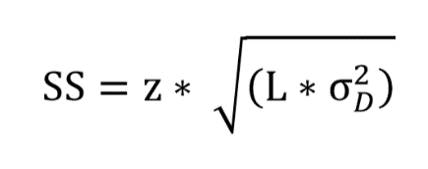

|  |  |  |  |  |  |  |
| --- | --- | --- | --- | --- | --- | --- |
| **Material** | **Quantity per piece** | **Unit of measure** | **Daily Usage Rate** | **5% Tolerance (Demand)** | **Lead Time (Days)** | **Safety Stock** |
| Piano Hinge | 0.254 | pc | 1.016 | 0.051 | 1.000 | 0.083 |
| Pin Nails | 72.000 | pc | 288.000 | 14.400 | 1.000 | 23.616 |
| Philip Screw | 6.000 | pc | 24.000 | 1.200 | 1.000 | 1.968 |
| Ply Wood (Leaf) | 0.820 | ply | 3.281 | 0.164 | 2.000 | 0.381 |
| Ply Wood (Leaf Stopper) | 0.001 | ply | 0.005 | 0.000 | 2.000 | 0.001 |
| Solid Wood (Bracket) | 0.250 | brdft | 1.000 | 0.050 | 2.000 | 0.116 |
| Ply Wood (Back Board) | 0.210 | ply | 0.840 | 0.042 | 2.000 | 0.097 |
| Ply Wood (Base) | 0.110 | ply | 0.440 | 0.022 | 2.000 | 0.051 |
| Sand Paper (Initial) | 1.000 | pc | 4.000 | 0.200 | 1.000 | 0.328 |
| Sand Paper (Semi -Fi) | 1.000 | pc | 4.000 | 0.200 | 1.000 | 0.328 |
| Sand Paper (Final) | 1.000 | pc | 4.000 | 0.200 | 1.000 | 0.328 |
| Wood Adhessive | 0.010 | Liter | 0.040 | 0.002 | 2.000 | 0.005 |
| Wood Filler | 0.003 | liter | 0.012 | 0.001 | 1.000 | 0.001 |
| Black Permapaint | 0.003 | Liter | 0.012 | 0.001 | 1.000 | 0.001 |
| Brown Permapaint | 0.010 | Liter | 0.040 | 0.002 | 1.000 | 0.003 |
| White Permapaint | 0.003 | Liter | 0.012 | 0.001 | 1.000 | 0.001 |
| Top Coat | 0.500 | Liter | 2.000 | 0.100 | 1.000 | 0.164 |
| Wood Stain | 0.500 | Liter | 2.000 | 0.100 | 1.000 | 0.164 |

**Table 47.** Safety Stocks

## **4.4 Summary of EOQ/ROP/SS**

**Table 48.** Summary of EOQ/ROP/SS

|  |  |  |  |  |
| --- | --- | --- | --- | --- |
| **Material** | **Unit of measure** | **Economic Order Quantity** | **Reordering Point** | **Safety Stock** |
| Piano Hinge | pc | 3.16 | 1.10 | 0.083 |
| Pin Nails | pc | 70.93 | 311.62 | 23.616 |
| Philip Screw | pc | 127.97 | 25.97 | 1.968 |
| Ply Wood (Leaf) | ply | 3.52 | 6.94 | 0.381 |
| Ply Wood (Leaf Stopper) | ply | 0.24 | 0.01 | 0.001 |
| Solid Wood (Bracket) | brdft | 1.57 | 2.12 | 0.116 |
| Ply Wood (Back Board) | ply | 0.97 | 1.78 | 0.097 |
| Ply Wood (Base) | ply | 0.70 | 0.93 | 0.051 |
| Sand Paper (Initial) | pc | 501.53 | 4.33 | 0.328 |
| Sand Paper (Semi -Fi) | pc | 501.53 | 4.33 | 0.328 |
| Sand Paper (Final) | pc | 501.53 | 4.33 | 0.328 |
| Wood Adhessive | Liter | 0.10 | 0.08 | 0.005 |
| Wood Filler | liter | 0.30 | 0.01 | 0.001 |
| Black Permapaint | Liter | 0.43 | 0.01 | 0.001 |
| Brown Permapaint | Liter | 0.79 | 0.04 | 0.003 |
| White Permapaint | Liter | 0.43 | 0.01 | 0.001 |
| Top Coat | Liter | 7.70 | 2.16 | 0.164 |
| Wood Stain | Liter | 28.86 | 2.16 | 0.164 |

## **4.5 Number of Orders per Year**

After computing the EOQ of each raw material, the proponents can now determine the number of orders per year for each material.

|  |  |  |  |  |
| --- | --- | --- | --- | --- |
| **Material** | **Unit of measure** | **Economic Order Quantity** | **Annual Demand** | **Number of Orders** |
| Piano Hinge | pc | 3.16 | 1756 | 555.66 |
| Pin Nails | pc | 70.93 | 497664 | 7016.50 |
| Philip Screw | pc | 127.97 | 41472 | 324.08 |
| Ply Wood (Leaf) | ply | 3.52 | 5670 | 1610.29 |
| Ply Wood (Leaf Stopper) | ply | 0.24 | 8 | 35.30 |
| Solid Wood (Bracket) | brdft | 1.57 | 1728 | 1098.03 |
| Ply Wood (Back Board) | ply | 0.97 | 1452 | 1493.70 |
| Ply Wood (Base) | ply | 0.70 | 760 | 1081.06 |
| Sand Paper (Initial) | pc | 501.53 | 6912 | 13.78 |
| Sand Paper (Semi -Fi) | pc | 501.53 | 6912 | 13.78 |
| Sand Paper (Final) | pc | 501.53 | 6912 | 13.78 |
| Wood Adhessive | Liter | 0.10 | 69 | 692.12 |
| Wood Filler | liter | 0.30 | 21 | 69.56 |
| Black Permapaint | Liter | 0.43 | 21 | 47.99 |
| Brown Permapaint | Liter | 0.79 | 69 | 87.63 |
| White Permapaint | Liter | 0.43 | 21 | 47.99 |
| Top Coat | Liter | 7.70 | 3456 | 448.99 |
| Wood Stain | Liter | 28.86 | 3456 | 119.73 |

**Table 49.** Number of Orders per Year

## **4.6 Length of the Order Cycle**

The order or replenishment cycle refers to the time between orders of a specific item. Most easily calculated by dividing the order quantity by the annual demand and multiplying by the number of days in the year.

The Order Cycle Formula in Days:

$$Order Cycle= \frac{EOQ}{Annual Demand}x Working Days$$

|  |  |  |  |  |
| --- | --- | --- | --- | --- |
| **Material** | **Unit of measure** | **EOQ** | **Annual Demand** | **Length of Order Cycle (Days)** |
| Piano Hinge | pc | 3.16 | 1756 | **0.52** |
| Pin Nails | pc | 70.93 | 497664 | **0.04** |
| Philip Screw | pc | 127.97 | 41472 | **0.89** |
| Ply Wood (Leaf) | ply | 3.52 | 5670 | **0.18** |
| Ply Wood (Leaf Stopper) | ply | 0.24 | 8 | **8.16** |
| Solid Wood (Bracket) | brdft | 1.57 | 1728 | **0.26** |
| Ply Wood (Back Board) | ply | 0.97 | 1452 | **0.19** |
| Ply Wood (Base) | ply | 0.70 | 760 | **0.27** |
| Sand Paper (Initial) | pc | 501.53 | 6912 | **20.90** |
| Sand Paper (Semi -Fi) | pc | 501.53 | 6912 | **20.90** |
| Sand Paper (Final) | pc | 501.53 | 6912 | **20.90** |
| Wood Adhessive | Liter | 0.10 | 69 | **0.42** |
| Wood Filler | liter | 0.30 | 21 | **4.14** |
| Black Permapaint | Liter | 0.43 | 21 | **6.00** |
| Brown Permapaint | Liter | 0.79 | 69 | **3.29** |
| White Permapaint | Liter | 0.43 | 21 | **6.00** |
| Top Coat | Liter | 7.70 | 3456 | **0.64** |
| Thinner | Liter | 28.86 | 3456 | **2.41** |

**Table 50.** Length of the Order Cycle

# **CHAPTER 5**

# **UNIT COST AND UNIT PRICE**

This chapter discusses the total cost in manufacturing one unit of the Adjustable Round Pointed Shovel and its value to the market. The unit cost consists of the direct materials cost, direct labor cost and overhead cost. The unit price refers to the unit cost added by a desired mark-up value, the profit per unit and the percentage of the unit cost.

## **5.1 Cost of Direct Materials**

The cost of direct materials is the total cost of the raw materials needed to manufacture one unit of an end product. The metrics below shows how the cost of each raw materials that is used in manufacturing the product is computed.

|  |  |  |  |  |  |  |
| --- | --- | --- | --- | --- | --- | --- |
| **PART CODE** | **PARTS** | **DESCRIPTION** | **QTY. PER PIECE** | **COMMERCIAL** | | **PRICE PER UNIT** |
| **Quantity** | **Price** |
| **PH** | Piano Hinge | 39.37 in, Angle 180 | 0.25 | 1 | 200 | 50.8 |
| **PN** | Pin Nails | 20 mm Brad Nail | 72 | 5000 | 150 | 2.16 |
| **PS** | Philip Screw | 6x1.25mm | 6 | 50 | 24 | 2.88 |
| **PL** | Ply Wood (Leaf) | Marine, 48x96x1/4inch | 0.820 | 1 | 420 | 262.5 |
| **PS** | Ply Wood (Leaf Stopper) | Ordinary, 48x96x1/8 inch | 0.001 | 1 | 240 | 12 |
| **PB** | Solid Wood (Bracket) | Lauan, 10x1x1/2 | 0.25 | 1 | 700 | 175 |
| **PBB** | Ply Wood (Back Board) | Marine, 48x96x1/2in | 0.21 | 1 | 770 | 192.5 |
| **PBS** | Ply Wood (Base) | Marine, 48x96x1/2 | 0.11 | 1 | 770 | 77 |
| **SI** | Sand Paper (Initial) | 100 grit, 3x5inch | 1 | 1 | 2.5 | 2.5 |
| **SS** | Sand Paper (Semi -Fi) | 180 grit, 3x5inch | 1 | 1 | 2.5 | 2.5 |
| **SF** | Sand Paper (Final) | 240 grit, 3x5inch | 1 | 1 | 2.5 | 2.5 |
| **WG** | Wood Adhessive | Aquapac 1 liter | 0.01 | 1 | 1,635 | 16.35 |
| **WF** | Wood Filler | Bosny Wood Filler 400g | 0.003 | 0.4 | 300 | 0.09 |
| **BP** | Black Permapaint | Boysen Black Permapaint 1L | 0.003 | 1 | 207 | 0.621 |
| **BRP** | Brown Permapaint | Boysen Brown Permapaint 1L | 0.01 | 1 | 207 | 2.07 |
| **WP** | White Permapaint | Boysen White Permapaint 1L | 0.003 | 1 | 207 | 0.621 |
| **TC** | Top Coat | Mirotone Top Coat 1L | 0.5 | 1 | 150 | 75 |
| **WS** | Wood Stain | Wood Stain 450 mL | 0.5 | 0.45 | 40 | 20 |
| **TOTAL COST** | | | | | | **897.902** |

## **5.2 Cost of Direct Labor**

The total labor cost of manufacturing one unit of the Detachable Wooden Shoe Organizer in which it is based on the recent minimum wage provision that the Department of Labor and Employment has provided. The metrics below shows how the cost of direct labor per worker in manufacturing the product is computed.

Sample Computation: Measuring-Tracing-Cutting-Assembling in Charge

$$Cost of Direct Labor = \frac{Rate Per Minute x Total Time in Working}{Total Units Processed Per Day}= \frac{0.90 x 451.86}{4.52}= 89.97$$

**Table 51.**Total Direct Labor Cost

|  |  |  |  |  |  |  |  |
| --- | --- | --- | --- | --- | --- | --- | --- |
| **Worker** | **Rate Per Day (Php)** | **Available Operation Time Per Day (Mins.)** | **Rate Per Minute (Php)** | **Total Time in Working** | **Labor Cost Per Day (Php)** | **Total Units Processed Per Day** | **Labor Cost Per Unit of Product (Php)** |
| Measuring -Tracing-Cutting -Assembling- in charge | 404 | 450 | 0.9 | 451.86 | 405.6699 | 4.52 | 89.97212 |
| Sanding - in charge | 404 | 450 | 0.9 | 449.8956 | 403.9063 | 5.94 | 68.166 |
| Polishing-in Charge | 404 | 450 | 0.9 | 449.5419 | 403.5887 | 4.37 | 92.583 |
| Mixing-Painting-Inspection and Packaging- in charge | 404 | 450 | 0.9 | 449.5722 | 403.6159 | 4.62 | 87.579 |
| **Total Cost of Direct Labor Per Product** | | | | | | | **338.3001** |

Table above shows that the total direct labor cost of manufacturing one unit of the Detachable Wooden Shoe Organizer is 338.30 php.

## **5.3 Overhead Cost**

The overhead or overhead cost refers to an on-going expense of operating a business, it also known as operating expense. It is usually necessary to the continued functioning and operating of the business, thus, cannot immediately associated with the products being offered but, does not directly generate profits. These are the expenditures which cannot be directly traced and identified with any particular cost in unit such expenses incurred may include advertising, insurance, interest, repairs, supplies taxes, wages, rent, electricity, labor or employee burden, among others. The total overhead cost of one unit of the Portable Speaker Charger is computed as the following:

$$Total Overhead Cost Per Product =\sum{Overhead Costs}$$

|  |  |
| --- | --- |
| **Type of Overhead Cost** | **Unit Cost (Php)** |
| Indirect Materials | 14.51 |
| Indirect Labor | 789.5 |
| Energy Cost | 57.86 |
| Water Consumption | 0.07 |
| Rent Expense | 300.00 |
| Depreciation Expense | 36.75 |
| **Total Overhead Cost Per Product** | **920.644** |

**Table 52**.Total Overhead Cost

Table above shows that the total overhead cost in manufacturing one unit of the Portable Speaker Charger is Php35.05.

**Cost of Indirect Materials**

The cost of indirect materials is the total cost incurred by other materials used in the production process which is indirectly seen in producing the product. It refers to the cost of materials and components that cannot easily and economically be identified either an individual unit of production or with a responsibility center.

**Table 53**.Total Cost of Indirect Materials

|  |  |  |  |  |
| --- | --- | --- | --- | --- |
| Material | Unit of Measure | Commercial | | Unit Cost (Php) |
| Quantity | Price (Php) |
| Sand Paper | Pc. | 1 | 2.5 | 2.51 |
| Paint Brush | Pc. | 1 | 12.00 | 12.00 |
|  |  |  |  |  |
| Total Indirect Material Cost | | | | **14.51** |

The table show that the total indirect material cost per unit is Php 14.51

**Cost of Indirect Labor**

The Indirect labor cost includes the labor expense or cost incurred in the administrative, security, logistics section of the organization. The metrics below shows how the cost incurred in indirect labor per personnel is computed.

Sample Computation: HR Staff

$$Cost of Indirect Labor = \frac{Total Labor Cost Per Day}{Total Units Processed Per Day}$$

$$Cost of Indirect Labor = \frac{550}{4}= 137.5$$

**Table 54**.Total Indirect Labor Cost

|  |  |  |  |  |
| --- | --- | --- | --- | --- |
| **Position** | **Number of Workers** | **Rate per Day (Php)** | **Total Units Produced Per Day** | **Unit Cost (Php)** |
| **HR Staff** | 1 | 550 | 4 | ₱137.50 |
| **Production Manager** | 1 | 600 | 4 | ₱150.00 |
| **QC Personnel/Inspector** | 1 | 600 | 4 | ₱150.00 |
| **Accounting Officer** | 1 | 600 | 4 | ₱150.00 |
| **Security Guard** | 1 | 404 | 4 | ₱101.00 |
| **Driver** | 1 | 404 | 4 | ₱101.00 |
| **Total Cost of Indirect Labor Per Product** | | | | **₱789.50** |

**Energy Cost**

The table shows the total cost of energy incurred during the manufacturing in which it gives an additional cost in the overall expenses of producing the product.

Sample Computation: Soldering Iron

$$Cost of Energy =Quantity x Wattage x Usage Rate Per Day x Energy Rate$$

$Cost of Energy =1 x 0.23 x 7.50 x 11.73$ = $Php 20.23$

**Table 55**.Total Energy Cost

|  |  |  |  |  |  |
| --- | --- | --- | --- | --- | --- |
| **Equipment** | **Quantity** | **Wattage (kW)** | **Usage Rate Per Day (Hours)** | **Energy Rate PHP** | **Total Cost Per Day PHP** |
| **Production Area** | | | | | |
| **Pin Nail Gunner** | 1 | 0.23 | 7.5 | ₱11.73 | ₱20.23 |
| **Grinder** | 1 | 0.24 | 7.5 | ₱11.73 | ₱21.11 |
| **Belt Sander** | 2 | 0.22 | 7.5 | ₱11.73 | ₱38.71 |
| **Automatic Paint Mixer** | 1 | 0.22 | 2 | ₱11.73 | ₱5.16 |
| **Administrative Area** | | | | | |
| **System Unit** | 2 | 0.276 | 7 | ₱11.73 | ₱45.32 |
| **Monitor** | 2 | 0.15 | 7 | ₱11.73 | ₱24.63 |
| **Printer w/ scanner** | 1 | 0.2 | 0.2 | ₱11.73 | ₱0.47 |
| **Air Condition** | 1 | 1.25 | 7.5 | ₱11.73 | ₱109.97 |
| **LED Lights** | 1 | 0.01 | 7.5 | ₱11.73 | ₱0.88 |
| **Telephone** | 1 | 0.1 | 7.5 | ₱11.73 | ₱8.80 |
| **Daily Energy Cost** | | | | | **₱231.42** |
| **Total Energy Cost Per Product** | | | | | **57.86** |

The energy rate was derived from General Service charge of the official mandate of the Visayan Electric Company (VECO) 2020. The table shows that the total energy cost of one unit of the product is

**Water Consumption**

The business assumes the after starting use of water consumption with the rate of Php 28.62 per cubic meter per use.

**Table 56**.Total Water Consumption Fee

|  |  |  |  |  |  |  |
| --- | --- | --- | --- | --- | --- | --- |
| **Activities** | **Frequency** | **Consumption (cubic m/use)** | **Headcount** | **Daily Consumption** | **Consumption rate** | **Consumption Cost (Php)** |
| **Handwashing** | 1 | 0.001 | 10 | 0.01 | 28.62 | 0.00286 |
| **Toilet Flushing** | 1 | 0.005 | 10 | 0.05 | 28.62 | 0.07155 |
|  | | | | | | **0.074** |
|

The table shows that the Total Water Consumption cost per unit is 0.074.

**Rent Expense**

The rent expense is the cost incurred in occupying a space per period of time. The table shows the structure/space, rental fee incurred per unit of product.

**Table 57.**Rent Expense per Product

|  |  |  |  |  |
| --- | --- | --- | --- | --- |
| **Description** | **Rent Per Month (Php)** | **Rent Per Day (Php)** | **Total Produced Units Per Day** | **Unit Cost (Php)** |
| **Structure** | 36,000 | 1,200.00 | 4 | ₱300.00 |
| **Rent Expense Per Product** | | | | **₱300.00** |

The table above shows the Rent Expense per product at a value of Php 300.00.

**Depreciation Expense**

Depreciation expense is the part of a tangible capital asset of the business that is used for the daily operation of the business and is considered to have been consumed or expired, and has thus become an expense. The table shows the equipment depreciation cost incurred per unit of product.

Sample Computation: Pin Nail Gunner

$$Annual Depreciation =\frac{\left(Quantity x Unit Price\right)-Salvage Value}{Economic Life}$$

$$Annual Depreciation =\frac{\left(1 x 1250.00\right)-0.00}{5} =PHP 250.00$$

$$Depreciation Expense Per Product=\frac{\frac{Annual Depreciation}{Number of Days Per Year}}{Total Processed Units Per Day}$$

$$Depreciation Expense Per Product=\frac{\frac{250}{365}}{4}=Php 0.17$$

|  |  |  |  |  |  |  |  |  |
| --- | --- | --- | --- | --- | --- | --- | --- | --- |
| **Equipment** | **Quantity** | **Unit Price (Php)** | **Total Amount (Php)** | **Salvage Value (Php)** | **Economic Life** | **Annual Depreciation (Php)** | **Depreciation Expense Per Day (Php)** | **Depreciation Expense Per Unit (Php)** |
| **Production Area** | | | | | | | | |
| **Pin Nail Gunner** | 1 | 1,250.00 | 1,250.00 | 0 | 5 | 250 | 0.868055556 | 0.217013889 |
| **Grinder** | 1 | 1,855.00 | 1,855.00 | 0 | 2 | 927.5 | 3.220486111 | 0.805121528 |
| **Belt Sander** | 2 | 6,299.00 | 12598 | 0 | 5 | 2519.6 | 8.748611111 | 2.187152778 |
| **Automatic Paint Mixer** | 1 | 1789 | 1789 | 0 | 5 | 357.8 | 1.242361111 | 0.310590278 |
| **Administrative Area** | | | | | | | | |
| **Computer Set** | 2 | 25,500.00 | 25,500.00 | 0 | 5 | 10200 | 35.41666667 | 8.854166667 |
| **Printer w/ scanner** | 1 | 4,899.00 | 4,899.00 | 0 | 5 | 979.8 | 3.402083333 | 0.850520833 |
| **Air Conditioner** | 1 | 10,499.00 | 10,499.00 | 0 | 5 | 2099.8 | 7.290972222 | 1.822743056 |
| **LED Lamp** | 1 | 1,138.31 | 2,276.62 | 0 | 5 | 227.662 | 0.790493056 | 0.197623264 |
| **Telephone** | 1 | 1,599.00 | 1,599.00 | 0 | 5 | 319.8 | 1.110416667 | 0.277604167 |
| **Office Table** | 2 | 4,500.00 | 13,500.00 | 0 | 5 | 1800 | 6.25 | 1.5625 |
| **Office Chair** | 3 | 3,000.00 | 9,000.00 | 0 | 5 | 1800 | 6.25 | 1.5625 |
| **Cabinet** | 1 | 9,750.00 | 9,750.00 | 0 | 5 | 1950 | 6.770833333 | 1.692708333 |
| **Filling Cabinet** | 1 | 1,850.00 | 1,850.00 | 0 | 5 | 370 | 1.284722222 | 0.321180556 |
| **Renovation** | 1 | 300,000.00 | 300,000.00 | 0 | 10 | 30000 | 104.1666667 | 26.04166667 |
|  |  |  |  |  |  |  |  | **46.70309201** |
| **Total Depreciation Expense Per Product** | | | | | | | |

**Table 58**.Depreciation Expense Per Unit

## **5.4 Unit Cost**

The unit cost is total incurred cost in manufacturing the product. This refers the total expense of production line and the cost incurred in the entire process to make and produce the item directly and indirectly. The cost of production per unit is computed from the summation of direct materials, direct labor & overhead cost.

**Table 59**.Unit Cost

|  |  |
| --- | --- |
| **Summary of Costs** | **Unit Cost (Php)** |
| Direct Materials | ₱897.92 |
| Direct Labor | ₱338.30 |
| Overhead | ₱920.64 |
| **Cost per Unit** | **₱2,156.86** |

$$Unit Cost = Cost of Direct Materials+Cost of Direct Labor+Overhead Cost$$

$$Unit Cost =794.5748+338.30+758.72=Php 2156.864$$

## **5.5 Unit Price**

The unit price refers to the monetary value of selling the product. It is composed of the production cost of one unit of product along with its mark-up value. The common markup percentage used in industry ranges from 20% - 30%. In this case, the proponents used 20 markup percentage to support the business in the long-run and fund other expenses on operating the business.

**Table 60.**Unit Price

|  |  |  |
| --- | --- | --- |
| **Cost per Unit PHP** | **Mark-up** | **Unit Price PHP** |
| **₱2156.86** | **20%** | **₱2588.86** |

$Unit Price = Unit Cost x (1+Markup Percentage$)

$$Unit Price = 2156.864 x \left(1+0.2\right)=PHP 2588.864$$

The unit price of the Detachable Wooden Shoe Organizer shown above is a little bit expensive however, the product is within the range of the market value of the same product.

## **5.6 Discussion of the Value of Money**

The Detachable Wooden Shoe Organizer is a non-existing product that gets its inspiration on the existing modern design of shoe racks. The product is introduced to market with any age, home, facilities applicable to use the Detachable Wooden Shoe Organizer.

What makes the price a little bit expensive is because of the uniqueness of the product wherein it cannot be seen now from the market. If you are going to analyze the monetary value of the product, the features of the product will justify its price. The features and the characteristics of this product says it all. If the customer will buy this product, certainly they would be satisfied and they are guaranteed with that. There may be a high value of money, but also assuredly say, that customers as well are highly valued because of something new that this product offers.

# **CHAPTER 6**

# **BENEFITS AND INCENTIVE SCHEME**

Providing employees with rewards and opportunities is a great way to show them that you care and that you want them to be with you in the long run. Happy employees tend to be the most productive and loyal. When it comes to making employees happy, the basics still ring true. Just about everyone responds well to praise, better salaries, more time off, a positive corporate culture, and other employee benefits.

## **6.1 As Mandated by the Law**

1. Holidays: Eleven (11) paid national regular holidays and Nine (9) national special holidays per year as provided under Proclamation No. 845 (2020 Declared Holidays).

**Regular Days**

|  |  |
| --- | --- |
| **LEGAL HOLIDAYS** | **DATE** |
| New Year’ Day | 1-Jan |
| Araw ng Kagitingan | 9-Apr |
| Maundy Thursday | 9-Apr |
| Good Friday | 10-Apr |
| Labor Day | 1-May |
| Independence Day | 12-Jun |
| National Heroes Day | 26-Aug |
| Bonifacio Day | 30-Nov |
| Christmas Day | 25-Dec |
| Rizal Day | 30-Dec |

**Special Non-Working Days**

|  |  |
| --- | --- |
| **LEGAL HOLIDAYS** | **DATE** |
| Chinese New Year | 25-Jan |
| EDSA Revolution Day Anniversary | 25-Feb |
| Black Saturday | 11-Apr |
| Ninoy Aquino Day | 21-Aug |
| All Saint’s Day | 1-May |
| Feast of Immaculate Conception of Mary | 12-Jun |
| Last day of the Year | 26-Aug |
| All Souls Day | 30-Nov |
| Christmas Eve | 24-Dec |

2. Vacation: Thirteen (13) vacation leave, with additional 1 day every year starting on the 3rd year of service and convertible to cash at the end of each year. Maximum vacation leave is 18 days.

3. Retirement: The plan is 100% funded by the company calculated at one month’s base salary per year of service based on the employee’s latest basic rate upon normal retirement at age 60, death or total and permanent disability. Early retirement benefit can be available to 10 years of service equal to 50% of normal retirement benefit.

4. Healthcare: The plan provides a comprehensive health care coverage for employees and eligible dependents through Medicard’s accredited hospitals and doctors nationwide. The annual premium for Principal/Employees is 100% shouldered by the company. For direct dependents, OSPI covers 53% of the cost and the rest of the 47% is on employees account. The company also maintains an onsite medical clinic manned by a company nurse per shift and a group of company doctors who reports to the clinic six days a week on specified time schedules providing free medical consultations, emergency medicines, minor and first-aid treatments and health counseling. As part of preventive health care, free multivitamins are also provided to employees while on duty and all employees are required to undergo an annual medical, dental and eye check-up conducted onsite.

* Dental: Free dental benefits are likewise provided with two (2) dentists alternately visiting the factory rendering unlimited dental consultations, unlimited simple tooth extractions and permanent/temporary fillings, annual oral prophylaxis, re-cementation of jacket crown inlays and onlays, simple adjustment of dentures and emergency treatments.
* Outpatient Medicine Reimbursement: The Company reimburses expenses for outpatient medicines for employees and dependents. Out-patient medicines are 100% reimbursable while Php 2,000 per year is provided for dependents. Approval of reimbursement requires submission of prescription and official receipts.

5. Work and Overtime Hours: Typically, a worker will not work more than eight (8) hours of the day, and will not be permitted to work mutiple (1) hour day by day lunch. Be that as it may, the Philippine enactment does not deny under (8) hours of work. Working hours included, untouched amid which a worker is endured and allowed to work. Rest periods amid working hour are considered working hours. At some point, all representatives who are required additional time pay rates depend of the work being performed.

**OTHER LEAVES:**

1. Sick Leave: Twelve (12) days for the first two years of service and additional 1 day every year starting on the 3rd year. Maximum total sick leave is 15 days. All unused leaves are convertible to cash at the end of the year.
2. Paternity Leave: All married male employees are eligible for 7 working days up to four (4) child birth including miscarriage of legitimate spouse to be availed within sixty (60) days from delivery/miscarriage.
3. Bereavement: Three (3) days applicable to immediate family member which includes the employee’s children, parents, grandparents, brother, sister, spouse, and parents-in-law.
4. Solo Parent Leave: Seven (7) working days
5. Calamity Leave: Two (2) days leave for employees who were affected by flood, fire and typhoon (must be supported by a Government proclamation or may be declared by the Company).
6. Magna Carta for Women (Special Leave): Sixty (60) calendar days leave. This is given to all female employees who underwent surgery caused by gynecological disorders and who have rendered at least six (6) months continuous aggregate employment service for the last twelve (12) months prior to surgery.

**OTHER BENEFITS:**

1. **13th month:** The Company grants a 13th month pay equivalent to one (1) month’s pay to all eligible employees provided that they worked for at least one (1) month during a calendar year.

The Labor Code also requires employers to become members of the Pag-IBIG Fund, PhilHealth, and SSS, as well as remit monthly contributions on behalf of their employees to these government offices. This ensures that employees have access to affordable house financing, health insurance, and [social security benefits](https://www.moneymax.ph/government-services/articles/4-useful-sss-benefits), as mandated by the law.

1. **PAG-IBIG Fund:** All members of PAG-IBIG or employees who earn a monthly of Php 1,500.00 or less shall contribute 1% per month, whereas those above, pay 2% per month. The employees of the PAG-IBIG members are required under the PAG-IBIG Law to provide counterpart contribution to the PAG-IBIG a monthly compensation at a rate of 2% per month. A PAG-IBIG member who pays 1% of each individual compensation automatically triples the monthly saving by adding employee counterparts while a PAG-IBIG member who pays 2% per month immediate doubles each savings.
2. **SSS Membership:** Republic Act No. 1611 protects employees from disability, sickness, age or death. The Act requires all employees to be SSS member. Its contribution is based on its gross monthly income reflected in the SSS Contribution timetable.
3. **Philippine Health Insurance:** The Philippine Health Insurance Corporation (PhilHealth) administered the National Health Insurance Program (NHIP) under the Republic Act (RA) 7875 and was established in 1995. The mandate of the PhilHealth is to provide all Filipinos with health insurance coverage. The monthly contributions paid by each member must be received by their value. It depends on the income bracket to which employees belong to every month.

## **6.2 Discretion of the Company**

This piece of the examination demonstrates different advantages in the organization beside the advantages commanded by the administration. This will give extra inspiration to the representatives to consistently improve their execution and persistently work for the organization.

*Loyalty Token*

Employees are recognized for their loyal and dedicated service to the company for every five years of continuous service by the way of gift check or token, plus plaque of appreciation during the service award ceremony.

*Employee of the Month*

This is given to the employee for showing high performance.

*Christmas Bonus*

Every employee in the company will be given Php 500.00 worth of grocery items. This incentive is given only once during Christmas season.

*Christmas Party*

The organization will hold Christmas party each year to give somewhere around multi day of fun and bliss to the representatives who are buckling down to accomplish the organization destinations and to build up the relationship of workers to each other.

# **CHAPTER 7**

# **QUALITY CONTROL**

Quality Control is the best way to ensure that the products being produce meets the requirements or criteria made and chosen by the customers. It is a set of procedures in checking the quality of the product. In this process, it is where the possible defects are determined before reaching the product to the customer. Based on International for Standardization (ISO) 9000 defines that the quality control as “part of quality management focused on fulfilling quality requirement.” Quality is always defined by a business’ customers. Quality should be offered through the product to satisfy or exceed the expectation of the customers, at the same time gives good reputation name to the business. In order to achieve the quality needed by the end-user of a product, quality control management is essential to get there.

## **7.1 Attributes of the Product Requiring Control**

Product attributes refer to additional characteristics of the product made. Moreover, attribute are those characteristics of the products that are counted rather than measured. This can attract customers for quality is being observed. In making Detachable Wooden Shoe Organizer, there are attributes that at some point can be critical that it will need constant controls:

**Appearance.** refers to the looks of the product, includes the color. Correctness done in painting process.

**Precision.** Refers to the state of being accurate in assembling the parts.

**Correctness** – it refers to the correctness of the product as the market accept or the product meet the required standard.

**Durability** – it refers to the performance of the product to the users. The functions that is correct for the design of the product to be beneficiary to the users. The measure of how well the product functions in a span of its life. The product should be relevant to the user over the time.

## **7.2 Variables of the Product Requiring Control**

The variables of the product refer to the part that is measured with accordance to its requirements. The variable of the product requiring control is within the limit of the required measurement of the components.

**Measurement-** This measurement refers to the dimensions that are needed for the product for precision.

**Alignment**– The alignment of the parts of the product in the assembly process.

## **7.3 Suggested Practical Method of Controlling Attributes**

|  |  |
| --- | --- |
| **Provide important details about the job posted near workstations** | Important details refer to the procedures, pictorial view of correct and incorrect work, and pictorial view of types of defects. Correct procedures must be written and posted near each work station for if the process is done in accordance to its design procedure, then the quality of the output will justify it. Additional posts are with regards to correct and incorrect work which will help the workers see if they are doing the right thing. Also, pictures of the types of defects to guide the workers about the attribute defects of the product and eventually makes them conscious in producing the output. |
| **Provide posted written and visual procedure of doing the work** | It will be helpful that there will be a written and visual procedure of doing the task, it is one way of adopting the quality concept of “do things right the first time” because if the job is done according to the design procedure then the quality of the output will justify it. |
| **Provide visual standards of the correct and wrong work** | Providing pictorial view of the correct and incorrect work is needed for the employee to visualize the defined quality set by the management. It will eventually limit the defects produce because the workers will be guided. |
| **Provide visual standards view of the types of defects** | Posted pictorial view of the types of defects in every station will guide the workers on the attributes defects of the product and it will allow them to be more conscious in producing their output and eventually minimize producing defective products. |
| **Visual inspection of the product** | Aside from the visual inspection done by the inspector at some control points, the worker itself should inspect the output before it will be turnover for the next process. |
| **Provide checklist to the inspector** | Upon performing the inspection, the inspectors should be provided with a checklist to tally the observed attribute defects of the output. The purpose of the checklist is to track which defects occur the most and needs to be address. The Daily Inspection Report is the checklist for attribute data. All the defects will be tallied according to its type. The space allotted for the point of inspection will be filled with the inspection process in which the defect was detected. |

## **7.4 Suggested Practical Method of Controlling Variable**

|  |  |
| --- | --- |
| **Provide posted table of specified variable characteristic of the product** | Posted table will guide the workers on what is the acceptable variable characteristic of the output. It will help in early detection non-conformance of the output. |
| **Provide measuring device such as measuring tape, ruler/meter stick** | Providing measuring device will help in performing comprehensive inspection. It will make the inspection more exact on the variable characteristics of the output. |
| **Perform initial inspection of electronic materials before releasing for production** | Upon purchasing the material, the QC will ensure that the materials are in good state before releasing for production. Early detection of the defects will be less in cost compare to late detection. |
| **Proper maintenance for the tools and equipment used** | Properly maintained tools and equipment will avoid errors in performing the job. Damaged tools and equipment will result poor quality outputs. |
| **Provide Quality Control Report to the inspector** | Upon performing the inspection, the inspectors should be provided with a checklist to tally the observed variable characteristic of the output. The purpose of the checklist is to evaluate the process whether it produces conformed products or not. |

### **7.5 Inspection along the Line**

Inspection activity will take place in each process. Built-in checking will be done to maintain the good state of the product done in every process. This is a way to check if the worker is doing the right work. Points of inspection in production are as follows:

*Receiving Area of Raw Materials (Warehouse)*

Before storing the materials received from suppliers, the personnel assigned should check and verify the ingoing raw materials to avoid problems in the production.

*Measuring Tracing and Cutting Area*

In measuring, tracing and cutting, these processes require precision and accuracy in its execution. Thus, in each respective operation of every part has a built-in inspection wherein the workers first-handedly inspect the parts themselves.

*Assembling Area*

In assembling, it requires proper handling materials to ensure the precision of positioned parts. There should be a strict inspection of the assembly part before passing it through the next process.

*Sanding Area*

In this part, appropriate materials should be used in order to have a good quality outcome. There should also be a proper inspection here before passing it forward.

*Inspection Area (Finished Good (end of line/Inspection Process))*

This part involves the final inspection of the finished good. The end of the line inspection is where quality assurance occurs. Making sure that the produced final output has a quality that is deliverable and acceptable to the customers.

## **7.6 Statistical Method of Controlling Quality**

Statistical method of controlling quality is a method wherein statistical tools are used in controlling quality. The use of statistics is useful in making decisions about the process based on an analysis of the information given. Statistical methods play a vital role in quality control and improvement of a process or product.

### **7.6.1 Suggested Tool to Control Attributes**

* **Process failure mode and effect analysis (PFMEA)**

This is an analytical tool widely used by businesses to identify and evaluate the potential failures of a process. It can effectively identify the specific area of the production to be prioritized.

|  |  |  |  |
| --- | --- | --- | --- |
| **RATING** | **DESCRIPTION** | | |
| **Severity** | **Occurrence** | **Detection** |
| **1** | No effect | Very low | Near certain |
| **2** | Very slight error | Low | Very high |
| **3** | Slight error | Low | High |
| **4** | Minor error | Moderate | Moderately high |
| **5** | Moderate error | Moderate | Moderate |
| **6** | Significant error | Moderate | Low |
| **7** | Major error | High | Very low |
| **8** | Serious error | High | Remote |
| **9** | Critical error | High | Very remote |
| **10** | Extreme error | Very high | Near impossible |

**Table 61.** PFMEA rating scale



** Table 62.** PFMEA

* **Process Control Plan (PCP)**

It is a method for documenting the functional elements of quality control that are to be implemented in order to assure that quality standards are met for a particular product or service.





**Table 63. Process-Control-Plan**

### **7.6.2 Suggested Tool to Control Variables**

**STATISTICAL PROCESS CONTROL**- This tool is used to ensure that processes meet standards. Its objective is to provide a statistical signal when assignable causes of variation are present. Statistical process control has its control charts.

$\overline{x}$**-Chart-** tells whether changes have occurred in the central tendency of a process (e.g., tool wear, a gradual increase in temperature, a different method used on the second shift, or new and stronger materials)

Setting mean-chart limits:

${UCL}_{\overline{x}}$ = $\overline{\overline{x}}+ {Zσ}_{\overline{x}}{LCL}_{\overline{x}}$ = $\overline{\overline{x}}-{Zσ}_{\overline{x}}$

Where:

$\overline{x}$-mean of the sample mean

𝑧-number of normal standard deviations (2 for 95.45% confidence, 3 for 99.73%)

$σ_{\overline{x}}$-standard deviation of the sample means ($σ/{\sqrt{n}})$

𝜎-population (process) standard deviation

𝑛-sample size

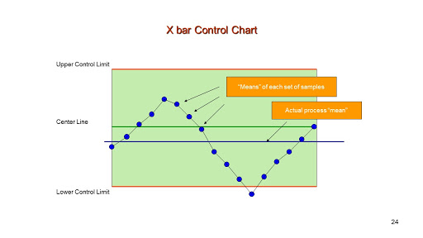

**Figure 34.** X-Bar Control Chart Sample

**𝑅-chart-** values indicate that a gain or loss in dispersion has occurred (e.g., worn bearings, a loose tool, an erratic flow of lubricants to a machine, or to sloppiness on the part.

Setting mean-chart limits:

${UCL}_{R}$ = $D_{4}\overline{R}{LCL}_{R}$ = $D_{3}\overline{R}$

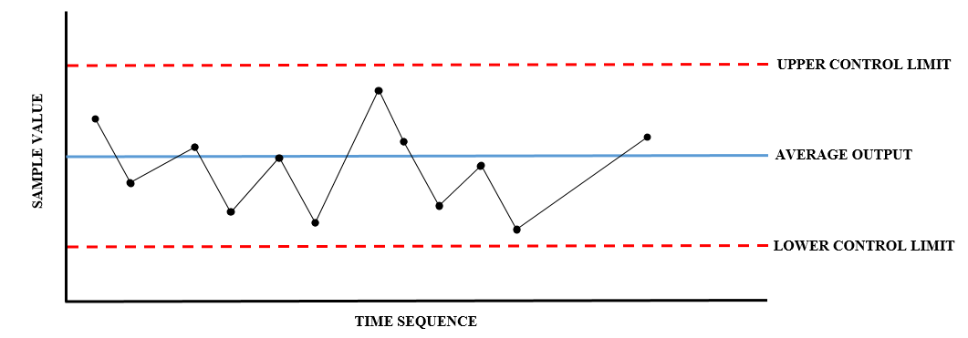

**Figure 35.** Process Control Chart

## **7.7 Suggested Policy regarding Rework**

Reworks are services or product that does not meet the requirements of customer.

**POLICY FOR REWORK**

|  |  |  |
| --- | --- | --- |
| **GN COMPANY** | **REWORK POLICY** | **Page 1 of 1** |
| Revised: |
| **Issued on:** | Version No. 1 |  |
| *The following are the recommended policies for rework such as but not limited to the following:* | | |
| 1. Rework operation can only be carried out in designated rework area. | | |
| 2. All item subjected to rework must be and directly reported to the production in-charge or the management. | | |
| 3. Minimal defects such as scratch and dents must be filtered and discuss by the quality control personnel. the decision for rework will be done by the quality control personnel. | | |
| 4. Request for additional material for reworks must be signed by the general manager. in the absence of the responsible personnel immediate authorized personnel may take over the signing. | | |
| 5. Customer complaint reworks will be subject to thorough investigation. | | |
| 6. Three (3) consecutive MAJOR reworks (needs additional materials or requires (1 hour above repair time) done by the worker will be subjected to investigation. proven fault by workers will be subjected to sanction. | | |

|  |  |
| --- | --- |
| **SANCTIONS** | |
| **1st offense** | The employee will receive verbal notice |
| **2nd offense** | Written notice (requires explanatory letter) |
| **3rd offense** | Salary deduction |
| **4th offense** | Termination |

**Table 64.** Rework Sanction

## **7.8 Qualification of Personnel in Charge of Quality Control**

|  |
| --- |
| **QUALIFICATIONS OF A QUALITY CONTROL MANAGER** |
| Male or Female |
| Preferably a graduate of Industrial Engineering |
| Has previous experience in production or manufacturing |
| Strong attention of detail, observation, organizational, and leadership skills |
| In depth knowledge of Quality Control Procedures and legal standards |

**Table 65.** Qualifications of a QC Manager

|  |
| --- |
| **QUALITY INSPECTOR** |
| Job Qualifications |
| **Male or Female** |
| **18-30 years Old** |
| **A college level is advantage** |
| **Willing to be trained in quality** |

**Table 66.** Qualifications for Quality Inspector

In creating the Detachable Wooden Shoe Organizer, the work force accountable for quality control is the Quality Control Manager along with its personnel. The company will hire employees has the following qualification for the job as quality control personnel.

## **7.9 Organizational Structure of Quality Control Section/Department**

The organizational structure of the quality control section as shown in the figure below, illustrates the hierarchy of the position of the person that carries the responsibility in ensuring the production of quality products.



**Figure 36.** Organizational Structure of Quality Control Section/Department

# **CHAPTER 8**

# **MATERIAL HANDLING**

## **8.1 Principles of Material Handling**

In working with material handling, it is important to know the principles of material handling to ensure that all material handling is executed deliberately and efficiently. The following are the principles of Material Handling:

**Figure 37**. Material Handling Principles

**1. Planning Principle.** All material handling should be the result of a deliberate plan where the needs, performance objectives and functional specification of the proposed methods are completely defined at the outset. The plan should be developed in a consultation between the planner and the users of the equipment.

**2. Standardization Principle.** This principle believes that all equipment, controls and materials should be standardized within the limits of achieving overall performance.

**3. Work Principle.** This principle believes that material handling work should be minimized without hindering productivity or the service level requires for the operation. Work principle simplifies processes by reducing, eliminating unnecessary movement that also reduces works.

**4. Ergonomic Principle.** Human capabilities and limitations must be recognized and respected in the design of material handling tasks and equipment to ensure safe and effective operations. Equipment should be selected that eliminates repetitive and strenuous manual labor and which effectively interacts with human operators and users.

**5. Unit Load Principle.** Unit loads shall be appropriately sized and configured in a way which achieves the material flow and inventory objectives at each stage in the supply chain. Less effort and work is required to collect and move many individual items as a single load than to move many items one at a time.

**6. Space Utilization Principle.** In work areas, cluttered and unorganized spaces and blocked aisles should be eliminated. In storage areas, the objective of maximizing storage density must be balanced against accessibility and selectivity. When transporting loads within a facility the use of overhead space should be considered as an option.

**7. Environmental Principle.** Environmental impact and energy consumption should be considered as criteria when designing or selecting alternative equipment and material handling systems. Containers, pallets and other products used to form and protect unit loads should be designed for reusability when possible and/or biodegradability as appropriate. Materials specified as hazardous have special needs with regard to spill protection, combustibility and other risks.

**8**. **System Principle.** Material movement and storage activities should be fully integrated to form a coordinated, operational system which spans receiving, inspection, storage, production, assembly, packaging, unitizing, order selection, shipping, transportation and the handling of returns. Systems integration should encompass the entire supply chain including reverse logistics. It should include suppliers, manufacturers, distributors and customers.

**9. Automation Principle.** Material handling operations should be mechanized and/or automated where feasible to improve operational efficiency, increase responsiveness, improve consistency and predictability.

**10. Life Cycle Cost Principle.** Life cycle costs include capital investment, installation, setup and equipment programming, training, system testing and acceptance, operating (labor, utilities, etc.), maintenance and repair, reuse value, and ultimate disposal.

**8.2** **Measured Distance between Workstations**



**Figure 38**. Measured Distance Between Workstations

## **8.****3 Total Distance between Workstations**

|  |  |
| --- | --- |
| **OPERATION** | **WORKSTATION** |
| Measuring & Tracing | I |
| Cutting |
| Assembling |
| Sanding | II |
| Polishing | III |
| Mixing & Painting | IV |
| Inspection and Packaging |

**Table 67.** Operation Per Workstation

|  |  |
| --- | --- |
| **WORKSTATION** | **DISTANCE** |
| **I-II** | 2.5 m |
| **II-III** | 1.4 m |
| **III-IV** | 1.4 m |

**Table 68.** Distance Per Workstation

Based on the table above, the estimated total distance travelled of a material per workstation is 5.3 meters.

## **8.****4 Recommended MHE’s to move the materials**

Listed on the table below are the recommended material handling equipment’s to be used in moving the materials involved in production.

|  |  |  |
| --- | --- | --- |
| **EQUIPMENT** | **IMAGE** | **USES** |
| Platform Cart/Platform Trolley |  | This is used to move bulk loads such as the woods needed for the production in the GN Manufacturing. |
| Movable Storage Rack |  | Used to maximize the floor space area by storing the materials and tools needed for the production. This rack is designed also to be movable so that the materials needed will be transferred and conveyed easily to other area. |

**Table 69.** Recommended MHE’s to move the materials

# **CHAPTER 9**

# **MAINTENANCE OF FACILITIES**

## **9.1 Maintenance of Production Facilities**

The purpose of maintaining the facilities is to ensure that it is operating efficiently at all times in order to produce products for the customers.

### **9.1.1 Preventive Maintenance**

Preventive maintenance is the maintenance that is regularly performed on a piece of equipment to lessen the likelihood of it failing. It is performed while the equipment is still working so that it does not break down unexpectedly. Preventive maintenance helps to identify maintenance actions on important equipment and incorporate that into the preventive maintenance program activities that result in the greatest benefit within the available budget. Minimize corrective and breakdown maintenance, maintain satisfactory equipment conditions and improve plant reliability

**Listed below are six preventative maintenance steps to help keep woodworking:**

|  |
| --- |
| 1. Schedule maintenance according to equipment usage. Although some machines prompt the operator to perform certain maintenance tasks, waiting until this happens can interfere with production. If tasks are scheduled in advance, they’re less likely to be postponed or forgotten. The more you use a machine, the more abuse it takes, so plan machine maintenance frequencies accordingly. |
| 2. Ensure that the preventive maintenance tasks being performed are beneficial to the equipment. Greasing the rack and pinion of a beam saw, for instance, can cause grease and saw dust to solidify inside the gears over time, eventually preventing them from moving. If you’re unsure which tasks are beneficial to each piece of equipment, ask your equipment representative. |
| 3. Ensure that the preventive maintenance tasks being performed are beneficial to the equipment. Greasing the rack and pinion of a beam saw, for instance, can cause grease and saw dust to solidify inside the gears over time, eventually preventing them from moving. If you’re unsure which tasks are beneficial to each piece of equipment, ask your equipment representative. |
| 4. Buy spare parts before they’re needed. Ask your equipment provider for a recommended spare parts list. You need not buy everything on the list, but when service technicians are in your plant, ask what they recommend that you keep in your plant. The most needed parts usually can be purchased inexpensively, minimizing downtime when they’re needed. |
| 5. Let employees learn from equipment service personnel. When a technician is working on a machine, have appropriate personnel watch and ask questions. After a few visits with a service tech, your operator may be able to troubleshoot, fix simple problems, and know when to call for expert help. The technician can tell you which preventive maintenance procedures your operator may be competent to perform. |
| 6. Document service visits. When you schedule a maintenance visit with an equipment manufacturer, make sure that the service tech will record the inspection. It’s important to document not only the date of service, but also what parts of the machine have been checked and what service was performed. Have the rep provide a copy of the inspection record. This checklist will function as a record to the manufacturer and will help you identify items your employees should be inspecting on their own. |

|  |  |  |
| --- | --- | --- |
| **Equipment** | **Recommended Maintenance** | **Schedule** |
| Philip’s Screw Driver | Keep the tip clean and sharp to permit a solid grip on the tip of the screw. | Before use |
| Pin Nail Gunner | Test the functionality. | Before use |
| Grinder | Check the blade’s sharpness. | Before use |
| Inspect the handle of the Cutter. |
| Measuring Tape | Check the number’s visibility. | Before use |
| Automatic Paint Mixer | Inspect the alignment of the ruler. | Before use |
| Test the functionality. | Before use |
| Belt Sander | Test the functionality. | Before use |
| Paint Brush | Clean the brush between paintings | During Use |
| Clean the paint brush immediately after use | After Use |
| Store clean brushes vertically, head-side up | After Use |

**Table 70.** Recommended Maintenance

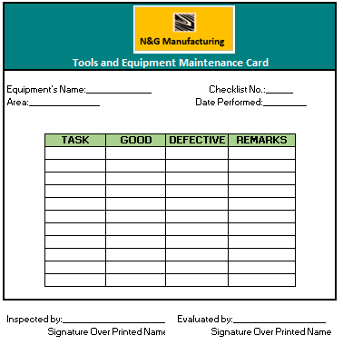

**Figure 39.** Maintenance card for tools and equipment

### **9.1.2 Maintenance of Material Handling Equipment**

Proper maintenance for material handling is necessary to avoid delays and damages in handling raw materials or finished products in the production area. Material handling equipment is the mechanical equipment involved in the complete systems.

|  |  |  |
| --- | --- | --- |
| **EQUIPMENT** | **RECOMMENDED MAINTENANCE TECHNIQUE** | **FREQUENCY OF MAINTENANCE** |
| Platform Cart/Trolley Cart | Check lubricants and wheels | Monthly |
| Movable Storage Rack | Check lubricants and wheels | Monthly |
| Check the allowable limits for the load |

**Table 71.** Maintenance of Material Handling

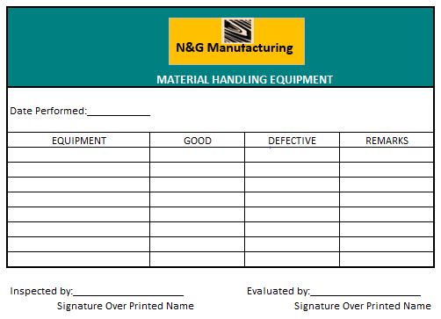

**Figure 40***.* Material handling equipment card

### **9.1.3 Total Preventive Maintenance**

Total Preventive Maintenance is very useful in maintaining the good condition of tools and equipment in production. It includes the action needed in maintaining, remarks, the specific area of damage and its location, and the date occurred.

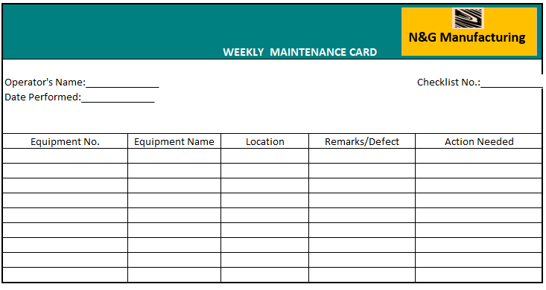

**Figure 41**. Sample Weekly TPM Card

## **9.2 Maintenance of Non-Production Facilities**

The non-production facilities are referring to the facilities and equipment that do not directly involved and contributed during the production assembly period.

### **9.2.1 The Building**

The building is one of the most important non-production facilities of the company; it is where the production process takes place. The building must be maintained regularly to keep the area free from any reasons of accidents.

|  |  |
| --- | --- |
| **HOUSEKEEPING** | 6S should be observed |
| Always clean the workstation after the shift. |
| Do not leave the workstation without putting back the tools and equipment used in its proper area. |
| If the equipment is not functioning well, never attempt to fix it if not authorized to do so. |

**ROUTINE MAINTENANCE**

**a. Items of work which need be attended daily:**

i. Cleaning of the floors and walls, etc. not only by brushes but also swabbing daily and regularly as may be required, twice and even thrice in cases of hospitals. Non-cleaning would allow dirt and dust to be accumulated causing early decay.

ii. Water closets should be cleaned by brushes and at least once in a week by acid or by other commercially available cleaning chemicals.

iii. Cleaning of the sanitary installations and premises must be followed by spreading detergent powder or by detergent liquid on hygienic ground.

iv. Glass panes of doors and windows are to be cleaned properly and at least once in a week with the help of liquid cleaners available commercially.

**b. Items of work which need be attended weekly:**

i. The roof top should be cleaned weekly as otherwise dust and rubbish would block the outlets causing accumulation of rain water on the roof, which ultimately would find way through the roof causing severe structural damage.

ii. Bathrooms and bathing places should be cleaned by flushing with 2/3 buckets of hot water at least once in a week. This will loosen up oil and fat particles clogging the trap. Earth and ashes should not be used for cleaning the utensils as this would cause chokage of the trap and, ultimately, shorten its life.

iii. The doors and windows may give uneasy sound of hinges indicating oiling is required. The hinges should be oiled once in a week.

iv. The ventilation installations need be checked, cleaned and oiled once in a week.

v. The decorations inside and outside are to be cleaned properly at least once in a week.

### **9.2.2 The Drainage System**

Drainage System Maintenance is one of the critical parts of our society that is difficult to maintain wherein deep actions must be apply. Drainage System is a system of watercourses or drains for carrying off excess water which include the disposal of the solid and liquid wastes. Improper planning of the drainage system will result to frequent experience of floods during rainfall seasons. Drainage must be free from any waste to avoid blocking the path of the water. To somehow avoid poor drainage system in company, a drainage inspection must be imposed. Drain inspections are vital to help businesses prevent potential risks such as leaks, floods, and other public health and safety issues. Proper execution of drain inspections can:

* Detect early problems to eliminate expensive repairs;
* Prevent the hassle of slow water drainage and waste clogs;
* Mitigate the risk of damaged pipelines and drainages systems; and
* Increase and promote environmental safety.

Poor drainage maintenance may result in a negative impact on the business which can cost expensive repair on damages, environmental penalties, or worse property loss. These hassles can be avoided by performing regular drain survey and implement the following preventive tips to eliminate drain blockages:

**Table 72.** Preventive Maintenance List to Eliminate Drain Blockage

|  |
| --- |
| **PREVENTIVE MAINTENANCE LIST TO ELIMINATE DRAIN BLOCKAGE** |
| 1.      Do not flush napkins, toilet paper, or any non-biodegradable materials to your toilet drains. |
| [2.      Install mesh screens over your drains to filter hair strands and other solid wastes.](https://safetyculture.com/checklists/solid-waste-management/) |
| 3.      Install a water softener to prevent mineral buildup. |
| 4.      Use a fat trap to dispose of waste oils and fats. |
| 5.      Do not try to dispose of unused medicines through water drains, these can harm groundwater and be toxic to the environment. |
| 6.      Do not treat your drains like a trash bin, dispose of your rubbish in designated areas. |
| 7.      When washing mops and other cleaning tools, rinse the dirt and mud off before you scrub it on the sink. |
| 8.      If a solid item accidentally falls off on your drain systems report it immediately. |
| 9.      Cover your drain opening with grills to filter plant matters. |
| 10.  If experiencing a slow water drain, contact your facilities team to investigate as soon as possible. |
| 11.  If there are sudden formation of sheet ice, excavate out the ice formation to ensure water can flow away from the road area. |
| 12.  Be aware of the property structure and perform regular drain maintenance. |

### **9.2.3 The Electrical System**

All electrical systems require periodic maintenance in addition to non-scheduled maintenance caused by unpredictable events such as storms, accidents, and equipment failure. The intent of periodic maintenance is to keep the system operating at an acceptable level of service to the whole company as the electrical framework is considered as one of the hazardous parts of the business and if inappropriately introduced, it may cost one's life.

I. There may be electric pumps and motors installed. These need be checked weekly and their performance noted in the log book. The tube-wells, if there be any, shall be checked regularly and their yield measured and entered in the log book.

II. Heavy electrical installations like transformers, switch gears, etc. need be examined by a qualified engineer regularly and checked for their performance. In case of oil-based transformer, the level of oil must be checked.

III. Regular check-ups of the electrical wiring connections must be done.

IV. Skinned and damaged wires should be with new wires.

|  |  |
| --- | --- |
| **Things needed for Electrical System Maintenance** | **Function** |
| **Checklist** | Checklist is important to monitor the condition of the electrical system of the company |
| **Logbook/Database Program** | The performance or condition noticed from the checklist will be noted in a logbook/database program |

**Table 73.** Things for Electrical System Maintenance

### **9.2.4 Personnel in Charge of Maintenance Work**

The maintenance personnel are responsible in maintaining the functionality of the facilities present within the company and should have enough experienced in working/dealing with electrical and mechanical aspect for safety purposes.

|  |  |
| --- | --- |
| **PERSONNEL-IN CHARGE** | **WORK AREA** |
| **Electrical/Safety Engineer** | He is assigned to handle and lead the maintenance team all over the company which consists the maintenance of the building, the drainage system and the electrical system. |
| **Production Worker/Operator** | Whoever is assigned on the operation that uses the materials, tools and equipment must also be the one to take care of those. He must be responsible enough to maintain the condition of the materials and tools he is using by following the instructions and filling up the checklists provided by the management. |

**Table 74.** Personnel in Charge of Maintenance Work

# **CHAPTER 10**

# **SAFETY AND HEALTH**

Under the OSH Act, businesses are in charge of giving a protected and restorative work environment. OSHA interests to ensure protected and sound working environments by setting and forcing models, and through preparing, effort, instruction and help. The board ought to agree to all OSHA guidelines and keep the working environment free from extreme perceived perils or dangers.

## **10.1 Measures against Occurrence of Accidents in the Plant**

Occupational risks assessment and taking action to protect workers’ safety and health is an obligation of each employer. There are numerous measures considered as relevant for accident prevention, e.g. design and use of more safe equipment and technologies, improvement of working environment, use and maintenance of personal protective equipment, management and staff training, improvement of communication, etc. This chapter focuses on the common organizational measures of accident prevention, which will be applied in the company.

As stated in Occupational Health and Safety Act 1993, it requires employers to bring about and maintain, as far as reasonable practice, a work environment that is safe and without risk to the health of the worker. This entails that the employers must make sure that the working environment is free from hazards.

These are risks that cause potential damage or damage to the work of employees.

|  |  |  |
| --- | --- | --- |
| Process | Potential Hazard | Prevention |
| Cutting | Fingers might be cut off with the tool used and cause wounds. | Use of PPE such as gloves. |
| Sanding and Polishing | Eyes might get dusts. | Use of PPE such as goggles. |
| Painting | Chemicals might irritate or get into the eyes. Also, it can cause difficulty in breathing because of long exposure and inhalation of chemical toxins. | Use of PPE such as gloves, masks and safety goggles. |
| Preventive and Corrective maintenance | Finger might be wounded or cut off due to accident turning on of machine or equipment. | Provide accurate and clear verbal instructions to the assigned personnel and provide safety visual paraphernalia about the safe usage of machines. Also, use PPE such as gloves to prevent cuts. |

**Table 75.** Potential Hazard and Prevention

The most effective solution to rising organizational system failures is to be constructive and counteractive intervention. An ounce of anticipation is stronger than a pound of remedy. Security within the company would be done in order to get a reliable expert, culminating in an effective and distinct component being shipped. The following procedures will be implemented to prevent any system failures in the plant.

### **Personal Protective Equipment**

Under Workplace Health and Safety (WHS) legislation, to engage in risk management and conduct assessments of risk, the use of PPE is often required as a safety measure. The table below shows the PPE that should be used by the workers.

**Table 76.** Personnel Protective Equipment

|  |  |  |  |
| --- | --- | --- | --- |
| **Description** | **Pictures** | **Uses** | **Quantity** |
| **Gloves** |  | With the help of comfortable and strong work gloves, the employees will have some sort of defense for your hands against injuries, like abrasions and cuts. | 5 pcs. |
| **Safety Goggles** |  | Protects eyes from flying objects or dust | 5 pcs. |
| **Dust Mask** |  | This is used to protect workers from inhaling dust and any harmful substances in the work area. | 5 pcs. |

**Provide Safety Reminders, Procedure and Instruction in Using the Equipment**

Safety Protocols are really important in the business to use the facilities to avoid accidents. If the equipment is not properly controlled or maintain this may cause injuries or worst, it will result to death of the workers.

Accidents are unavoidable and unintentional event that will occur in any situation but with a corresponding safety procedures and reminders it could be lessen or prevented.

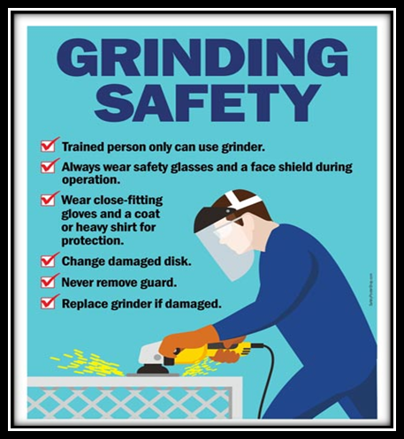

**Figure 42.** Safety Procedure of Hand Grinders



**Figure 43**. Safety Procedure of Belt Sander

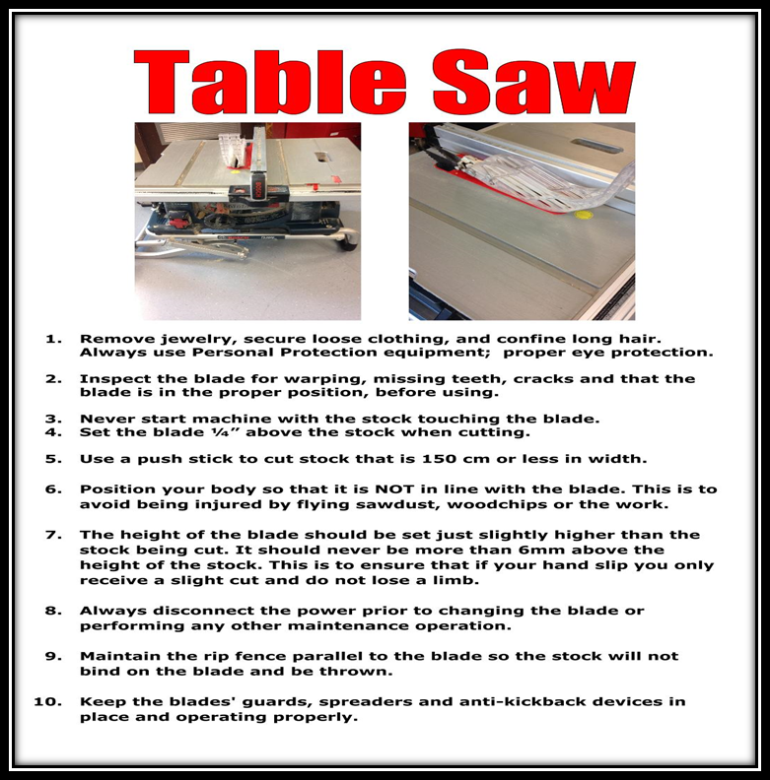

**Figure 44.** Safety Procedure of Table Saw

|  |
| --- |
| **MATERIAL SAFETY DATA SHEET (MSDS)- WOOD GLUE** |
| **Section 1. PRODUCT IDENTIFICATION and COMPANY INFORMATION** |
| Product Name: Wood Glue |
| Recommended Use: Adhesive for furniture. Ready for Use. |
|  |
| Contact Information: |
|  |
| Address: Mandaue City, Cebu, Philippines |
| Contact Number: 09429523632 |
| [Email Address: www.N&Gcompany.com](http://www.n&gcompany.com/) |
| **Section 2. HAZARD IDENTIFICATION** |
| Not a hazardous substance or mixture according to regulation 1272/2008 (CLP). |
| **Section 3. FIRST-AID and MEASURES** |
| **Inhalation:** If breathing is difficult, remove to fresh air and keep at rest in a position comfortable for breathing. Remove contaminated clothing and loosen remaining clothing. Allow person to assume most comfortable position and keep warm. Keep at rest until fully recovered. Get medical advice if breathing becomes difficult or if you feel unwell. |
|
| **If Swallowed:** Rinse mouth. DO NOT induce vomiting. Get medical attention if symptoms occur. Rinse mouth thoroughly with water. |
|
| **Skin Contact:** Wash with plenty of soap and water. If skin irritation occurs: get medical advice/attention. |
|
| **Eye Contact:** Rinse cautiously with water for 15 minutes. If eye irritation persists: Get medical advice. |
| **Section 4. HANDLING and STORAGE** |
| **Handling** |
| • Read label before use. |
| • Wash hands thoroughly after handling. |
| • Wear protective clothing. |
| • Handling Temperature: >100C |
|  |
| **Storage** |
| • Store in a dry, cool and well-ventilated place. |
| • Keep container tightly closed when not in use. |
| • Protect from moisture. |
| • Store away from strong acids, strong bases, strong oxidizers, water. |
| • Storage temperature: 10 – 350C |
| **Section 5. PERSONAL PROTECTION** |
| **Eyes:** Wear goggles or safety glasses. |
| **Hands and Skin:** Wear chemically resistant protective gloves. Wear suitable protective clothing. |
|
| **Eating and Smoking should not be permitted in areas where operation is processed.** |
|  |

**Table 77.** MSDS for Wood Glue

|  |
| --- |
| **MATERIAL SAFETY DATA SHEET (MSDS)- WOOD STAIN** |
| **Section 1. PRODUCT IDENTIFICATION and COMPANY INFORMATION** |
|  |
| Product Name: Wood Stain |
| Recommended Use: Product is used to color wood. The stain then sinks in to the wood protecting it deep into the layer. Ready for Use. |
|  |
| Contact Information: |
|  |
| Address: Mandaue City, Cebu, Philippines |
| Contact Number: 09429523632 |
| [Email Address: www.N&Gcompany.com](http://www.n&gcompany.com/) |
| **Section 2. HAZARD IDENTIFICATION** |
| According to the criteria of WorkSafe, this product is classified hazardous. |
| **Section 3. FIRST-AID and MEASURES** |
| **Ingestion:** If patient is fully conscious, give two glasses of water, Induce vomiting. Seek immediate medical advice. |
|
| **Inhalation:** Inhalation of mists, fumes or vapour may irritate the nose or throat. Remove to fresh air. Employ artificial respiration if needed. If symptoms persist obtain medical assistance. |
|
| **Skin Contact:** Wash skin thoroughly with soap and water as soon as reasonably practicable. Remove contaminated clothing and wash underlying skin. Launder clothing before re-use. |
|
| **Eye Contact:** Irrigate with copious quantities of water for 15 minutes, ensure eyelids are held open. Seek medical advice if any pain or redness develops or persists. |
|
| **Other Information:** Eye wash fountains and safety showers should be easily accessible. |
| **Section 4. HANDLING and STORAGE** |
| Store and transport in accordance with AS 1940-1993 and local and state regulations. Store in a cool well ventilated area. Store away from sources of heat or ignition. Store away from oxidizing agents and foodstuffs. Keep containers closed when not in use. Check regularly for leaks. |
|
| **Section 5. PERSONAL PROTECTION** |
| **Protective Equipment:** Avoid eye and skin contact. Avoid inhaling the vapour or mist. Follow normal industrial safety practices. The use of protective clothing and equipment depends on the degree of exposure. The following personal protective equipment should be used: |
|
| **Respiratory Protection:** Where concentrations in air exceed recommended exposure limits, or work practice or other means of exposure reduction are not adequate, use respirator fitted with filters that conform with AS 1716. |
|
|
| **Eye Protection:** Use safety glasses, chemical goggles or face shield as appropriate, refer AS 1337. |
| **Hand Protection:** Use chemical resistant rubber gloves, refer AS 2161. |
| **Protective Clothing:** Use long sleeved chemical resistant overalls, fastened at neck and wrists, refer AS 3765. |
|
| **Footwear:** Wear chemically impervious safety shoes/boots, refer AS 2210. |
| **Work/Hygienic Practices:**  Ensure high level of personal hygiene is maintained when using this product. Always wash hands before eating, drinking etc. |
|
|  |

**Table 78.** MSDS for Wood Stain

### **Implementation of 5S in the Company**

The 5S technique is a working environment association methodology comprising of five Japanese words: seiri, seiton, seiso, seiketsu, and shitsuke, which means sort, set all together, sparkle, institutionalize and support. Not exclusively do these columns bolster a lean inventory network and visual working environment, however they can likewise be stretched out to fortify working environment wellbeing. Through 5S representatives will be restrained to be progressively mindful of chaotic work environments and persuaded to improve the dimension of tidiness. More noteworthy solidarity and collaboration can be developed through inclusion of all inside an association. Representatives will be trained to pursue more secure and better methods for work, bringing about lesser dangers to mishaps. Representatives would be progressively aware of progress, which prompts more prominent productivity and viability.

### **Provision of Emergency Equipment**

Adequate emergency equipment and resources, communication systems, documentation (such as procedures, checklists, telephone numbers and manuals) should be available where needed to properly initiate and support the emergency response actions. It is vital that emergency equipment be laid out so that it can be reached during an emergency. The table below shoes the emergency equipment that will be present in the company.

|  |  |  |
| --- | --- | --- |
| **EQUIPMENT** | **IMAGE** | **USES** |
| First Aid Kit | Image result for first aid kit | Includes the resources needed to give first aid treatment to accidents |
| Fire Alarm | Image result for FIRE ALARM | Use to warn or aware people of the fire or other emergencies |
| Fire Extinguisher | Image result for fire extinguisher | Used to stop small amount of fire |
| Emergency Light | Image result for emergency light | Used as emergency light in case power supply fails |

**Table 79.** Emergency Equipment

### **Proper Signage**

In a company, Health and safety has to be at the forefront of everything. All employees must be kept away from potentially dangerous situations in the workplace, and one of the most important ways in which any company can do this is through appropriate signage.

Safety Signs are crucial in any work environment. The primary importance of displaying Safety Signs is to **prevent injury** and ensure staff and visitors are well aware of the possible dangers and hazards ahead in certain situations and/or environments.

**Table 80**. Plant Signages

|  |  |  |
| --- | --- | --- |
| **PICTURE** | **DESCRIPTION** | **USES** |
| https://tse3.mm.bing.net/th?id=OIP.iM0vrIvlb7W4CuzfmX8RJwHaDu&pid=15.1&P=0&w=322&h=163 | **Emergency Exit** | Guides the worker on where to exit during emergencies |
|
|
|
| https://tse1.mm.bing.net/th?id=OIP.cUk7ZyfXq-4FGdGylczbFAHaFH&pid=15.1&P=0&w=231&h=160 | **First Aid Kit** | Denotes the company medicines where it is located |
|
|
| http://www.safetysupplywarehouse.com/v/vspfiles/photos/FP-10311-2.jpg | **Fire Alarm** | Denotes the place where the fire alarm is located |
|
|
| http://www.safetysign.com/images/source/large-images/R5433.20170204.png | **Fire Extinguisher** | Guides the workers where the fire extinguisher is located |
|
| http://www.safetysign.com/images/source/large-images/J2501.png | **No smoking** | Warns the workers that the place is a smoke free |
|
| https://tse4.mm.bing.net/th?id=OIP.bXwmjyP-FCNLkTXAGF2VGAHaJS&pid=15.1&P=0&w=300&h=300 | **Electrical Hazard** | To warn the workers and other people of electrical dangers. |
|

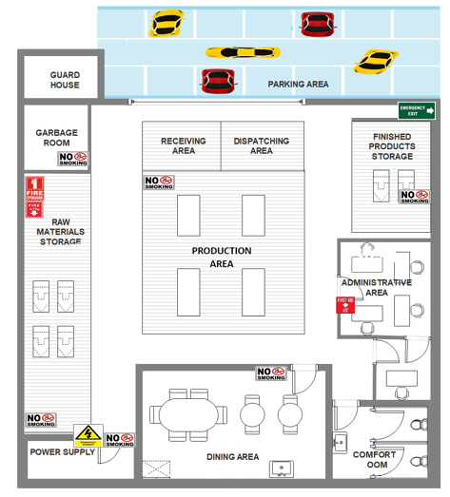

**Figure 45.** Signage around the Plant

### **Good Working environment**

Indoor environment conditions influencing the comfort of the occupant or the user are thermal, visual, acoustic and air quality**Invalid source specified.**. These factors may affect the work performance of the workers. It is important to take into consideration these factors since it effectively makes significant improvements to the workers’ productivity, safety, comfort and even morale, thus, improve the employee-employer relationship and positive feedbacks from stakeholders.

Workplace conditions

The working place should be as dust-free as possible, securing no work will be performed in the surrounding area other than the quarantined workplace since the operation will be dealing with chemicals that could possibly harm the workers. The workplace should be separated from the other areas and should be provided with safety signs, securing the cognitive ergonomic rules that would be practiced inside the workplace.

Thermal condition

To achieve the ideal thermal requirement, enforcing the workplace to be as close as possible is practicable to any laboratory. It is important to also consider the acceptable thermal preference of the workers where they could be at their most comfortable state in performing their assigned tasks. The business achieves the ideal thermal condition of a production and non-production area of the business such as: ISO 7730 and ASHRAE 55.

Lighting condition

Good lighting is essential. A user working a specific task at a certain position in a room requires the existence of sufficient lighting (Dounis et al, 1993). Having either too low or too high level of light can be the source of discomfort (Carlucci et al, 2015).

## **10.2 Measures in Securing the Plant Bad Elements of Society**

In order to ensure the company’s asset, the company must have security measures that protect and monitors the company 24/7. The company must secure their asset from the bad elements of society such robbery, vandalism, littering, and etc. Hiring a security guard is one of the best approach in securing the plant or company from bad elements from society. And due to fast growing of technology there are devices that would help the company to protect their assets. These are the list of devices, their usage and their location

**Safety Security Devices**

|  |  |  |  |
| --- | --- | --- | --- |
| Security  Device | Quantity | Uses | Location |
| download (3)  CCTV Camera | 3 | Helps in monitoring and securing the establishment | Admin Office, Raw Materials Storage, Finished Goods Storage |
| download (4)  Metal Detector | 1 | Detects harmful devices such as gun and knives. | Front Gate  (Upon Entering) |
| wireless-motion-alarm-im  Burglar Sensor Alarm | 3 | Used to detect when there is a sudden burglary or entry of bad elements | Admin Office, Raw Materials Storage, Finished Goods Storage |

**Table 81.** Safety Security Devices

### **Benefits and incentives scheme**

The business as of now gives protections and impetuses to the specialists, just to give benefits as an approach to offer back to the laborers. Protections additionally give a superior and sound connection between the specialists and the businesses inside the work environment. It likewise improves the notoriety of the business to different partners. Be that as it may, as there will be pre-preventative measures given by the business, it is inescapable for mishaps to happen. The business will give extra administrations to its specialists by giving advantage and motivating force plots on the off chance that mishaps happen inside the parameters of the creation and non-generation region.

## **10.3 Recommended Policies regarding Health of the Workers**

Safety is the key need of growing company for its employees as they are the organization's tremendous resource. Workers ' illnesses, injuries and accidents have a significant impact on their productivity and affect the company in collecting the consumers ' demands. This condition indicates that representatives ' health and power will be closely tested and monitored. Principles and guidelines on this topic ought to be constantly developed to prevent hazards.

Safety approach in the organization empowers the representatives to know about their duty in guaranteeing their wellbeing and security. This arrangement would oblige every representative to pursue what should be done which are written in the wellbeing approach. This could keep the businesses from costs and different results identified with wellbeing and security.

### **Health and Safety Policy**

1. Employees are obliged to perform restorative examination before employing to guarantee his/her capacity and wellness into the activity.

2. The representative must be legitimately situated first before putting to his/her assignment. He/she should know the do's and don'ts in the region, appropriate treatment of apparatuses and gear, and legitimate wearing of working clothing, use of crisis signage and the best possible conduct in the territory and in the event of crisis.

3. Wearing of appropriate individual defensive gear, for example, wellbeing googles, security gloves and other hardware must be worn where required.

4. Strict execution of methodology and strategies made for the activity and when found damaging the standards, authorize is given to the representatives.

5. Accidents in the working region, for example, cuts, consumes or different conditions regardless of how little should be accounted for quickly to anticipate real confusions.

6. Company gear must be assessed when utilizing to anticipate or diminish hazard event.

7. When perilous circumstance will be watched, report it quickly to any bosses.

8. Operate machines just when told and appropriately taught.

9. Breaks must be accommodated each worker morning break, mid-day break and evening break.

10. No smoking approach must be carefully watched.

11. Shut down machines before abandoning it unattended and when cleaning or fixing.

12. Workers will experience yearly restorative check – up financed by the company.

13. Sick leave with pay will be accommodated crisis cases as mandated by the law.

14. Heath advantages must be accommodated all representatives, for example, PhilHealth and SSS.

These strategies must be carefully executed to help everybody in the organization and anticipate conceivable conditions that may happen in route of the task.

## **10.4 Medical and Dental Services**

One of the privileges a person gets upon joining an organization is medical and dental safety. Restorative and dental care is provided to specialists; medications are provided to staff in case they sound wiped out and emergency assistance is given for minor incidents. The soundness of the members is often noted, as well as certain other unnecessary factors linked to well-being and factors that affect the members ' execution in the middle of working hours.

The workers' restorative and dental benefit is evaluated by giving drugs and security unit on the organization. The organization will have an accessible as needs be private specialists and dental specialist for the administration if genuine mishaps happen with the representatives.

**Table 82**. Emergency supplies

|  |  |  |
| --- | --- | --- |
| **EMERGENCY KIT** | **QUANTITY** | **USE** |
| **Betadine** | **5** | This is applied in minor cuts, burns, blisters and other minor wounds to prevent infection. |
| **Cotton** | **5** | This is used to apply liquid medication into the wound. It also stops or prevent bleeding from injections and other minor  punctures. |
| **Band-Aid** | **5** | A piece of material used either to support a medical device such as a dressing or splint, or on its own  to provide support to or to restrict the movement of a part of the body. |
| **Alcohol** | **5** | This is used to clean and disinfect wounds |
| **Adhesive Tape** | **5** | This is used to hold a bandage or dressing into the wound |
| **Gauze Pad** | **5** | Used to clean up scrapes and stop bleeding |
| **Bandage** | **5** | Used to secure dressing in place |
| **Scissor** | **5** | Used as cutting tool |
| **Petroleum Jelly** | **5** | This is mostly used in coating and lubricating properties. It is effective in accelerating wound healing stems from its sealing effect on cuts and burns. |
| **Antibacterial Soap** | **5** | Used to clean gently clean the area around the wound |
| **Antibiotic Ointments** | **5** | To dab on cuts and scrapes to prevent infection while healing |
| **Safety Pins** | **5** | Used to hold splints in place or fasten large bandages |
| https://tse2.mm.bing.net/th?id=OIP.MAkWLvigW1-BsRgQ9WYxqgHaHb&pid=15.1&P=0&w=300&h=300  **Thermometer** | **5** | Used to monitor the temperature of the person |

Table shows the different medicine kit that should be present in the company’s clinic to be used during medical emergencies. In addition, the company will also provide regular Annual Dental and Physical Check-up.

## **10.5 Food Services**

The Management will provide Dining Area inside the organization which will be situated near in the production are and administrative office since it is a Mandatory Requirement in each modern firm which given by the law to those workers who will spend their break and lunch hours inside the company premises. It is to ensure the safety and security of the representatives from outside mishaps, for example, vehicle related mishaps. Since the business is still starting and growing, there will be no free food services yet, however, employees can bring foods and spend their break time in the Dining Area.

# **CHAPTER 11**

# **PLANT LAYOUT**

Plant layout refers to the arrangement of physical facilities such as machines, equipment, tools, furniture etc. in such a manner so as to have quickest flow of material at the lowest cost and with the least amount of handling in processing the product from the receipt of raw material to the delivery of the final product. A plant layout must be suit in the accordance of the product to be produced. It involves deep planning of physical appearance of the building wherein deciding of how does the plant look alike and how much room to be occupied the space.

## **11.1 Space Requirements**

The space necessity alludes to the all-out zone required for the task to productively accomplish the plans that have been pondered. It is additionally perfect to assembled the offices closer particularly on the off chance that they are process related. The reason for the space necessity is likewise to boost the space and, in the meantime, to limit the voyaged separation starting with one workstation then onto the next workstation. The space prerequisite incorporates measurements of every office that is completely used by instruments, machine, squander the board and other hardware that is important to the procedure.

The space requirement refers to the total amount of distance needed for the operation to takes place. It is the space allotted for the facilities and workers to perform the job wherein production rate of the company will be measure in accordance of the given space allotted. In making this section it is ideal to put the area closer regardless of the operation that takes place. The purpose of space requirements is to minimize the travelled distance thus resulting to minimization of lead time and maximization of profit of manufacturing the product.

## **11.2 Non- Production Functional Areas**

The plant design comprises of two utilitarian territories, the non-generation practical zones and the creation useful zones. In this segment, the non-creation useful territories will be clarified and talked about. Non-production functional areas refer to the areas which can be found in the plant but does not directly contribute to the production activity. No actual production or manufacturing of goods are made in this areas. This includes the areas such as auxiliary and administrative areas. The table below shows the non-production area with their corresponding functions.

|  |  |
| --- | --- |
| **Non-Production Functional Area** | **Functions** |
| **Garbage Area** | The place in which the waste generated in the company are collected and stored before their proper disposal. |
| **Parking Area** | This parking space is provided for employee/customers/visitor’s vehicle |
| **Dining/Pantry Area** | The area provided where employees can eat during break time. |
| **Power Supply** | This area is where the power source of the whole production is located. |
| **Guard House** | This area is allocated for the safety personnel whose responsibility is to secure the plant from the bad elements of the surroundings. Checking and inspection of the people and equipment entering and going out of the plant. |
| **Comfort Room** | The hygiene facility designed to serve a particular function and to afford a particular service or convenience for the employees. |
| **Administrative Office** | This area is composed of the manager, purchaser, and the accountant. This area will also serve the customers for negotiation and for further information about the products. |

**Table 83**. Non- Production Functional Areas

## **11.3 Production Functional Area**

This region is the place the real item is delivered together with the innovatively developed instruments and hardware. The generation zone is the center of the organization on the grounds that everything about the item from accepting the crude materials until the item is discharged. This segment will talk about the regions that are available or can be found in the creation zone. The following is the table with the rundown of the zones found underway together with its capacities.

|  |  |
| --- | --- |
| **Production Functional Area** | **Functions** |
| **Raw Materials Storage** | This area is where the raw materials are received and stored until it is time for it to process. |
| **Workstation I** | This area is particularly the where the measuring and tracing, cutting and assembly process of the production takes place. |
| **Workstation II** | This area is where the sanding process of the production takes place. |
| **Workstation III** | This area is where the polishing process of the production takes place. |
| **Workstation IV** | This area is where the mixing, painting and inspection process of the production takes place. |
| **Receiving Area** | This area is where the incoming raw materials will be received. |
| **Dispatching Area** | This area is where the outgoing finished goods will be dispatched. |
| **Finished Products Storage** | This area is where all finished products are stored and kept until it is time for it to be transferred and delivered to the customers or buyers. |

**Table 84.** Production Functional Area

## **11.4 Space Relationship Diagram**

The space relationship diagram is a graphic visualization and indication of the relative importance and closeness among the operations within each workstation.

|  |  |  |
| --- | --- | --- |
| **Closeness Code** | **Interpretation** | **Definition** |
| **A** | Absolutely Necessary | The process that takes place between the two areas is very desirable in order to minimize transport time and this area has a great volume of resources used that will be distributed directly. |
| **E** | Especially Important | The areas have to be closed to each other especially the flow of the process that it takes place for the benefit of minimization of lead time. |
| **I** | Important | The closeness of the areas important in relation with their functions. |
| **O** | Ordinary Closeness | The closeness of the area is common in the any work place or it is tolerable. |
| **U** | Unimportant | The area does not have a great value of closeness or it is unnecessary to put near the two areas. |
| **X** | Undesirable | The areas do not have to be closed to each other regarding of the processes that will be performed or to prevent hazard that it may cause. |

**Table 85**. Space relationship diagram

**Closeness Code Distribution:**

$No. of Relationship= \frac{n(n-1)}{2}$**;** where N is the no. of department or areas,

$$No. of Relationship= \frac{12(12-1)}{2}=66$$

|  |  |  |
| --- | --- | --- |
| **Closeness Code** | **Interpretation** | **Definition** |
| **A** | Absolutely Necessary | The process that takes place between the two areas are very desirable in order to minimize transport time and this areas has a great volume of resources used that will be distributed directly. |
| **E** | Especially Important | The areas has to be closed to each other especially the flow of the process that it takes place for the benefit of minimization of lead time. |
| **I** | Important | The closeness of the areas important in relation with their functions. |
| **O** | Ordinary Closeness | The closeness of the area are common in the any work place or it is tolerable. |
| **U** | Unimportant | The area does not have a great value of closeness or it is unnecessary to put near the two areas. |
| **X** | Undesirable | The areas do not have to be closed to each other regarding of the processes that will be performed or to prevent hazard that it may cause. |

**Table 86**. Closeness Code Distribution

Space Relationship Diagram

The figure below shows the space relationship diagram of the 12 areas in the company. These 12 areas are rated based on the desired closeness of each area to the other with the used of closeness codes presented above.

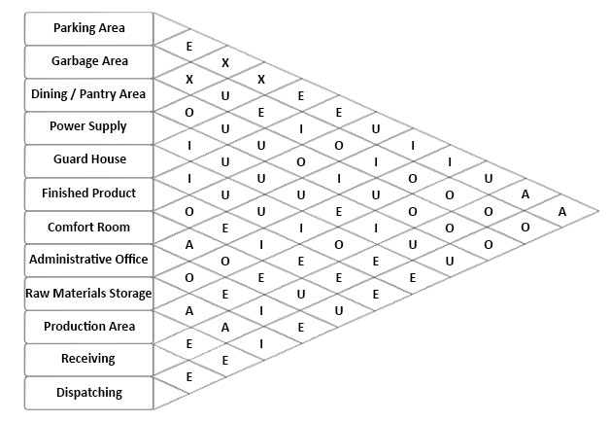

**Figure 46.** Space Relationship Diagram

## **11.5 Space Allocation**

Space is a central resource of a business. The allocation of space is conducted in a consistent and strategic manner designed to optimize the productive use of this resource, and to advance the missions and strategic priorities of the business.

### **11.5.1 Non-production Area**

Non-production areas are places which do not contribute to the physical object practically. Such territories ' capacity does not offer or contribute to the item estimation rather it fills in as the assistance of the item itself being produced. The tables below display the things contained in the area and the measurements thereof.

|  |  |  |  |  |  |  |  |
| --- | --- | --- | --- | --- | --- | --- | --- |
| **AUXILIARY AREA** | | | | | | | |
| **Non-Production Functional Area** | **Item** | **Qty.** | **Dimension (m)** | | **Area Occupied** | **Space Allowance** | **Total Area (m2)** |
| Length | Width |
| **Garbage Area** | Garbage Bins | 3 | 0.6 | 0.4 | 0.72 | 50% | **1.08** |
| **Parking Area** | Parking Space | 5 | 2 | 1.8 | 18 | 50% | **60** |
| Drive Way | 1 | 10 | 2.2 | 22 |
| **Dining/Pantry Area** | Long Dining Table | 1 | 3.4 | 0.71 | 2.41 | 50% | **12.61** |
| Small Dining Table | 2 | 1.7 | 0.71 | 2.41 |
| Food Chiller | 1 | 2.5 | 0.76 | 1.9 |
| Chairs | 10 | 0.41 | 0.41 | 1.68 |
| **Power Supply** | Power Source | 1 | 0.8 | 0.3 | 0.24 | 50% | **0.36** |
| **Guard House** | Table | 1 | 1.27 | 0.82 | 1.04 | 50% | **1.81** |
| Chair | 1 | 0.41 | 0.41 | 0.17 |
| **Comfort Room** | Cubicle | 2 | 0.51 | 0.48 | 0.49 | 50% | **0.96** |
| Sink | 1 | 0.5 | 0.3 | 0.15 |
| **TOTAL AUXILIARY AREA** | | | | | | | **76.8** |

**Table 87.** Total Auxiliary Area

|  |  |  |  |  |  |  |  |
| --- | --- | --- | --- | --- | --- | --- | --- |
| **ADMINISTRATIVE AREA** | | | | | | | |
| **Area** | **Item** | **Qty.** | **Dimension (m)** | | **Area Occupied** | **Space Allowance** | **Total Area (m2)** |
| Length | Width |
| **Human Resource Office** | Table | 1 | 1.9 | 0.4 | 0.76 | 50% | 1.62 |
| Chairs | 2 | 0.4 | 0.4 | 0.32 |
| **Production Supervisor Office** | Table | 1 | 1.9 | 0.4 | 0.76 | 50% | 1.38 |
| Chairs | 1 | 0.4 | 0.4 | 0.16 |
| **General Manager Office** | Table | 1 | 1.9 | 0.4 | 0.76 | 50% | 2.61 |
| Files | 1 | 1 | 0.5 | 0.5 |
| Chairs | 3 | 0.4 | 0.4 | 0.48 |
| **Accounting Office** | Table | 1 | 1.9 | 0.4 | 0.76 | 50% | 2.13 |
| Files | 1 | 1 | 0.5 | 0.5 |
| Chairs | 1 | 0.4 | 0.4 | 0.16 |
| **Conference Room** | Table | 1 | 3 | 1.5 | 4.5 | 50% | 8.19 |
| Chairs | 6 | 0.4 | 0.4 | 0.96 |
| **Quality Control Department Office** | Tables | 2 | 1.9 | 0.4 | 1.52 | 50% | 2.76 |
| Chairs | 2 | 0.4 | 0.4 | 0.32 |
| **Waiting Area** | Bench | 1 | 1.2 | 0.4 | 0.48 | 50% | 0.72 |
| **Front Desk** | Table | 1 | 2.5 | 0.3 | 0.75 | 50% | 1.125 |
| **TOTAL ADMINISTRATIVE AREA** | | | | | | | **20.535** |

**Table 88.** Total Administrative Area

### **11.5.2 Production Areas**

This refers to the areas which can be found in the plant that directly contributes to the production of the product.

**Table 89.** Total Production Area

## **11.6 Total Area of the Sections of Plant**

This section shows the different areas in the plant with their corresponding total space incurred both the Production Functional Area and Non- Production Functional Area. The table below presents the total space of the plant.

**Table 90.** Total Area of the Plant

|  |  |
| --- | --- |
| **Area** | **Total Space (m2)** |
| **Auxiliary** | 76.82 |
| **Administrative** | 20.535 |
| **Production** | 64.33 |
| **TOTAL** | **161.6891** |

## **11.7 Preliminary Layout – Dimensionless Block Diagram**

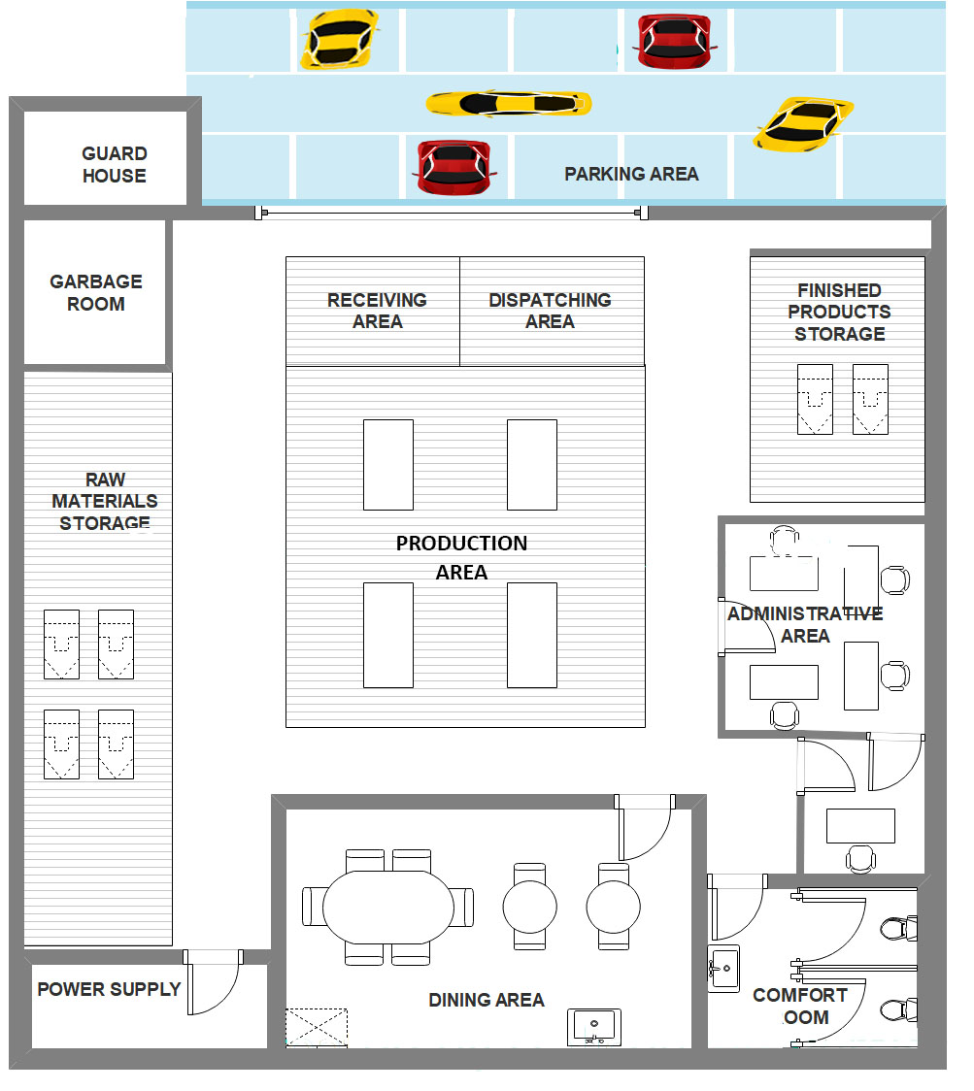

**Figure 47.** Dimensionless Block Diagram

## **11.8 Final Layout**

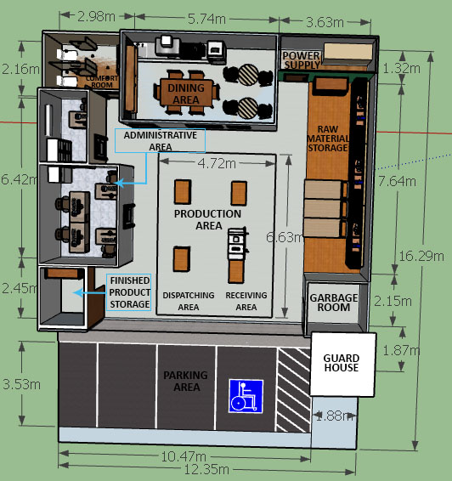

**Figure 48.** Final Plant Layout

## **11.9 Plant Location**

Location of an industry is an important management decision. It is a two-step decision: first, choice of general area or region and second, the choice of site within the area selected. Location decision is based on the organizations long-term strategies such as technological, mar­keting, resource availability and financial strategies. Without sound and careful location planning in the beginning itself, the new facilities may create continuous operating problems in future. Location decision also affects the efficiency, effectiveness, produc­tivity and profitability.

The location decision should be taken very carefully, as any mistake may cause poor location, which could be a constant source of higher cost, higher investment, difficult marketing and transportation, dissatisfied and frustrated employees and consumers, frequent interruptions of production, abnormal wastages, delays and substandard quality etc.

Therefore, decisions regarding selecting a location should be based upon a careful consideration of all factors that are essentially needed in efficient running of a particular industry. The table below shows the criteria used to evaluate the options; through this, the plant location was selected with proper basis as computed through weighted mean.

|  |  |  |
| --- | --- | --- |
| **CRITERIA** | **DESCRIPTION** | **WEIGHT** |
| **Proximity to Supplier** | It is essential for the organization to get raw material in right qualities and time in order to have an uninterrupted production. This factor becomes very important if the materials are perishable and cost of transportation is very high. | 0.21 |
| **Accessibility and Visibility** | The business can be easily seen and accessed by the customers, employees, and the suppliers | 0.19 |
| **Proximity to market** | This factor will produce the product to customer in short time period and hence it will be less damage to the product. It also reduces transportation cost. Also it will help the supplier to know the requirement of customers. | 0.21 |
| **Rent Expense** | The rent expense must lower which is good for starting the business | 0.19 |
| **Transportation facilities** | By this factor material will be transported less, which will affect the material quality, cost of transportation, time to transport etc. Hence for all above reasons producer has to select cheap & speedy transportation with various sources like road, airways, railways, waterways etc. | 0.2 |

**Table 91.** Criteria for Evaluating Options of Plant Location

The following options are evaluated by the proponents using Weighted Mean.

**Option 1:**

Location: Near SM, Mandaue City, Cebu

Total Area: 294 sq. meters

Rental Fee: Php 41,160 per month

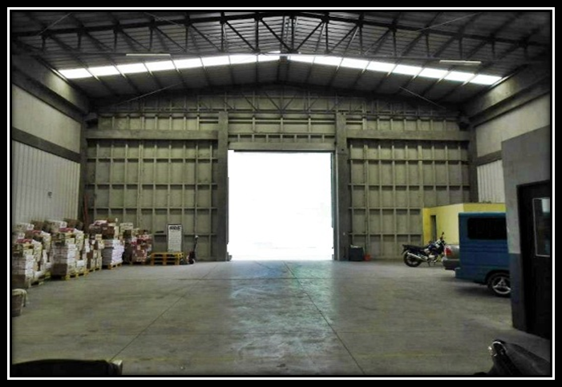

**Figure 49.** Plant Location Option 1

**Option 2:**

Location: Conveniently located near the access road to the Mandaue City -Mactan bridge

Total Area: 200 square meters

Rental Fee: Php 35,000 per month

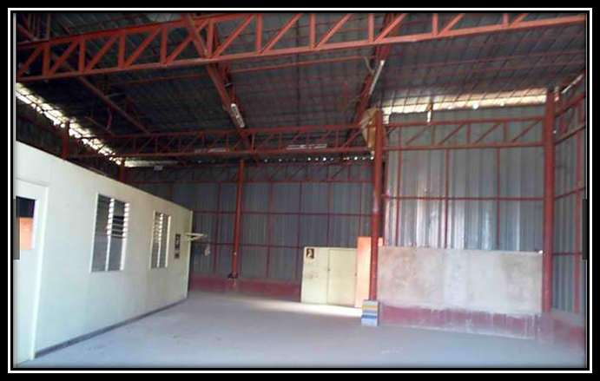

**Figure 50**. Plant Location Option 2

**Option 3:**

Location: Talamban Cebu City

Total Area: 386 square meters

Rental Fee: Php 88,000 per month

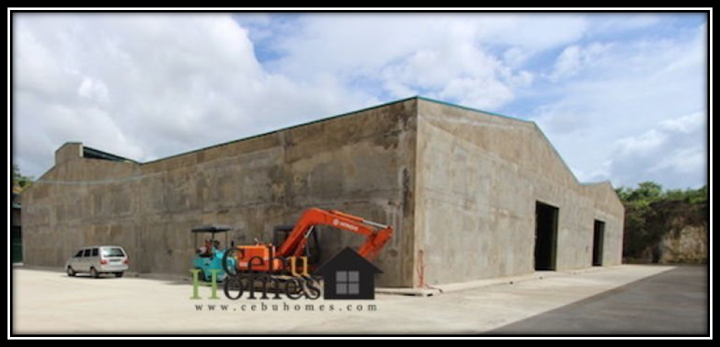

**Figure 51.** Plant Location Option 3

After finding several options for the plant selection, the researchers took over to evaluate the options of the possible plant location.

|  |  |  |  |  |  |  |  |  |
| --- | --- | --- | --- | --- | --- | --- | --- | --- |
| **OPTIONS** | | **CRITERIA** | | | | | **TOTAL** | **RANK** |
| **Proximity to Supplier** | **Accessibility and Visibility** | **Proximity to market** | **Rent Expense** | **Transportation facilities** |
| **0.21** | **0.19** | **0.21** | **0.19** | **0.2** |
| **OPTION 1** | RS | 4 | 4 | 4 | 3 | 4 | **19** | **2** |
| RS*Weight | 0.84 | 0.76 | 0.84 | 0.57 | 0.8 | **3.8** |
| **OPTION 2** | RS | 4 | 4 | 4 | 4 | 4 | **20** | **1** |
| RS*Weight | 0.84 | 0.76 | 0.84 | 0.76 | 0.8 | **4** |
| **OPTION 3** | RS | 3 | 3 | 4 | 2 | 4 | **16** | **3** |
| RS*Weight | 0.63 | 0.57 | 0.84 | 0.38 | 0.8 | **3.2** |

**Table 92.** Plant Location Selection

## **11.10 Percent of Lot Occupancy**

Percent of lot occupancy shows the total percentage of the lot occupied for the proposed manufacturing business to the available located lot intended.

The formula in solving percent of lot occupancy is shown below:

Total Area of Proposed Layout = 161.69 square meters

Total Area Available = 200 square meter

$$Percent of Lot Occupancy= \frac{Total Area of the Plant}{Total Area Available}×100\%$$

$$Percent of Lot Occupancy= \frac{161.69 square meters}{200 square meters}×100\%$$

$$Percent of Lot Occupancy= 80.84 \%$$

# **CHAPTER 12**

# **COST OF DEVELOPMENT**

The overall expense for establishing the company is seen in this segment. It includes the cost of structure, cost of renovation and cost of equipment.

## **12.1 Cost of Land**

The plant area is the location an organization makes, where the tasks are handled. Essential authority is greatly affecting plant territory judgment would cost livelihoods. The right zone is vital to the achievement of the company, even as the consequences of a disconcerting and costly outcome more in the financial edge and its potential movement go to the terrible area.

In building up an office plant, it is essential to check the sensibility of the region for it will impact the cost that will be allotted in renting the space. The plant office is situated in Mandaue City, Cebu and has a total domain of 200 square meters, which has a rent cost of Php 35,000.00 consistently with an advancement rental of 1 month.

$$Cost of Land=Rent Expense per Month+VAT$$

$$Cost of Land=Php 35,000 x (1+0+.12)$$

$$Cost of Land=Php 39,200 per month$$

## **12.2 Cost of Renovation**

The cost of the construction contributes for all the expenses involved with constructing for the factory. As for the building costs for the company's factory, below are the list of components, the quantities used, the unit cost per item and the overall construction costs expected.

**Table 93.** Cost of Renovation

|  |  |  |  |  |
| --- | --- | --- | --- | --- |
| **COST OF RENOVATION** | | | | |
| **Description** | **Quantity** | **Unit** | **Price** | **Total Cost** |
| **WALL/PARTITION WORKS** | | | | |
| Marine Plywood (1/4" 4'x8') | 80 | pcs. | ₱350.00 | ₱28,000.00 |
| Coco Lumbers (2"x2"x10") | 50 | pcs. | ₱70.00 | ₱3,500.00 |
| Nails 1" | 2 | kg. | ₱60.00 | ₱120.00 |
| Nails 2" | 2 | kg. | ₱60.00 | ₱120.00 |
| Nails 3'' | 2 | kg. | ₱60.00 | ₱120.00 |
| Sliding Window (100cmx100cm) | 6 | set | ₱2,500.00 | ₱15,000.00 |
| Flush Hollow Core Door | 2 | pcs. | ₱850.00 | ₱1,700.00 |
| PVC Door | 3 | pcs. | ₱1,100.00 | ₱3,300.00 |
| Regular Door | 2 | pcs. | ₱650.00 | ₱1,300.00 |
| **TOTAL** | | | | **₱53,160.00** |
| **PAINTING WORKS** | | | | |
| Island Wood Primer & Sealer 801 White (4L) | 5 | L | ₱506.00 | ₱2,530.00 |
| Island Epoxy Enamel, 1810 Lemon Yellow (4L) | 4 | L | ₱987.00 | ₱3,948.00 |
| Paint Thinner (4L) | 2 | L | ₱320.00 | ₱640.00 |
| Laquer Thinner (4L) | 2 | L | ₱415.00 | ₱830.00 |
| Sandpaper (100 grit, 3x5inch) | 5 | pcs. | ₱2.50 | ₱12.50 |
| Sandpaper (180 grit, 3x5inch) | 5 | pcs. | ₱2.50 | ₱12.50 |
| Sandpaper (240 grit, 3x5inch) | 5 | pcs. | ₱2.50 | ₱12.50 |
| Paint Roller Brush | 3 | pcs. | ₱30.00 | ₱90.00 |
| **TOTAL** | | | | **₱8,075.50** |
| **ELECTRICAL WORKS** | | | | |
| Solid Wire # 12 | 50 | meter | ₱15.00 | ₱750.00 |
| Outlet | 20 | pcs. | ₱40.00 | ₱800.00 |
| Male Plug | 20 | pcs. | ₱10.00 | ₱200.00 |
| **TOTAL** | | | | **₱1,750.00** |
| **HARDWARE WORKS** | | | | |
| Round Hand Knob | 5 | pcs. | ₱449.00 | ₱2,245.00 |
| Door lock and handles-Stainless Steel GUTE double lock | 2 | pcs. | ₱1,080.00 | ₱2,160.00 |
| Stanley Door Hinges 4” | 14 | pcs. | ₱120.50 | ₱1,687.00 |
| **TOTAL** | | | | **₱6,092.00** |
| **FLOORING WORKS** | | | | |
| Floor Tiles (12''x12'') | 260 | pcs. | ₱29.75 | ₱7,735.00 |
| Tile Adhesive Heavy-Duty | 25 | kg. | ₱250.00 | ₱6,250.00 |
| **TOTAL** | | | | **₱13,985.00** |
| **PIPING WORKS** | | | | |
| PVC Pipe, Blue 1” | 10 | pcs. | ₱100.00 | ₱1,000.00 |
| Pipe Adhesive | 4 | can | ₱400.00 | ₱1,600.00 |
| PVC Pipe, Orange 4" | 6 | pcs. | ₱250.00 | ₱1,500.00 |
| **TOTAL** | | | | **₱4,100.00** |

**Table 94.** Labor Cost

|  |  |  |  |  |
| --- | --- | --- | --- | --- |
| **LABOR COST** | | | | |
| **Labor** | **Headcount** | **Daily Rate (Php)** | **No. of Working Days** | **Total Labor Cost (Php)** |
| Carpenter | 5 | ₱600.00 | 7 | ₱21,000.00 |
| Carpenter Assistant | 5 | ₱450.00 | 7 | ₱15,750.00 |
| Plumber | 2 | ₱600.00 | 5 | ₱6,000.00 |
| Electrician | 3 | ₱600.00 | 5 | ₱9,000.00 |
| Painter | 3 | ₱500.00 | 3 | ₱4,500.00 |
| **TOTAL LABOR COST** | | | | **₱56,250.00** |

**Table 95** Table. Total Cost of Renovation

|  |  |
| --- | --- |
| **TOTAL COST OF RENOVATION** | |
| **Developments** | **Cost** |
| Partition Cost | ₱53,160.00 |
| Painting Cost | ₱8,075.50 |
| Electrical Cost | ₱1,750.00 |
| Hardware Cost | ₱6,092.00 |
| Flooring Cost | ₱13,985.00 |
| Piping Cost | ₱4,100.00 |
| Labor Cost | ₱56,250.00 |
| **TOTAL** | **₱143,412.50** |

## **12.3 Cost of Equipment**

The costs of equipment are the cost in acquiring the equipment needed in the operation. The equipment is group into two equipments needed in the production and the equipment needed in the management.

**Table 96.** Cost of Equipment (Production, Auxiliary and Administrative Area)

|  |  |  |  |
| --- | --- | --- | --- |
| **COST OF EQUIPMENT** | | | |
| **Description** | **Quantity** | **Price** | **Total Cost** |
| **PRODUCTION AREA** | | | |
| LED Light | 4 | ₱390.00 | ₱1,560.00 |
| Lumber Storage Racks | 3 | ₱2,700.00 | ₱8,100.00 |
| Push Carts | 11 | ₱1,450.00 | ₱15,950.00 |
| Dust Collector | 2 | ₱1,525.00 | ₱3,050.00 |
| Table Saw | 1 | ₱3,049.00 | ₱3,049.00 |
| Chair | 3 | ₱250.00 | ₱750.00 |
| Working Table | 3 | ₱574.00 | ₱1,722.00 |
| Shelves | 3 | ₱1,200.00 | ₱3,600.00 |
| Drying Racks | 3 | ₱749.00 | ₱2,247.00 |
| **TOTAL** | | | **₱40,028.00** |
| **ADMINISTRATIVE AREA** | | | |
| Computer Set | 5 | ₱13,500.00 | ₱67,500.00 |
| Printer w/ Scanner | 1 | ₱4,632.00 | ₱4,632.00 |
| Air Conditioner | 3 | ₱9,488.00 | ₱28,464.00 |
| Office Chair | 2 | ₱492.00 | ₱984.00 |
| Filer | 1 | ₱140.00 | ₱140.00 |
| Bench | 1 | ₱2,239.00 | ₱2,239.00 |
| Projector Set | 1 | ₱6,164.00 | ₱6,164.00 |
| Office Table | 8 | ₱793.00 | ₱6,344.00 |
| **TOTAL** | | | **₱116,467.00** |
| **AUXILIARY AREA** | | | |
| Dining table set (Small) | 2 | ₱1,707.00 | ₱3,414.00 |
| Dining table set (Long) | 1 | ₱4,000.00 | ₱4,000.00 |
| Food Chiller | 1 | ₱7,000.00 | ₱7,000.00 |
| Cubicle | 2 | ₱1,284.00 | ₱2,568.00 |
| Sink | 1 | ₱580.00 | ₱580.00 |
| Table | 1 | ₱793.00 | ₱793.00 |
| Chair | 1 | ₱250.00 | ₱250.00 |
| **TOTAL** | | | **₱18,605.00** |

**Table 97**. Cost of Emergency and Security Equipment

|  |  |  |  |  |
| --- | --- | --- | --- | --- |
| **COST OF EMERGENCY AND SECURITY EQUIPMENT** | | | | |
| **Equipment Name** | **Unit** | **Quantity** | **Unit Price (Php)** | **Total Amount** |
| CCTV Camera | pcs. | 3 | ₱450.00 | ₱1,350.00 |
| Metal Detector | pcs. | 1 | ₱579.00 | ₱579.00 |
| Burglar Sensor Alarm | set | 1 | ₱1,142.00 | ₱1,142.00 |
| Emergency Light | pcs. | 5 | ₱950.00 | ₱4,750.00 |
| Fire Extinguisher | pcs. | 3 | ₱1,100.00 | ₱3,300.00 |
| Fire Alarm | pcs. | 3 | ₱176.00 | ₱528.00 |
| Signage | pcs. | 20 | ₱30.00 | ₱600.00 |
| **TOTAL** | | | | **₱12,249.00** |

**Table 98**. Cost of Medical Equipment

|  |  |  |  |  |
| --- | --- | --- | --- | --- |
| **COST OF MEDICAL EQUIPMENT** | | | | |
| **Equipment Name** | **Unit** | **Quantity** | **Unit Price (Php)** | **Total Amount** |
| Betadine | pcs. | 5 | ₱120.00 | ₱600.00 |
| Cotton | pcs. | 5 | ₱7.00 | ₱35.00 |
| Band-Aid | pcs. | 5 | ₱29.00 | ₱145.00 |
| Adhesive Tape | pcs. | 5 | ₱100.00 | ₱500.00 |
| Alcohol 500 ml | pcs. | 5 | ₱50.00 | ₱250.00 |
| Gauze Pad | pcs. | 5 | ₱90.00 | ₱450.00 |
| Bandage | pcs. | 5 | ₱32.00 | ₱160.00 |
| First-aid Kit | pcs. | 1 | ₱159.00 | ₱159.00 |
| Scissor | pcs. | 5 | ₱25.00 | ₱125.00 |
| Petroleum Jelly | pcs. | 5 | ₱33.00 | ₱165.00 |
| Antibacterial Soap | pcs. | 5 | ₱25.00 | ₱125.00 |
| **TOTAL** | | | | **₱2,714.00** |

**Table 99**. Cost of Sanitary Tools / Equipment

|  |  |  |  |  |
| --- | --- | --- | --- | --- |
| **COST OF SANITARY TOOLS/EQUIPMENT** | | | | |
| **Equipment Name** | **Unit** | **Quantity** | **Unit Price** | **Total Amount** |
| Broom | pcs. | 10 | ₱50.00 | ₱500.00 |
| Dust Pan | pcs. | 10 | ₱50.00 | ₱500.00 |
| Mop | pcs. | 2 | ₱120.00 | ₱240.00 |
| Trash Bins (Big) | pcs. | 3 | ₱680.00 | ₱2,040.00 |
| Trash Bins (Small) | pcs. | 5 | ₱120.00 | ₱600.00 |
| Dust Bag | pcs. | 1.5 | ₱1,000.00 | ₱1,500.00 |
| **TOTAL** | | | | **₱5,380.00** |

**Table 100.** Cost of Office Supplies

|  |  |  |  |  |
| --- | --- | --- | --- | --- |
| **COST OF OFFICE SUPPLY** | | | | |
| **Equipment Name** | **Unit** | **Quantity** | **Unit Price** | **Total Amount** |
| Ballpen | box | 1 | ₱60.00 | ₱60.00 |
| Pencil | box | 1 | ₱50.00 | ₱50.00 |
| Calculator | pcs. | 2 | ₱200.00 | ₱400.00 |
| Bond paper (Long) | rim | 1 | ₱165.00 | ₱165.00 |
| Bond paper (Short) | rim | 1 | ₱152.00 | ₱152.00 |
| White Folder (Short) | pcs. | 10 | ₱6.00 | ₱60.00 |
| White Folder (Long) | pcs. | 10 | ₱5.00 | ₱50.00 |
| Scissor | pcs. | 3 | ₱10.00 | ₱30.00 |
| Stapler | pcs. | 2 | ₱30.00 | ₱60.00 |
| Stapler Bullet | box | 5 | ₱33.00 | ₱165.00 |
| Scotch Tape | pcs. | 3 | ₱40.00 | ₱120.00 |
| Paper Clip | box | 1 | ₱30.00 | ₱30.00 |
| Organizer | set | 3 | ₱150.00 | ₱450.00 |
| Correction Tape | pcs. | 3 | ₱15.00 | ₱45.00 |
| Time Card | pack | 1 | ₱125.00 | ₱125.00 |
| Printer Ink | pcs. | 1 | ₱600.00 | ₱600.00 |
| **TOTAL** | | | | **₱2,562.00** |

Table. Installation / Labor Cost

|  |  |
| --- | --- |
| **INSTALLATION AND LABOR COST** | |
| **Installation** | **Total Cost** |
| Internet Connection and Telephone | ₱1,299.00 |
| Installation Fee | ₱1,000.00 |
| **TOTAL** | **₱2,299.00** |

Table. Summary Cost of Equipment

|  |  |
| --- | --- |
| **SUMMARY COST OF EQUIPMENT** | |
| **Specifications** | **Total** |
| Equipment |  |
| - Production | ₱40,028.00 |
| - Administrative | ₱116,467.00 |
| - Auxiliary | ₱18,605.00 |
| Emergency and Security | ₱12,249.00 |
| Medical Equipment | ₱2,714.00 |
| Sanitary Tools/Equipment | ₱5,380.00 |
| Office Supplies | ₱2,562.00 |
| Installation | ₱2,299.00 |
| **TOTAL** | **₱200,304.00** |

**Cost of Fencing**

Cost of fencing is necessary to every manufacturing company to protect the company assets from strangers and unwanted theft. Since the rented area has concrete fence already, the proponents only renovate the fence by repainting and changing the barbed wire.

**Table 101.** Cost of Fencing

|  |  |  |  |  |
| --- | --- | --- | --- | --- |
| **COST OF FENCING** | | | | |
| **Description** | **Quantity** | **Unit** | **Price** | **Total Cost** |
| Barbed Wire | 40 | kg. | ₱54.00 | ₱2,160.00 |
| Steel | 20 | length | ₱101.25 | ₱2,025.00 |
| Welding Rod | 5 | kg. | ₱120.00 | ₱600.00 |
| Island Wood Primer & Sealer 801 White (4L) | 5 | L | ₱506.00 | ₱2,530.00 |
| Island Epoxy Enamel, 1810 Lemon Yellow (4L) | 4 | L | ₱987.00 | ₱3,948.00 |
| **LABOR COST** | | | | **₱2,000.00** |
| **TOTAL FENCING COST** | | | | **₱12,263.00** |

## **12.4 Total Cost of Development**

Total cost of development is the summation of the cost of land, cost of structure, cost of equipment and the cost of fencing. The table below shows the Total Cost of Development.

Table. Total Cost of Development

|  |  |
| --- | --- |
| **TOTAL COST OF DEVELOPMENT** | |
| **Development Cost** | **Cost Involved** |
| Cost of Land | ₱39,200.00 |
| Cost of Renovation | ₱143,412.50 |
| Cost of Equipment | ₱200,304.00 |
| Cost of Fencing | ₱12,263.00 |
| **TOTAL** | **₱395,179.50** |

# **Chapter 13**

# **ORGANIZATIONAL STRUCTURE OF THE PLANT**

This section shows or outlines how certain activities are directed in order to achieve the goals of N&G Manufacturing.

## **13.1 Organizational Chart**

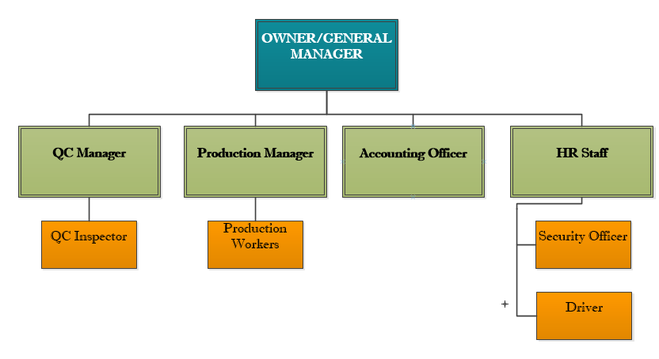

**Figure 52**. Organizational Chart

### **13.1.1 Function of Organizational Positions**

|  |  |
| --- | --- |
| JOB DESCRIPTION | |
| Job Title: | **GENERAL MANAGER** |
| JOB OVERVIEW:  He oversees the operations on the manufacturing and distribution of goods and is usually responsible for hiring employees, providing feedback, and developing team-building strategies. | |
| RESPONSIBILITIES/DUTIES:   * Oversee and improve manufacturing operations, establishing and driving production goals and developing organizational structures. * Ensure compliance with safety regulations and standard operating procedures, providing resources and training. * Oversee employee hiring, training, development, and management, providing guidance to leadership teams. * Develop performance and efficiency metrics, identifying areas for improvement and reporting results to executive leadership. * Manage finances, monitoring budgets, expenses, and product unit costs to drive revenue and margin projections. | |
| QUALIFICATIONS;   * Preferably a Graduate of Industrial Engineering * Ha good knowledge in business functions * Strong leadership qualities * Excellent Communication Skills * Good interpersonal Skills * Meticulous attention to detail * Computer Literate * Highly Organized | |

|  |  |
| --- | --- |
| JOB DESCRIPTION | |
| Job Title: | **PRODUCTION MANAGER** |
| JOB OVERVIEW:  Production managers are responsible for the technical management, supervision and control of industrial production processes. Production managers ensure that manufacturing processes run reliably and efficiently. | |
| RESPONSIBILITIES/DUTIES:   * planning and organizing production schedules * assessing project and resource requirements * estimating, negotiating and agreeing budgets and timescales with clients and managers ensuring that health and safety regulations are met * determining quality control standards overseeing production processes * organizing the repair and routine maintenance of production equipment | |
| QUALIFICATIONS;   * Preferably a Graduate of Industrial Engineering * 21-45 years old * Previous experience in production or manufacturing is a plus * Confident * Good in project management skills * Organized and efficient in work * Strong in leadership and interpersonal skills * Has good problem solving skills * Has good IT and numerical skills * Can communicate well * A good team player | |

|  |  |
| --- | --- |
| JOB DESCRIPTION | |
| Job Title: | **QUALITY CONTROL MANAGER** |
| JOB OVERVIEW:   He/she supervises staff and oversees product development procedures to ensure that products meet quality and efficiency standards. | |
| RESPONSIBILITIES/DUTIES:   * Finds ways to improve the manufacturing process to ensure higher-quality goods * Setting the requirements for raw materials from suppliers and monitoring their compliance * Inspecting the final output, comparing it to the requirements, and approving or rejecting the final products * Gaining feedback from the clients, attending meetings, submitting reports, and assisting external auditors and inspectors | |
| QUALIFICATIONS;   * A Bachelor's degree in Industrial Engineering or business-based program * Previous experience in production or manufacturing is a plus * Strong attention to detail, observation, organizational, and leadership skills Good in project management skills * In-depth knowledge of quality control procedures and legal standards * In-depth knowledge of quality control procedures and legal standards | |

|  |  |
| --- | --- |
| JOB DESCRIPTION | |
| Job Title: | **ACCOUNTING OFFICER** |
| JOB OVERVIEW:  He/she manages the bookkeeping of the finances of company. | |
| RESPONSIBILITIES/DUTIES:   * sends bills to customers * interacts with collection agencies on past-due accounts * create and monitor internal auditing procedures * track expenses of the company | |
| QUALIFICATIONS;   * Male/Female * Graduate of Bachelor of Science in Accounting * 21-35 years old * At least 1 year experience * Good attention to detail * Knowledge of database and spreadsheet software * computer literacy | |

|  |  |
| --- | --- |
| JOB DESCRIPTION | |
| Job Title: | **HR STAFF** |
| JOB OVERVIEW:   He/she is responsible for recruiting, screening, interviewing and placing workers | |
| RESPONSIBILITIES/DUTIES:   * Consult with employers to identify needs and preferred qualifications * Hire or refer qualified candidates * Interview applicants about their experience, education and skills * Conduct new employee orientations | |
| QUALIFICATIONS;   * Male/Female * Candidate must possess at least Bachelor's/College Degree in Human Resource Management, Psychology or equivalent. * At least 2 Year(s) of working experience in the related field is required for this position. * Competence to build and effectively manage interpersonal relationships at all levels of the company * Can communicate well * A good team player | |

|  |  |
| --- | --- |
| JOB DESCRIPTION | |
| Job Title: | **PRODUCTION WORKERS** |
| JOB OVERVIEW:  He/she is responsible for operating equipment in a **factory** and preparing items for distribution. | |
| RESPONSIBILITIES/DUTIES:   * Accomplish goods from production * Assemble goods on production lines * Carry out basic quality and testing checks * Maintain equipment and work areas | |
| QUALIFICATIONS;   * Male/Female * Preferably High school level/graduate/ College level * 18-45 years old * Ability to complete repetitive tasks * Attention to detail * Flexibility * Organized and efficient in work | |

|  |  |
| --- | --- |
| JOB DESCRIPTION | |
| Job Title: | **DRIVER** |
| JOB OVERVIEW:  He transports products, materials, equipment and company staff to and from specified locations and assist the company with all transport-related duties. | |
| RESPONSIBILITIES/DUTIES:   * Safely transport company staff, materials and products to a specified location * Assist in loading and offloading of the products and materials * Ensure accurate time of records of the company vehicle’s goings and comings * Regular washing and cleaning of company vehicle | |
| QUALIFICATIONS;   * Male * High school graduate/College Level is preferred * Valid Driver’s License * Sound knowledge of road safety regulations * The ability to utilize maps, GPS systems, and car manuals | |

|  |  |
| --- | --- |
| JOB DESCRIPTION | |
| Job Title: | **SECURITY OFFICER** |
| JOB OVERVIEW:  He guards the work environment and secure wellbeing. | |
| RESPONSIBILITIES/DUTIES:   * Inspect building * restraining trespassers * permitting entry * informing violators of policy and procedures | |
| QUALIFICATIONS;   * Male/Female * 25-45 years old * Trained security officer with diploma * Dependability * Excellent knowledge of public safety and security procedures/protocols | |

# **Chapter 14**

# **Conclusion and Recommendations**

## **Conclusions**

This world where we are living right now is already becoming a place where things are randomly and exclusively created for the good of mankind. Mankind demands from this world just to give them the satisfaction and comfort that they need whether it’s for everyday living, for leisure and fun, working kits and equipment and other technical things that we want to acquire. With this, product design is recognized to make new and innovative products that could make everyone’s work efficient and highly productive.

With the innovation concerning product design, the researchers of this study have come up with an idea of a shoe rack with a twist, a detachable wooden shoe rack. This product is made of a plywood that makes it lighter in weight but still without compromising its durability and quality. The researchers have chosen this product to be redesigned and be innovated because of the personal inspiration and experience of having too many shoes but getting a problem of not having a good storage of shoes. Since shoe racks are already availed from everywhere, the researchers have set quite a twist on a typical shoe rack by adding features onto it and bringing it to a new next level. The researchers assure the Quality and Aesthetics of this product by setting skilled workers to produce its units and by standardizing everything in the work of production as what just an Industrial Engineer should do.

## **Recommendations**

To maintain a good and excellent performance of a company, it is important to take note of some key points and advices that would improve the system and state of a company. It is wise to anticipate the coming needs of customers and lay down preparations for the future. With this, the researchers have recommended the following that will be useful and helpful for other studies and for other companies:

* Improve design in the future if there is any new idea that will be generated
* Strictly impose standardization of works inside the production area and in all aspects of the business
* Increase the number of workers when the demand increases; and as the demand increases, the company should also provide ways and ideas to adapt this change and provide for the customers
* Adapt new technology to improve processes that would make the production more efficient

# **BIBLIOGRAPHY**

# **APPENDIX**

# **CURRICULUM VITAE**



**PERSONAL DATA:**Last Name: **ABACAJAN**  
First Name: **NELLIZA**    
Middle Name: **CANDIDO**  
Address: Lagtang, Talisay City, Cebu, Philippines  
Telephone Mobile: ***+63 9567206608***  
Email: **abacajannelliza24@gmail.com**   
Marital Status: Single  
Date of Birth: March 24, 1999  
Gender: Female  
Country of Origin: Philippines  
Present Nationality: Filipino  
Languages and Fluency Level: English, Tagalog & Bisaya

**EDUCATION:**

Secondary

Talisay City National High School

Poblacion, Talisay City

2011-2015

Tertiary

Cebu Technological University- Main Campus

M.J. Cuenco Ave., Cebu City

2015- Present

**FAMILY BACKGROUND:**

Father’s Name : Neilson G. Abacajan

Occupation: Electrician

Mother’s Name: Elizabeth Abacajan

Occupation: -----

**CURRICULUM VITAE**

**PERSONAL DATA:** Last Name: **TAMPUS**  
First Name: **GEORGIE**    
Middle Name: **SANCHEZ**  
Address: Lagtang, Lapu-lapu City, Cebu, Philippines  
Telephone Mobile: ***+63 9567206608***  
Email: **abacajannelliza24@gmail.com**   
Marital Status: Single  
Date of Birth: March 24, 1999  
Gender: Female  
Country of Origin: Philippines  
Present Nationality: Filipino  
Languages and Fluency Level: English, Tagalog & Bisaya

**EDUCATION:**

Secondary

Babag National High School

Poblacion, Talisay City

2011-2015

Tertiary

Cebu Technological University- Main Campus

M.J. Cuenco Ave., Cebu City

2015- Present

**FAMILY BACKGROUND:**

Father’s Name : Neilson G. Abacajan

Occupation: Electrician

Mother’s Name: Elizabeth Abacajan

Occupation: -----