

SCHOOL OF EDUCATION

TYPE OF EXAM | Multiple choice/Essay | Term | 1st Semester 2018-2019
Subject Code | A-EDSPEC 12G | Descriptive Title | Basic Geography
Name of Student |  | Course

1. Geography deals mainly with the study of space, the earth as the home of mankind. What do you call the part of the
earth where people lived?
a. Hydrosphere c. Biosphere
b. Lithosphere d. Atmosphere
2. Natural sciences find common grounds with Geography. Which of the
following below is NOT part of it?
a. meteorology c. oceanography
b. anthropology d. pedagogy
3. How do you understand Human geography?
a. The distribution of the natural features of the earth.
b. The study of the human body parts and its function.
c. The distribution of people, and their activities on the Earth’s surface.
d. The distribution of people and their cultural attributes.
e. Both c and d
f. Both a and b
4. On which of the following planets would landing be nearly impossible.
a. Mercury c. Venus
b. Earth d. Saturn

Draw the image of our Solar System inside the box. Label and arrange the planets accordingly.
5. __ 6. __ 7. __ 8. __ 9. __ 10. __ 11. __ 12. __ 13.__

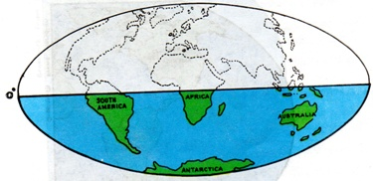
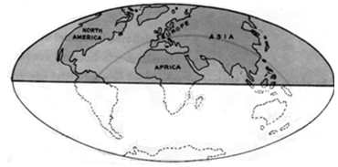

23 ½˚ N

23 ½˚ S

14. Based on the illustration above, what is the smallest continent? _________
15. If the sun’s vertical rays strike the earth’s surface up to 23½˚ north
of the equator, what is the coldest continent? _______________

16. Based on the geographical location of the continents seen above, which
part of the hemisphere has the widest coverage of land? ____________

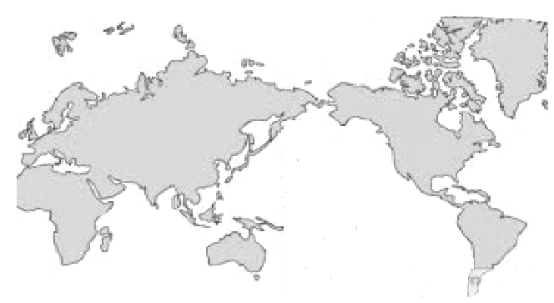

EURASIA
PACIFIC
OCEAN

AFRICA

AUSTRALIA

0°
17. Label the Prime Meridian that is found in the 0° longitude.
18. Count by 20° starting from 0° Prime Meridian, draw a line that indicates the exact place where the International
Date Line crosses at 180°.

19. On what specific place in the world does the International Date Line falls at 180° Eastern Hemisphere?
a. Africa d. Pacific Ocean
b. Australia e. b and c
c. Eurasia f. None of the above

20. Arctic and Antarctic Circles serve as the boundary for latitudinal zones of the earth, what are considered
as the Temperate Zones or the Middle Latitudes?
a. Arctic Circle and Tropic of Capricorn
b. 66 and ½° North and South Tropics of
Cancer and Capricorn
c. Eastern and Western Hemisphere
d. Between 66 and ½ North anbs South Tropics of Cancer and Capricorn
e. b and c
21. The North and South Poles are areas that are called the Frigid Zones. What is the more appropriate term
to describe these polar regions?
a. Low latitude b. High latitude c. Cold latitude d. Middle latitude

22. If we are to measure the distance between longitudes how will it appear?
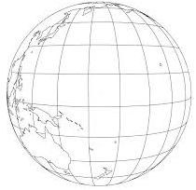
a. b. c. d.

23. If we are to measure the distance between latitudes how will it appear?
a. b. c. d.

Use the illustration on the left to label the special parallels and their corresponding distances from the equator:

Parallel Distance

24._______________ 25. ___________
26._______________ 27. ___________ 28._______________ 29. ___________
30._______________ 31. ___________
32. _______________33. ____________

Answer briefly:
(34-38) Cite a situation where your knowledge of longitudes and latitudes may be applied.
_____________________________________________________________________
_______________________________________________________________________________
_______________________________________________________________________________
_______________________________________________________________________________

(39-43) In the real differentiation of the earth’s surface, scientists found out that “There are no two
places that are exactly the same”. Do you agree with their findings? Why?
_____________________________________________________________________
_______________________________________________________________________________
_______________________________________________________________________________
_______________________________________________________________________________

(44-50) Based on the line of the Prime meridian, what hemisphere is the Philippines located?
Prove your point.
_____________________________________________________________________
_______________________________________________________________________________
_______________________________________________________________________________
_______________________________________________________________________________

