ICT INTEGRATED CLASSROOM SETUP

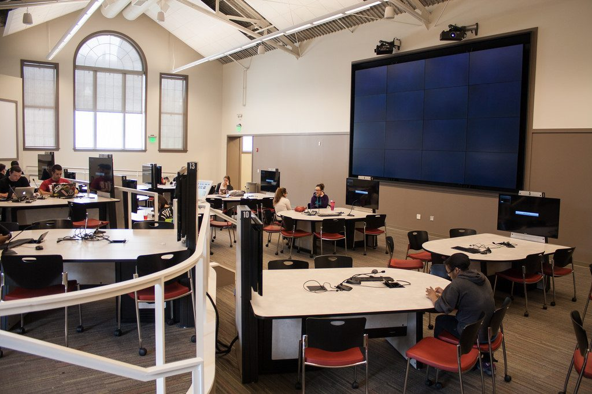

*Bruff, Derek. (2019). Active Learning Classrooms: Adapted from a 2018 Agile Learning blog post. Retrieved from* [*https://cft.vanderbilt.edu/guides-sub-pages/learning-spaces/*](https://cft.vanderbilt.edu/guides-sub-pages/learning-spaces/)

*The author classifies that active learning classrooms (ALCs) are the top strategic technology in a survey of EDUCAUSE 2017. The author discusses that the feature of this classroom includes round or curved tables with movable seating that allow students to face each other. This setup supports small-group discussion or work. The tables are paired with own whiteboards for brainstorming activities. This type of classroom also features multiple displays for the benefit of the teacher to project their laptops. It also has microphones, sound projection, strong WiFi connection and power for student laptops and smart phones.*

*The author concludes that this type of learning environment is useful for STEM integration and engages students in the process than traditional lecturing.*

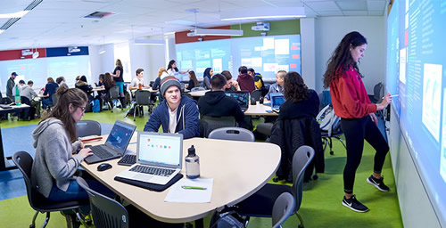

*Ulman, Ellen. (2019). What is a Smart Classroom? eCampus News: Today’s Innovations in Education. Retrieved from* <https://www.ecampusnews.com/2018/08/31/what-is-a-smart-classroom/>

*The article discusses on the features of a smart classroom. It describes a typical smart classroom and its features. In these classrooms, group tables and interactive whiteboards are necessary. Two of the rooms have SMART BOARD attached to the walls while the third has the newest active learning lab with eight Nureva Walls that stretch around the room. The author emphasizes that students can come together in a shared space to construct, negotiate and manipulate around the said technology. The author discusses that their interactive walls were design for complementary capacity. The students can contribute to the assembly and can stay focused within the perimeter of the room.*