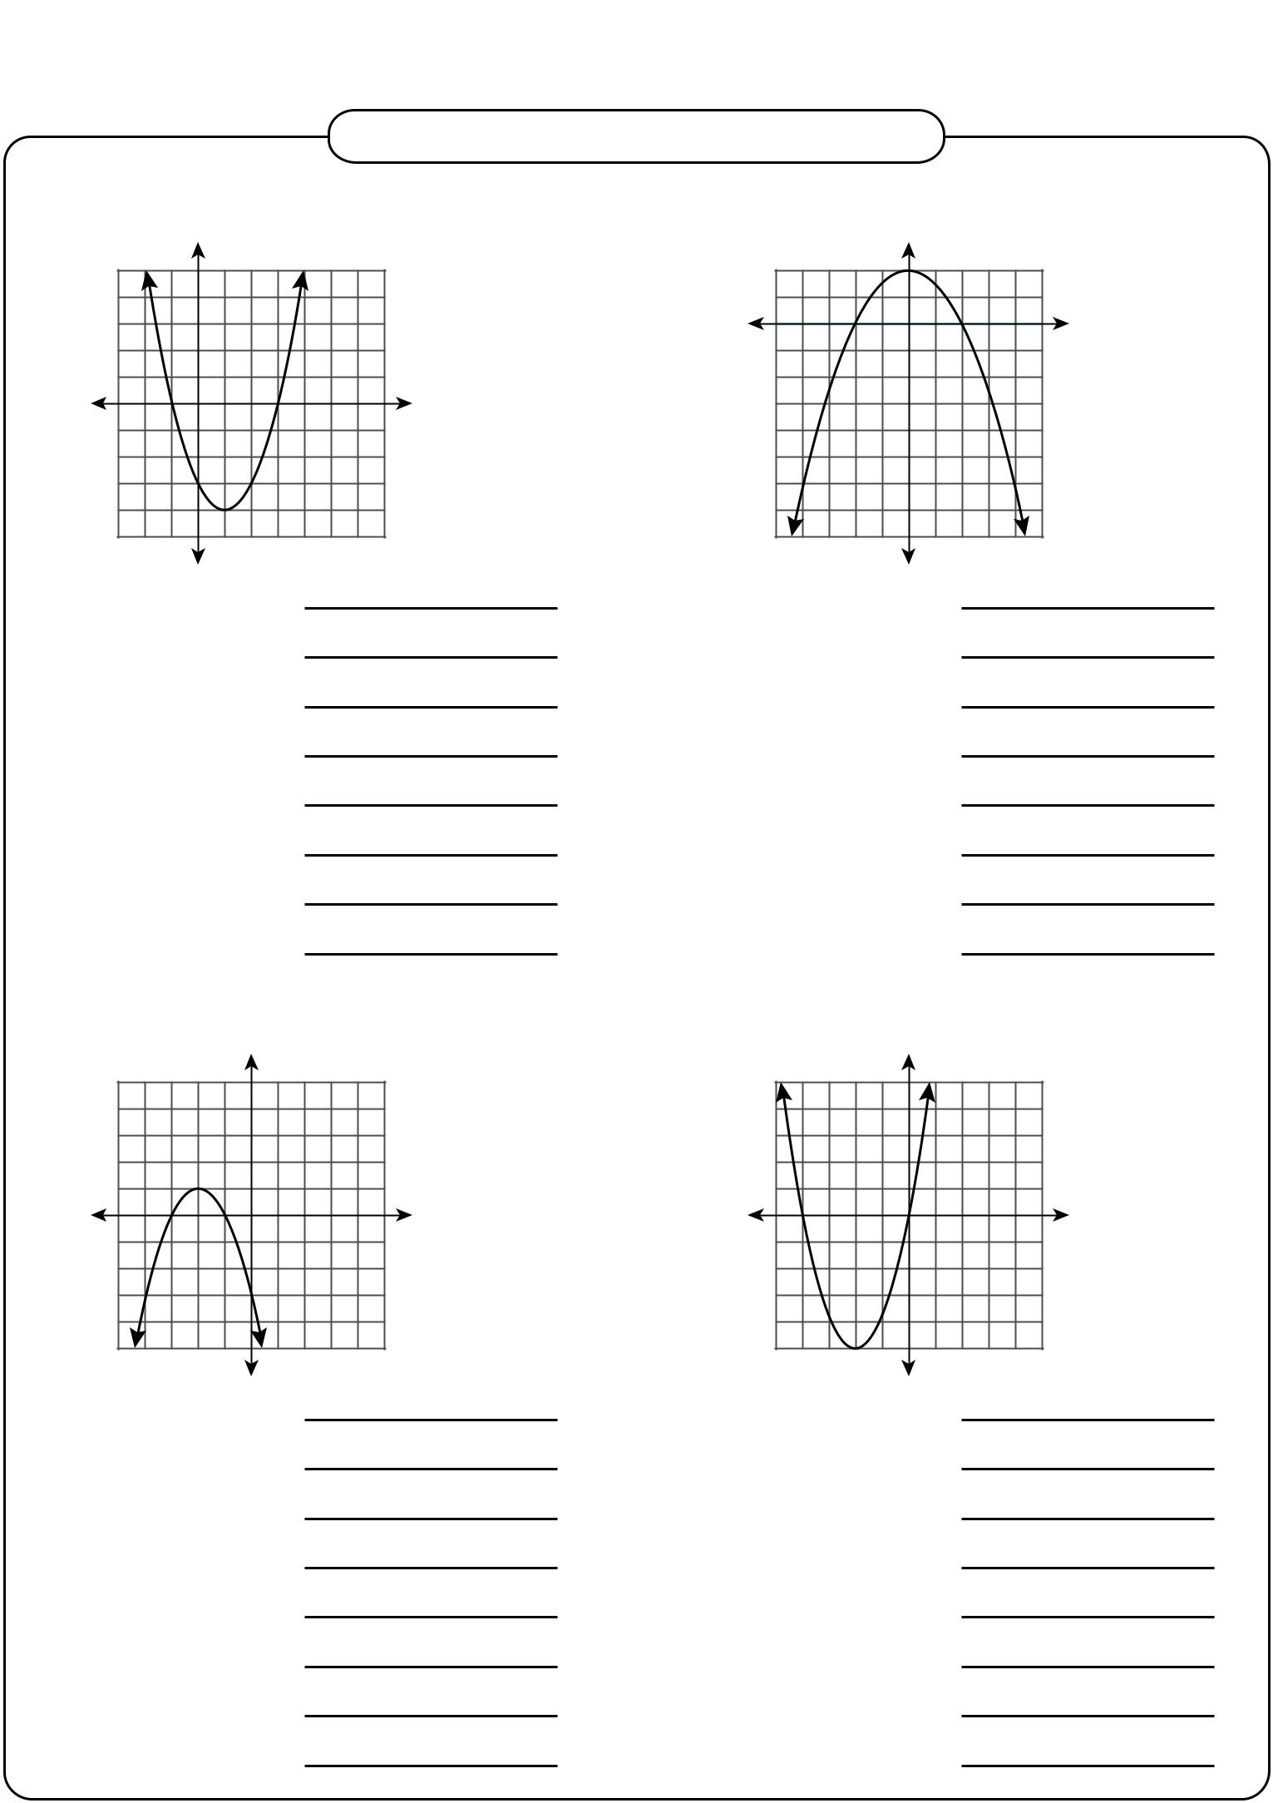
Name : |  |  | Score :
 |  | Properties of Quadratic Function |  | Sheet 1

Find the properties of each quadratic function.

1) | Y
 | 5
 | 4
 | 3
 | 2
 | 1
 | X
-6 -4 -2 | 2 4 6 8 101214
 | -1
 | -2
 | -3
 | -4
 | -5

Domain :

Range :

X-intercepts :

Y-intercept :

Vertex :

Minimum value :

Axis of symmetry :

Open up or down :

2) | Y
4
2 | X
-5 -4 -3 -2 -1 | 12345
-2
-4
-6
-8
-10
-12
-16
-18

Domain :

Range :

X-intercepts :

Y-intercept :

Vertex :

Maximum value :

Axis of symmetry :

Open up or down :

3) | Y
 | 5
 | 4
 | 3
 | 2
 | 1
 | X
-5 -4 -3 -2 -1 | 12345
 | -1
 | -2
 | -3
 | -4
 | -5

Domain :

Range :

X-intercepts :

Y-intercept :

Vertex :

Maximum value :

Axis of symmetry :

Open up or down :

4) | Y
 | 5
 | 4
 | 3
 | 2
 | 1
 | X
-5 -4 -3 -2 -1 | 12345
 | -1
 | -2
 | -3
 | -4
 | -5

Domain :

Range :

X-intercepts :

Y-intercept :

Vertex :

Minimum value :

Axis of symmetry :

Open up or down :

Printable Math Worksheets @ www.mathworksheets4kids.com

Name : |  | Answer key | Score :
Name : |  | Answer key | Score : | Sheet 1
 |  | Properties of Quadratic Function |  | Sheet 1

Find the properties of each quadratic function.

1) | Y
 | 5
 | 4
 | 3
 | 2
 | 1
 | X
-6 -4 -2 | 2 4 6 8 101214
 | -1
 | -2
 | -3
 | -4
 | -5

2) | Y
4
2 | X
-5 -4 -3 -2 -1 | 12345
-2
-4
-6
-8
-10
-12
-16
-18

Domain :

Range :

X-intercepts :

Y-intercept :

Vertex :

Minimum value :

Axis of symmetry :

Open up or down :

Real Numbers

{ Y is real : Y ≥ –4 }

(–2, 0) and (6, 0)

(0, –3)

(2, –4)

Y=–4

X = 2

Up

Domain :

Range :

X-intercepts :

Y-intercept :

Vertex :

Maximum value :

Axis of symmetry :

Open up or down :

Real Numbers

{ Y is real : Y ≤ 4 }

(–2, 0) and (2, 0)

(0, 4)

(0, 4)

Y = 4

X = 0

Down

3) | Y
 | 5
 | 4
 | 3
 | 2
 | 1
 | X
-5 -4 -3 -2 -1 | 12345
 | -1
 | -2
 | -3
 | -4
 | -5

4) | Y
 | 5
 | 4
 | 3
 | 2
 | 1
 | X
-5 -4 -3 -2 -1 | 12345
 | -1
 | -2
 | -3
 | -4
 | -5

Domain :

Range :

X-intercepts :

Y-intercept :

Vertex :

Maximum value :

Axis of symmetry :

Open up or down :

Real Numbers

{ Y is real : Y ≤ 1 }

(–3, 0) and (–1, 0)

(0, –3)

(–2, 1)

Y = 1

X=–2

Down

Domain :

Range :

X-intercepts :

Y-intercept :

Vertex :

Minimum value :

Axis of symmetry :

Open up or down :

Real Numbers

{ Y is real : Y ≥ –5 }

(–4, 0) and (0, 0)

(0, 0)

(–2, –5)

Y=–5

X=–2

Up

Printable Math Worksheets @ www.mathworksheets4kids.com

