Bloom identified six levels within the cognitive domain, from the simple recall or recognition of facts, as the lowest level, through increasingly more complex and abstract mental levels, to the highest order which is classified as evaluation. A description of the six levels as well as verb examples that represent intellectual activity are listed here.

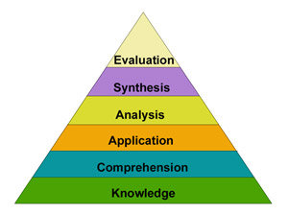
Knowledge is defined as remembering of previously learned material. This may involve the recall of a wide range of material, from specific facts to complete theories, but all that is required is the bringing to mind of the appropriate information. Knowledge represents the lowest level of learning outcomes in the cognitive domain.
Verbs: arrange, define, duplicate, label, list, memorize, name, order, recognize, relate, recall, repeat, reproduce state.
The model above is included because it is still common currency, but Anderson and Krathwohl (2001) have made some apparently minor but actually significant modifications, to come up with:
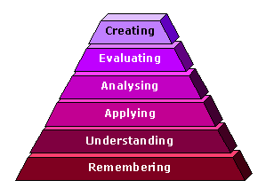
Revised taxonomy of the cognitive domain
following Anderson and Krathwohl (2001)

Comprehension is defined as the ability to grasp the meaning of material. This may be shown by translating material from one form to another (words to numbers), by interpreting material (explaining or summarizing), and by estimating furture trends (predicting consequences or effects). These learning outcomes go one step beyond the simple remembering of material, and represent the lowest level of understanding.
Verbs: classify, describe, discuss, explain, express, identify, indicate, locate, recognize, report, restate, review, select, translate.
Application refers to the ability to use learned material in new and concrete situations. This may include the application of such things as rules, methods, concepts, principles, laws, and theories. Learning outcomes in this area require a higher level of understanding than those under comprehension.
Verbs: apply, choose, demonstrate, dramatize, employ, illustrate, interpret, operate, practice, schedule, sketch, solve, use, write.
Analysis refers to the ability to break down material into its component parts so that its organizational structure may be understood. This may include the identification of the parts, analysis of the relationships between parts, and recognition of the organizational principles involved. Learning outcomes here represent a higher intellectual level than comprehension and application becasue they require an understanding of both the content and the structural form of the material.
Verbs: analyze, appraise, calculate, categorize, compare, contrast, criticize, differentiate, discriminate, distinguish, examine, experiment, question, test.
Synthesis refers to the ability to put parts together to form a new whole. This may involve the production of a unique communication (theme or speech), a plan of operations (research proposal), or a set of abstract relations (scheme for classifying information). Learning outcomes in this area stress creative behaviors, with major emphasis on the formulation of new patterns or structures.
Verbs: arrange, assemble, collect, compose, construct, create, design, develop, formulate, manage, organize, plan, prepare, propose, set up, write.
Evaluation is concerned with the ability to judge the value of material (statement, novel, poem, research report) for a given purpose. The judgements are to be based on definite criteria. These may be internal criteria (organization) or external criteria (relevance to the purpose) and the student may determine the criteria or be given them. Learning outcomes in this area are highest in the cognitive hierarchy because they contain elements of all the other categories, plus conscious value judgements based on clearly defined criteria.
Verbs: appraise, argue, assess, attach, choose compare, defend estimate, judge, predict, rate, core, select, support, value, evaluate.
Affective: the Affective domain has received less attention, and is less intuitive than the Cognitive. It is concerned with values, or more precisely perhaps with perception of value issues, and ranges from mere awareness (Receiving), through to being able to distinguish implicit values through analysis. (Kratwohl, Bloom and Masia (1964))
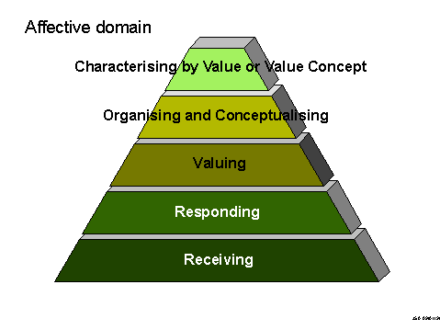
- Psycho-Motor: Bloom never completed work on this domain, and there have been several attempts to complete it. One of the simplest versions has been suggested by Dave (1975): it fits with the model of developing skill put forward by Reynolds (1965), and it also draws attention to the fundamental role of imitation in skill acquisition.
