**LAB: WEGENER’S PUZZLING CONTINENTS**

Directions:

1. Label the land masses on each sheet. Color the fossil areas to match the legend below.

2. Cut out each of the continents along the edge of the continental shelf (the outermost dark line). Alfred Wegener's fossil evidence for continental drift is shown on the cut-outs.

3. Try to logically piece the continents together so that they form a giant supercontinent. Use Wegener’s fossil evidence to place them in the correct positions.

4. When you are satisfied with the 'fit' of the continents, glue the land masses down on a piece of paper and answer the analysis questions that follow.

**Key to Wegener’s Puzzling Evidence – Fossils:**

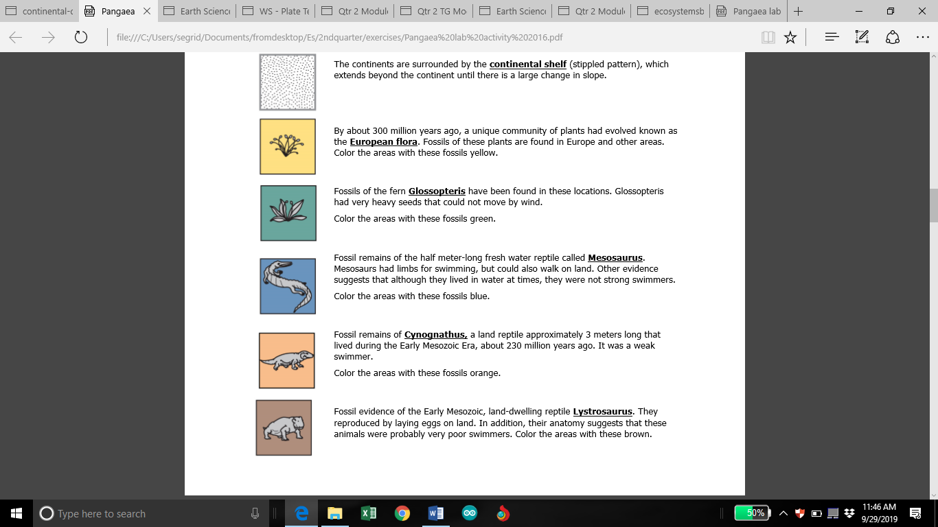

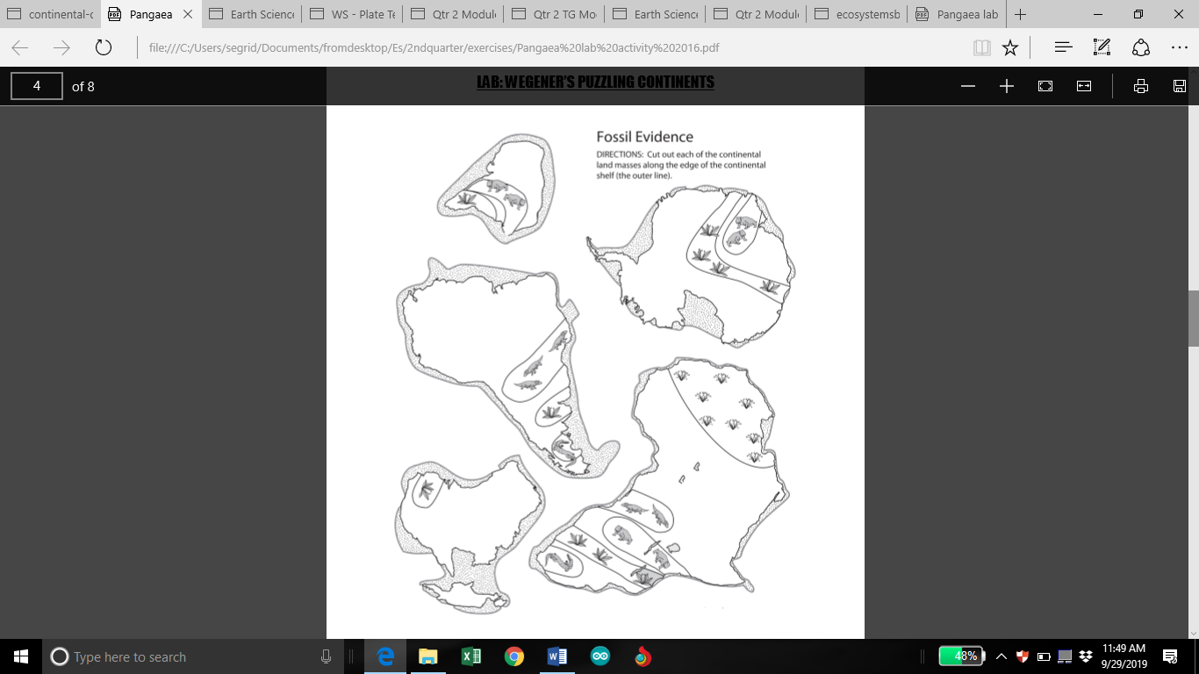

Imagine you are Alfred Wegener. Write a one- paragraph statement to summarize your work. Your summary must included descriptions on:

a. What your map shows about the Earth 225 million years ago (What does the map show?)

b. How the fossil evidence helped you to put the landmasses together (What was your process?)

c. Why the fossil evidence is good (Why do you think your map is a good one?)

2. Imagine you are a skeptic of Alfred Wegener. Write a one-paragraph statement to criticize his work. Your criticism must included challenges about:

a. Why the continents could NOT possibly move the way Wegener is describing

b. How the fossils could naturally be located in the places Wegener found them, without the continents moving

c. Why Wegener is not qualified to be proposing theories in the fields of geology and Earth history