**Arduino Alarm Clock**

In this project, we designed an Arduino based Real Time Clock with alarm. A Real Time Clock or RTC is a battery powered clock that measures time even when there is no external power or the microcontroller is reprogrammed.

An RTC displays clock and calendar with all timekeeping functions. The battery, which is connected to the RTC is a separate one and is not related or connected to the main power supply.

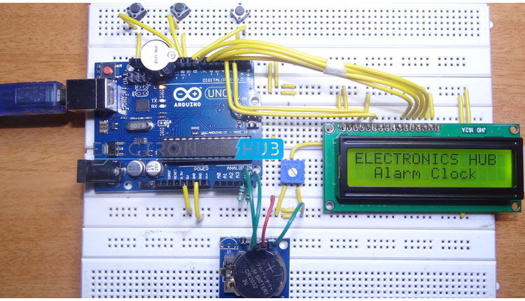

When the power is restored, RTC displays the real time irrespective of the duration for which the power is off. Such Real Time Clocks are commonly found in computers and are often referred to as just CMOS (Complementary Metal Oxide Semiconductor).

Most microcontrollers and microprocessors have built in timers for keeping time. But they work only when the microcontroller is connected to power supply. When the power is turned on, the internal timers reset to 0. Hence, a separate RTC chip is included in applications like data loggers for example, which doesn’t reset to 0 when the power is turned off or reset.

Real Time Clocks are often useful in data logging applications, time stamps, alarms, timers, clock builds etc. In this project, a Real Time Clock, which displays accurate time and date along with an alarm feature is designed.

One of the frequently used RTC ICs DS1307 is used in this project along with Arduino. The circuit, design and working are explained in the following sections.

Table of Contents

* [Circuit Diagram](https://www.electronicshub.org/arduino-alarm-clock/#Circuit_Diagram)
* [Components Required](https://www.electronicshub.org/arduino-alarm-clock/#Components_Required)
* [Component Description](https://www.electronicshub.org/arduino-alarm-clock/#Component_Description)
  + [DS1307](https://www.electronicshub.org/arduino-alarm-clock/#DS1307)
* [Circuit Design](https://www.electronicshub.org/arduino-alarm-clock/#Circuit_Design)
* [Working](https://www.electronicshub.org/arduino-alarm-clock/#Working)
* [Output Video](https://www.electronicshub.org/arduino-alarm-clock/#Output_Video)
* [Code](https://www.electronicshub.org/arduino-alarm-clock/#Code)

**Circuit Diagram**

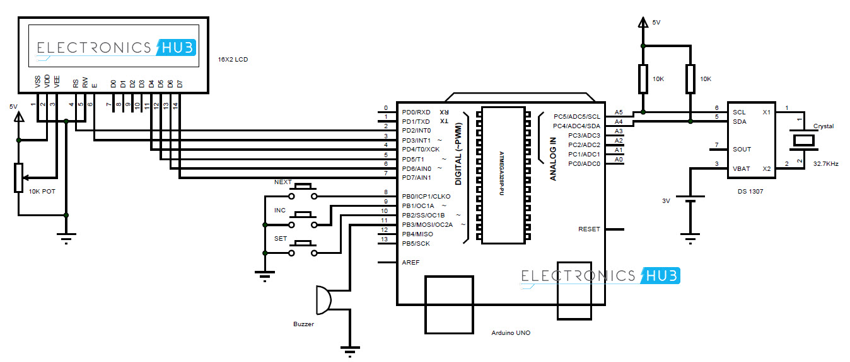

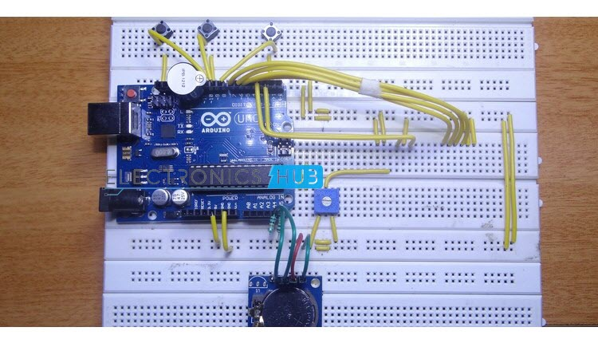

**Components Required**

* **Arduino UNO – 1**
* **DS 1307 RTC Module – 1**
* **Push Buttons – 3**
* **16X2 LCD Display – 1**
* **Buzzer – 1**
* **10 KΩ – 2**
* **10 KΩ POT – 1**

**Component Description**

**DS1307**

DS1307 is the frequently used real time clock (RTC) IC for clock and calendar. The clock function provides seconds, minutes and hours while the calendar function provides day, date, month and year values.

The clock can operate in either 12 hour with AM/PM indication or 24 hour format. A 3V backup battery must be connected to the RTC so that the IC can automatically switch to the backup supply in case of power failure. A

32.768 KHz crystal is connected to the oscillator terminal of DS1307 for 1 Hz oscillations.

**Circuit Design**

The communication between microcontroller and RTC IC DS1307 is serial I2C bidirectional bus. I2C protocol is a method of communication between a faster device (Microcontroller or Arduino in this case) in master mode and a slower device (RTC) in slave mode.

There are two pins on Arduino for I2C communication. Analog pins 4 and 5 will act as SDA (Serial Data) and SCL (Serial Clock).

These are connected to respective SDA and SCL pins of RTC. Both these pins of RTC are pulled high using 10KΩ resistors.

An LCD is used to display the clock. 6 pins of LCD must be connected to Arduino. RS, E, D4, D5, D6 and D7 (Pins 4, 6, 11, 12, 13 and 14) of LCD are connected to pins 2, 3, 4, 5, 6 and 7 of Arduino.

Three buttons are used to set the alarm. These buttons are connected to pins 8, 9 and 10 of Arduino. A buzzer is connected to pin 11 of Arduino that acts as an alarm.

**Working**

The aim of this project is to create a real time clock along with an alarm feature. The working of the project is explained below.

All the connections are made as per the shown circuit diagram. The code for Arduino is uploaded and the LCD displays the current date and time.

In order to set the alarm, we press the set button. It’ll go to alarm mode and asks for hours with current time being displayed. The increment button must be pressed must be pressed to change the hours.

As the clock is in 24 hour format, the hours will be incremented between 0 and 23. Once the hours of the alarm is set, we must press the next button to go to minutes tab.

Again increment button is pressed to change the minutes. Once the alarm time is entered, set button is pressed and the alarm is set.

The values entered as alarm are stored in the EEPROM of the Arduino. These values are continuously compared with the present time.

When the stored values and current value match, the buzzer for the alarm will be triggered. In order to stop the alarm, the next button is pressed.

**Code:**

|  |
| --- |
| #include <Wire.h> |
|  | #include<EEPROM.h> |
|  | #include <RTClib.h> |
|  | #include <LiquidCrystal.h> |
|  | LiquidCrystal lcd(2, 3, 4, 5, 6, 7); |
|  | RTC_DS1307 RTC; |
|  | int tmp,Inc,hor,mIn,add=11; |
|  | int set=8; |
|  | int cge=9; |
|  | int mod=10; |
|  | int off=0; |
|  | #define buz 11 |
|  | int Hor,Min,Sec; |
|  | ///////////////////////////////////////Function to adjust the time////////////////////////////////// |
|  | void time() |
|  | { |
|  | int tmp=1,mins=0,hors=0,secs=0; |
|  | while(tmp==1) |
|  | { |
|  | off=0; |
|  | if(digitalRead(cge)==0) |
|  | { |
|  | Hor++; |
|  | if(Hor==24) |
|  | { |
|  | Hor=0; |
|  | } |
|  | } |
|  | lcd.clear(); |
|  | lcd.setCursor(0,0); |
|  | lcd.print("Set Alarm Time "); |
|  |  |
|  | lcd.setCursor(0,1); |
|  | if(Hor<=9) |
|  | lcd.print("0"); |
|  | lcd.print(Hor); |
|  | lcd.print(":"); |
|  | lcd.print(Min); |
|  | lcd.print(":"); |
|  | lcd.print(Sec); |
|  | delay(200); |
|  | lcd.setCursor(0,1); |
|  | lcd.print(" "); |
|  | lcd.print(":"); |
|  | lcd.print(Min); |
|  | lcd.print(":"); |
|  | lcd.print(Sec); |
|  | delay(200); |
|  | if(digitalRead(set)==0) |
|  | { |
|  | hor=Hor; |
|  | EEPROM.write(add++,hor); |
|  | tmp=2; |
|  | while(digitalRead(set)==0); |
|  | } |
|  | } |
|  |  |
|  | while(tmp==2) |
|  | { |
|  | if(digitalRead(cge)==0) |
|  | { |
|  | Min++; |
|  | if(Min==60) |
|  | {Min=0;} |
|  | } |
|  | lcd.setCursor(0,1); |
|  | lcd.print(Hor); |
|  | lcd.print(":"); |
|  | if(Min<=9) |
|  | lcd.print("0"); |
|  | lcd.print(Min); |
|  | lcd.print(":"); |
|  | lcd.print(Sec); |
|  | lcd.print(" "); |
|  | delay(200); |
|  | lcd.setCursor(0,1); |
|  | lcd.print(Hor); |
|  | lcd.print(":"); |
|  | lcd.print(" "); |
|  | lcd.print(":"); |
|  | lcd.print(Sec); |
|  | lcd.print(" "); |
|  | delay(200); |
|  | if(digitalRead(set)==0) |
|  | { |
|  | mIn=Min; |
|  | EEPROM.write(add++, mIn); |
|  | tmp=0; |
|  | while(digitalRead(set)==0); |
|  | } |
|  | } |
|  | off=1; |
|  | delay(10); |
|  | } |
|  | ///////////////////////////////////////////function to sound the buzzer////////////////////////////////// |
|  | void Buz() |
|  | { |
|  | if(digitalRead(set)==0) |
|  | off=0; |
|  | if(off==1) |
|  | { |
|  | digitalWrite(buz,HIGH); |
|  | delay(500); |
|  |  |
|  | digitalWrite(buz, LOW); |
|  | delay(500); |
|  | } |
|  | } |
|  | //////////////////////////////////////////function to compare the alarm time with current RTC time////////////////// |
|  | void TimeCheck() |
|  | { |
|  | int tem[17]; |
|  | for(int i=11;i<17;i++) |
|  | { |
|  | tem[i]=EEPROM.read(i); |
|  | } |
|  | if(Hor == tem[11] && Min == tem[12] && off==1) |
|  | { |
|  | add=11; |
|  | Buz(); |
|  | Buz(); |
|  | lcd.clear(); |
|  | lcd.print("alarm..........."); |
|  | lcd.setCursor(0,1); |
|  | lcd.print("...........alarm"); |
|  | Buz(); |
|  | Buz(); |
|  | } |
|  | } |
|  | ////////////////////////////////////////////////////////////setup/////////////////////////// |
|  | void setup() |
|  | { |
|  | Wire.begin(); |
|  | RTC.begin(); |
|  | lcd.begin(16,2); |
|  | pinMode(cge, INPUT); |
|  | pinMode(set, INPUT); |
|  | pinMode(mod, INPUT); |
|  | pinMode(buz, OUTPUT); |
|  | digitalWrite(set, HIGH); |
|  | digitalWrite(mod, HIGH); |
|  | digitalWrite(cge, HIGH); |
|  |  |
|  | lcd.setCursor(0,0); |
|  | lcd.print("ELECTRONICS HUB"); |
|  | lcd.setCursor(0,1); |
|  | lcd.print(" Alarm Clock "); |
|  | delay(2000); |
|  |  |
|  | if(!RTC.isrunning()) |
|  | { |
|  | RTC.adjust(DateTime(__DATE__,__TIME__)); |
|  | } |
|  | } |
|  | ////////////////////////////////////////////////////////////loop///////////////////////////////////// |
|  | void loop() |
|  | { |
|  | DateTime now = RTC.now(); |
|  | if(digitalRead(mod) == 0) |
|  | { |
|  | current(); |
|  | time(); |
|  | delay(1000); |
|  | lcd.clear(); |
|  | lcd.setCursor(0,0); |
|  | lcd.print(" Alarm On"); |
|  | delay(2000); |
|  | } |
|  | lcd.clear(); |
|  | lcd.setCursor(0,0); |
|  | lcd.print("Time:"); |
|  | lcd.setCursor(6,0); |
|  | Hor=now.hour(),DEC; |
|  | if(Hor<=9) |
|  | { |
|  | lcd.print("0"); |
|  | lcd.print(Hor=now.hour(),DEC); |
|  | } |
|  | else |
|  | lcd.print(Hor=now.hour(),DEC); |
|  | lcd.print(":"); |
|  | Min=now.minute(),DEC; |
|  | if(Min<=9) |
|  | { |
|  | lcd.print("0"); |
|  | lcd.print(Min=now.minute(),DEC); |
|  | } |
|  | else |
|  | lcd.print(Min=now.minute(),DEC); |
|  |  |
|  | lcd.print(":"); |
|  | Sec=now.second(),DEC; |
|  | if(Sec<=9) |
|  | { |
|  | lcd.print("0"); |
|  | lcd.print(Sec=now.second(),DEC); |
|  | } |
|  | else |
|  | lcd.print(Sec=now.second(),DEC); |
|  | lcd.setCursor(0,1); |
|  | lcd.print("Date: "); |
|  | lcd.print(now.day(),DEC); |
|  | lcd.print("/"); |
|  | lcd.print(now.month(),DEC); |
|  | lcd.print("/"); |
|  | lcd.print(now.year(),DEC); |
|  | TimeCheck(); |
|  | delay(200); |
|  | } |
|  | ///////////////////////////////////////////////////////function to get current RTC time////////////////////////////// |
|  | void current() |
|  | { |
|  | lcd.setCursor(0,1); |
|  | lcd.print(Hor); |
|  | lcd.print(":"); |
|  | lcd.print(Min); |
|  | lcd.print(":"); |
|  | lcd.print(Sec); |
|  | } |

**Source Link:** <https://www.electronicshub.org/arduino-alarm-clock/>

|  |
| --- |
|  |