
April 2020

Dear Valued Partners,

The

COVID-19 (corona) pandemic has created a truly unprecedented situation which affects us

all. Our hearts go out to anyone who has been impacted by the virus, either directly or

indirectly.

As we are in the midst of uncertainty facing this pandemic, we hope we could help you assist in servicing your needs in distance learning for the upcoming school year 2020-2021. We have always speculated about the dramatic change technology will bring to education. Now, at a time of great uncertainty, schools can show how technology will secure our children’s future through distance education, and the use of Learning Management System (LMS) such as our TekTeach LMS.

TekTeach LMS is a distance education platform that enables the teachers to create learning experiences of students wherever they are: at home, in school, or wherever they need to be. TekTeach allows:

·Access to subscribed TechFactors Courseware which are complete learning resources required to study a subject.

TechFactors Courseware provides gamified assessments to keep students engaged. Interactive exercises help students to navigate skill-based components. More importantly, students submit evidences of learning from performance tasks.

Students will benefit from online guidance of teachers from TekTeach

Teachers can provide their own content like quizzes, lectures, etc., or curated reference materials from other sources.

To know more about TekTeach LMS, please see our advertorial presentation that is attached to this letter. As a technology-based learning company, TechFactors can help schools implement distance education with TekTeach, today. With over 600 partner schools nationwide and around 600,000 student subscriptions to various TechFactors Coursewares, the school is assured of a strong partnership with TechFactors.

To make learning a great experience, TechFactors Curriculum Consultants support schools in charting a technology-enabled 21st century school environment. Please anticipate a call from TechFactors Curriculum Consultants, soon. You can also email inquiries to ejmdelacruz@techfactors.com

Thank you and Stay Safe!
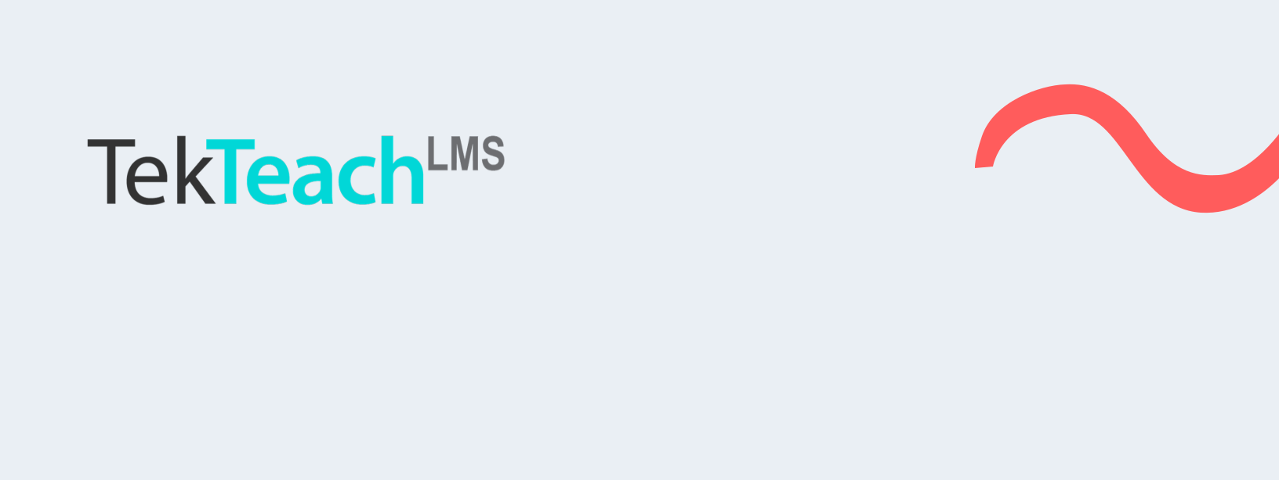
Implementing Distance Education with

TekTeach LMS is a distance education platform that uses online learning technologies to conduct classes. It provides seamless learning experiences from remote sessions to periods of standard classroom instruction or blended learning. TekTeach can also be used to access subscriptions of techFactors Courseware which are complete learning resources to study subjects. TekTeach allows teachers to curate their own learning resources that may include content from other providers.

At a time and environment where schools gain competitive advantage by leveraging technology to implement distance education, there is a greater need to strengthen technology competencies of learners. techFactors, a leading company in eLearning, offers TekTeach LMS to support schools in their quest for continuity in quality education.


How TekTeach works?
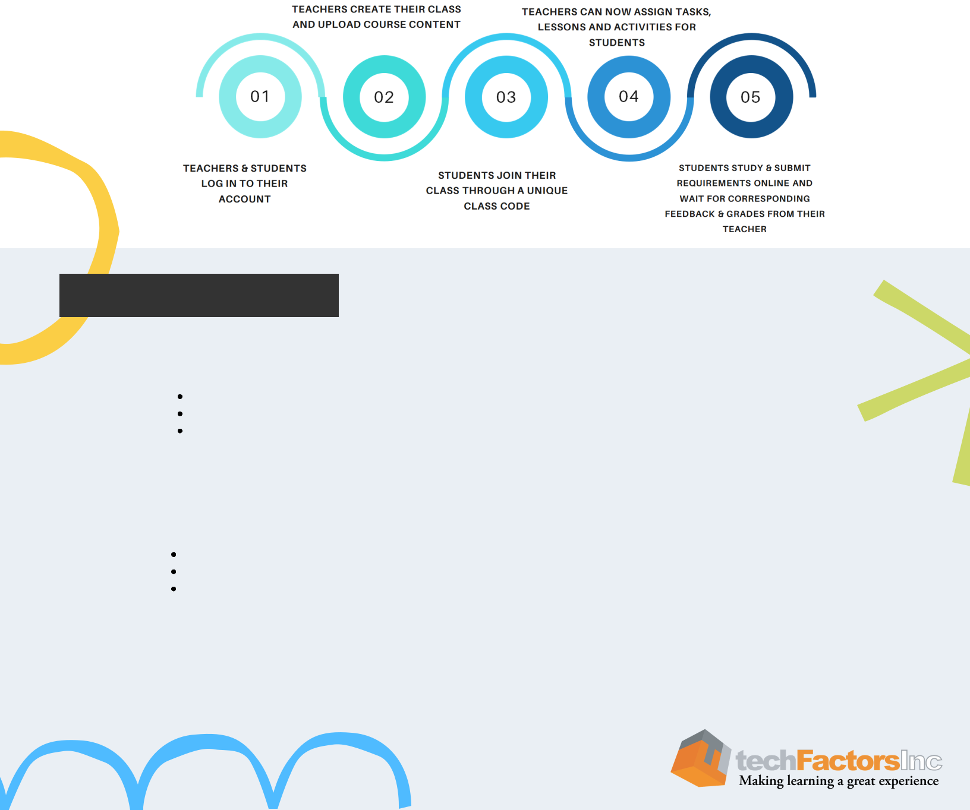

Our TekTeach Offering

 A responsive distance education platform that implements blended online learning for:

Conducting classes (synchronous & asynchronous)
Managing learning resources
Creating assessments

Complete access to your subscriptions of techFactors Courseware

Comprehensive training for successful TekTeach LMS implementation

User training - know how to utilize TekTeach functionalities
Technical training – know how to do basic trouble shooting tasks
Instructional design training- know how develop lesson plans for blended online learning

Infrastructure support (with option to implement campus wide access to TekTeach LMS)
Easy and effective implementation program to make digital learning fun and enjoyable.


 Courseware


techFactors Courseware are complete learning resources to study a subject that includes:

STUDENTS TEACHERS

Lesson Texts and Discussions Lesson Plans
Pretest and Post-test Lesson Slides
Module Project Answer Keys
Module Quiz
Interactive Exercises
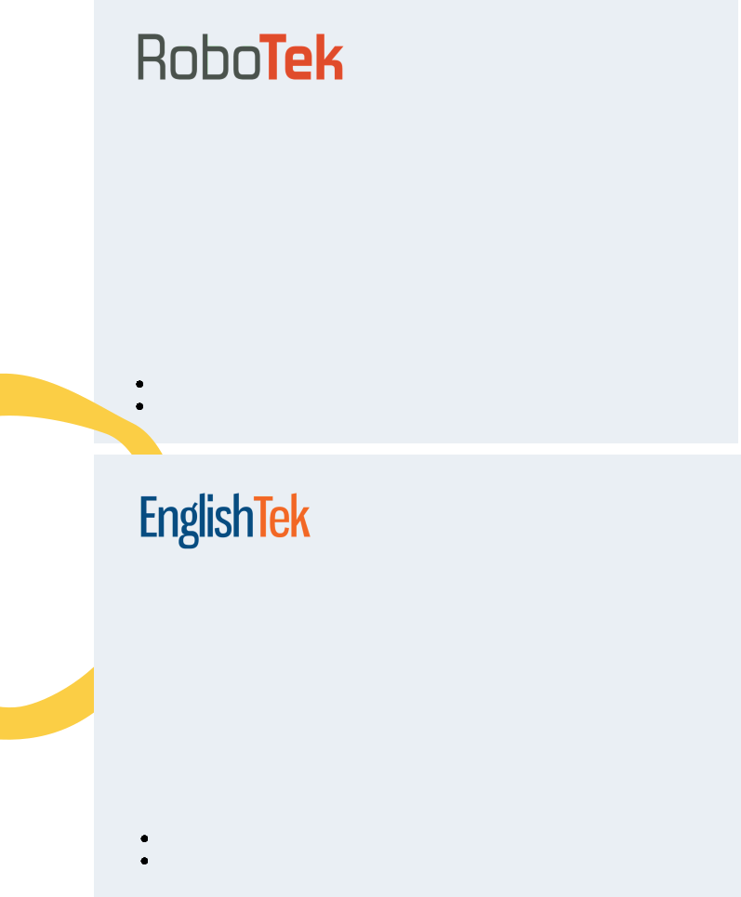

Develop ICT Competencies for the 21st Century
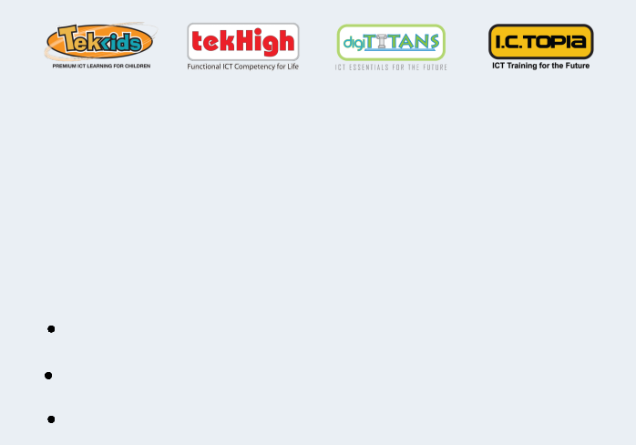

Nowadays the role of ICT in education plays an important role in the process of conducting educational activities. Thus, the development of ICT competencies becomes more essential. TechFactors' ICT courseware enhance ICT competencies to develop the 21st Century skills: critical thinking, creativity, communication, and collaboration. ·

Competencies are based on international standards (ISTE Competencies for Students)
Demonstrate evidences of learning through interactive exercises and student products
Offers complete and comprehensive coverage


Equip students for an environment driven by ubiquitous intelligent devices

To ensure that our future is in good hands, it is important to prepare students to thrive in the evolving technological
landscape. techFactors' RoboTek framework

systematically develops the seven robotics competencies. Through the problem-based learning approach, students’ ability to think creatively and innovatively are enhanced to prepare them for the demands of the future.

Targets seven robotics competencies Integrates STEAM education

Inquiry-based approach to Studying Science

A courseware for Science that enables the teachers to harness the students’ curiosity and channel that into learning experiences about Science driven by the students themselves. With ScienceTek, teachers implement the most effective way to teach Science, through Inquiry-Based Learning.

Simulated Laboratory Activities
Robotics Integration

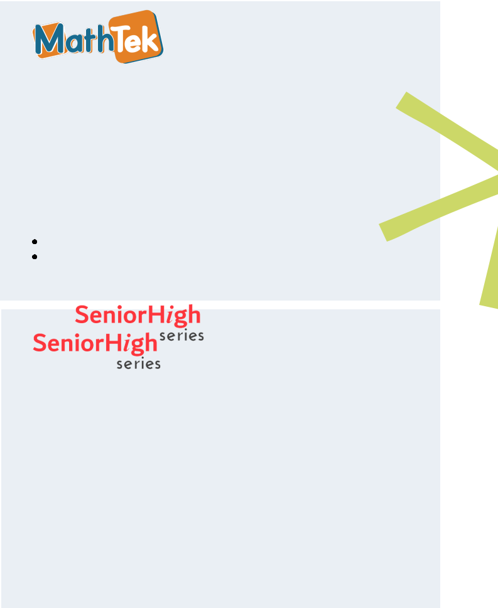

Develop Effective Communicators and Global Collaborators

English in the 21st century means building skills for effective communication and for critical consumption and production of multi-modal forms of expression. techFactors supports students in achieving this goal by immersing them in communicative task-based activities and by exposing them to real-life uses of the language. Through the use of theme-based lessons, students find learning more relevant and engaging.

Features CLT approach
Integrates localized context


Develop Model Thinkers and Problem Solvers

Mathematics is a real world 21st century skill that students will need regardless of what they end up doing with their lives. MathTek develops solid foundations of math skills and enable students to become critical thinkers and problem solvers ready to face the challenges of our ever-changing world. Also, with the use of manipulatives, learning is both fun and meaningful.

Features CPA approach
Uses context-based learning

Teksto, Wika, Teknolohiya

Ang FilipinoTek ay ang pag-aaral sa wikang Filipino na may pagpapaunlad katulong ang teknolohiya. Nakapaloob dito ang pag-aaral sa teksto o mga panitikan na likha ng iba’t ibang manunulat sa Pilipinas. Ang wika naman ay ang pag-aaral ngbalarila o gramatika na lalong hahasa sa kaalaman ng mag-aaral patungkol dito.

Preparing Students for Lifelong Learning

In a constantly changing environment where everyone should learn to adapt, it is important to create responsive learning experiences to prepare senior high students to be future ready. The courseware makes use of an outcomes-based approach, using experiential and self-directed learning framework. All titles come with a build section that culminates student’s portfolio that is geared to equip students with necessary tools in a globally competitive environment.

