COMPUTER SYSTEM:

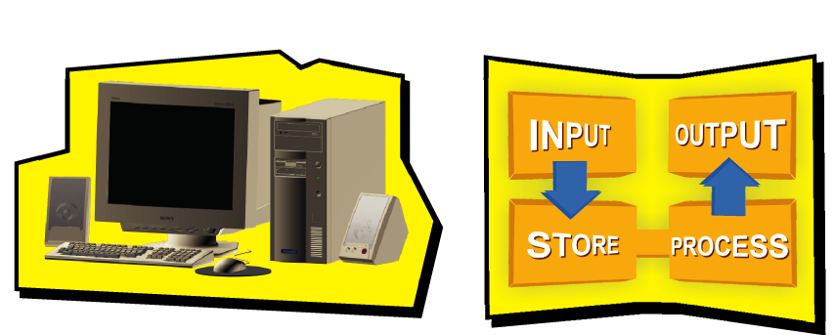

Computers are electronic devices. They perform four basic operations: input, process, store and output. Through computers, we can convert data into useful information.

