Data Encoding

If computers use binary digits to perform its operations, why don't we use binary digits to input data?

Take a look at your keyboard.

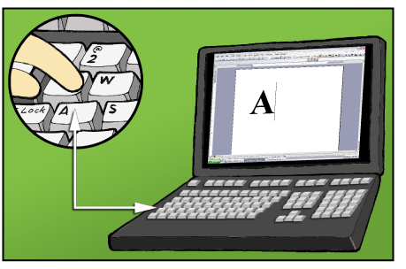

When you press the letter A on the keyboard, the letter A will be transformed into a set of 1's and 0's. This set of binary digits is then fed to the processor. The processor stores this into its memory temporarily and then sends it back to the monitor. The monitor then shows you the alphanumeric equivalent of the binary digits, which is the letter A.

