Hardware, Software and Peopleware

A computer system has many aspects. These include hardware, software, and peopleware.

Computer hardware refers to the devices that make up the computer. It also refers to devices we attach to our computer.

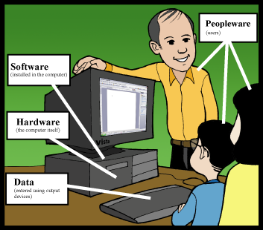

Another aspect of computer systems is computer software.

Software includes all computer programs that computers use. Computer programs are sets of instructions that computers can understand. They are instructions on how to carry out operations. They provide the way through which the user can communicate with the computer.

A third aspect of a computer system is peopleware. This refers to the people who use computers. It also includes people who make programs that run on computer systems.

