The System Unit

The computer's main hardware components are housed in a metal or plastic case called a system unit. The system protects the internal components from physical damage. It protects them from heat and moisture. It also provides a frame for mounting internal components. System units come in different shapes and sizes. The way in which internal components are arranged also varies. The form factor defines this physical arrangement.

The monitor, keyboard and system unit of a desktop personal computer are separate from each other. However, Apple's eMac, which is also a desktop computer, combines the monitor and the system unit into a single plastic case.

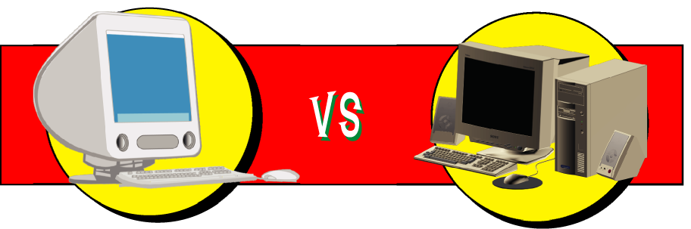
In portable computers such as the laptop and notebook, the monitor and keyboard are combined with the system unit along with other computer components.

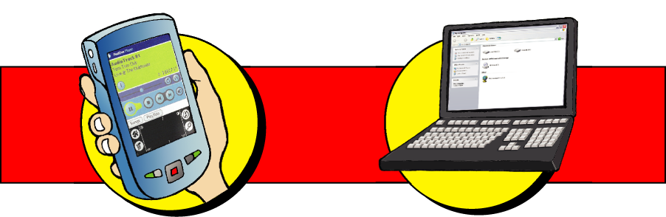

Thus, portable computers take up less space than desktop computers.

