TASK PANE

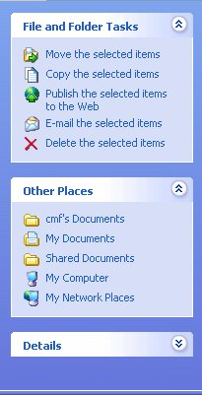
Task pane is a dialog box that allows you to easily access commands that you often use in an application. It shows options for files and folders, which include renaming, moving, copying, publishing to the Web, e-mailing, printing, and deleting. It also lets you share the contents of a folder with other users on your computer or network.

