Disk Defragmentation

When you save a single file onto a disk, the different bits of data that make up the file are not necessarily stored in the same track. Often these are scattered across the disk because it occupies the first space available. Because the data is read across the entire disk, it takes more time to access a file if the data is scattered.

In order to reduce this access time, a process called disk defragmentation is performed. During this process, fragments of data belonging to the same file are stored on the same track or on tracks lying next to each other.

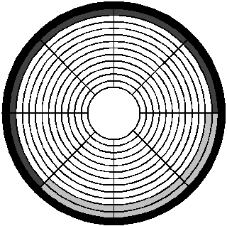
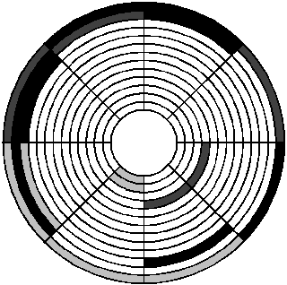
Disk defragmentation
Before Disk defragmentation, a single file may be stored to clusters that do not lie next to each other.
After Disk defragmentation , a single file is transferred to clusters that lie next to each other for easier access

