What is a Desktop?

The computer’s desktop allows a user to communicate with it, with the help of a mouse or other pointing the device. The mouse pointer allows the user to click on icons or graphics on the desktop to access files or run programs.

XP is the latest version of Windows. Its desktop has the following basic elements: the background, the Start menu, and the taskbar.

Background

It is the entire area of your screen that contains icons and other graphics, which let you communicate with the computer. It may have color or design, called wallpaper.

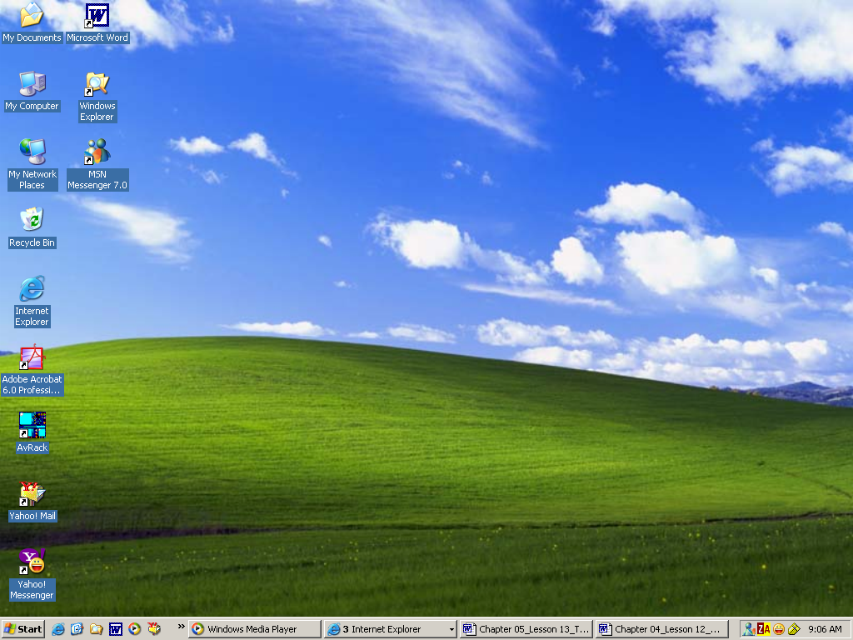
Background
Icons

