Eros and Psyche
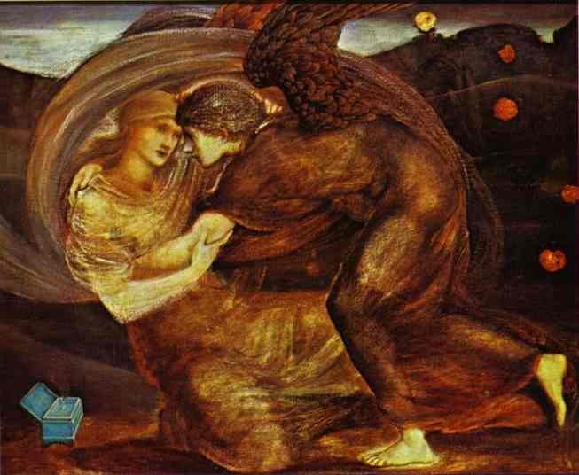
One day on Mount Olympus, Aphrodite decided she had become fed up with the beauty of Psyche, the maiden. Psyche was very beautiful and was often complimented for her beauty. Aphrodite wanted to set her straight. So she called her son, Eros, to shoot one of his arrows, which poisoned immortal and mortal alike with love, at Psyche, while she was sleeping. "What is the point of shooting an arrow at her when she is asleep?" asked Eros.
"When she wakes up," replied Aphrodite "I will be sure to supply her with someone like the castle dwarf, or maybe a donkey. Yes, that's a possibility."
"That is a cruel trick," said Eros.
"It is meant to be cruel. Now go and obey your mother," replied Aphrodite.
When Eros was above the sleeping Psyche, he took out an arrow and prepared to shoot it. But he accidentally poked himself with the arrow, and all of a sudden Psyche was the most valuable and wonderful thing the earth had ever created. He loved Psyche more than anyone or anything in the world. He flew back to Mount Olympus, leaving Psyche unaffected.
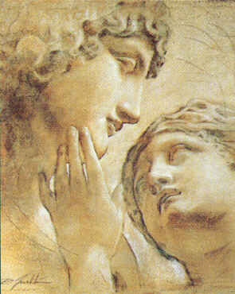
Aphrodite was furious at Eros for not complying with her orders. The fight that followed was one of the worst Olympus, or for that matter, the world, had ever seen. While Eros was sulking, no one fell in love and Aphrodite began to wither. So eventually Aphrodite saw that Eros must have his way. "What is it you wish?" she asked him.
"The girl," replied Eros.
"You shall have her," said Aphrodite.
So Aphrodite had Zephyr, the west wind, come and bring Psyche to Eros. But Eros could not be seen by Psyche for a little while after their marriage. When Psyche's sisters visited her, they convinced Psyche that her invisible husband was a monster. Psyche, curious, brought a candle into her husband's bedchamber and looked at him. It was Eros, the god of love. In her shock, Psyche let a drop of candle wax drip from the candle. Eros awoke with a start and became very angry with Psyche. "Yes, I am love itself, and I cannot live where I am not believed." Then Eros left.
But eventually Eros forgave Psyche and invited her back to live with him, and Psyche was made immortal upon Eros' request. Psyche is now the goddess of the soul, and that is where we get the prefix "pysch-", as in psycho, psychology, and psychiatrist.

