AESOP'S FABLES
The Silkworm and Spider

"True art is thoughtful, delights and endures."

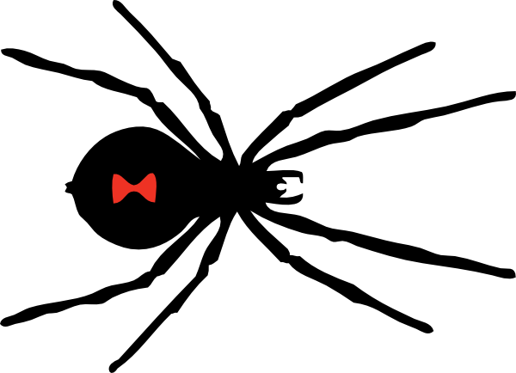
Having received an order for twenty yards of silk from Princess Lioness, the Silkworm sat down at her loom and worked away with zeal.

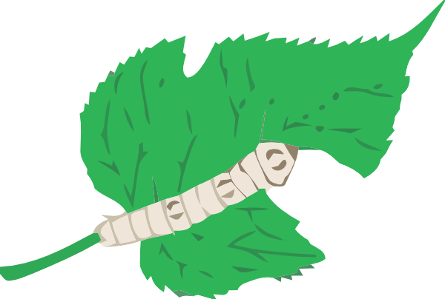

A Spider soon came around and asked to hire a web-room near by. The Silkworm acceded, and the Spider commenced her task and worked so rapidly that in a short time the web was finished. "Just look at it," she said, "and see how grand and delicate it is. You cannot but acknowledge that I'm a much better worker than you. See how quickly I perform my labors."

"Yes," answered the Silkworm, "but hush up, for you bother me. Your labors are designed only as base traps, and are destroyed whenever they are seen, and brushed away as useless dirt; while mine are stored away, as ornaments of Royalty."

