Apple Launches iPad

http://www.apple.com/hotnews/
January 27, 2010
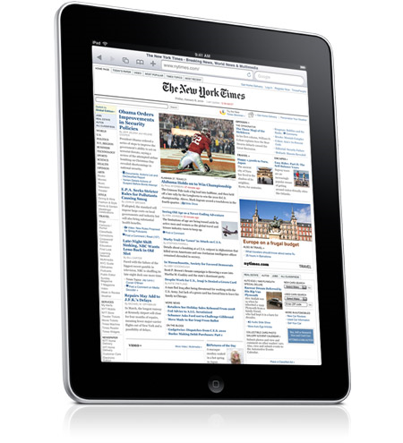
Apple today introduced iPad, a revolutionary device for browsing the web, reading and sending email, enjoying photos, watching videos, playing games, reading e-books, and much more. Its high-resolution Multi-Touch display lets you interact with content — including 12 innovative new apps designed especially for iPad and almost all of the 140,000 apps available on the App Store. At just 0.5 inches thick and 1.5 pounds, iPad is thinner and lighter than any laptop or notebook. iPad will be available in March starting at the breakthrough price of just $499.

