Little Miss Muffett
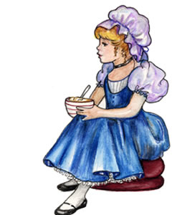
Little Miss Muffett
Sat on a tuffett
Eating her curds and whey.

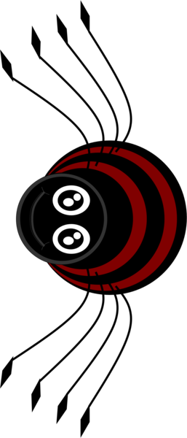
Along came a spider,
Who sat down beside her,
And frightened Miss Muffett away.

