An Excerpt from The Little Prince

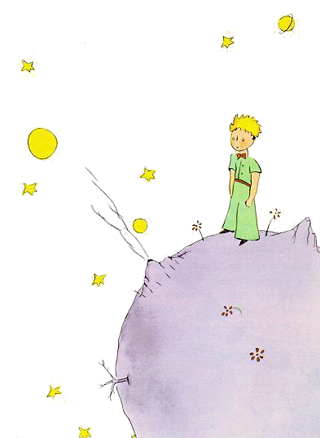

I have serious reason to believe that the planet from which the little prince came is the asteroid known as B-612.

This asteroid has only once been seen through the telescope. That was by a Turkish astronomer, in 1909.

On making his discovery, the astronomer had presented it to the International Astronomical Congress, in a great demonstration. But he was in Turkish costume, and so nobody would believe what he said.

Grown-ups are like that...

Fortunately, however, for the reputation of Asteroid B-612, a Turkish dictator made a law that his subjects, under pain of death, should change to European costume. So in 1920 the astronomer gave his demonstration all over again, dressed with impressive style and elegance. And this time everybody accepted his report.

If I have told you these details about the asteroid, and made a note of its number for you, it is on account of the grown-ups and their ways. When you tell them that you have made a new friend, they never ask you any questions about essential matters. They never say to you, "What does his voice sound like? What games does he love best? Does he collect butterflies?" Instead, they demand: "How old is he? How many brothers has he? How much does he weigh? How much money does his father make?" Only from these figures do they think they have learned anything about him.

If you were to say to the grown-ups: "I saw a beautiful house made of rosy brick, with geraniums in the windows and doves on the roof," they would not be able to get any idea of that house at all. You would have to say to them: "I saw a house that cost $20,000." Then they would exclaim: "Oh, what a pretty house that is!"

Just so, you might say to them: "The proof that the little prince existed is that he was charming, that he laughed, and that he was looking for a sheep. If anybody wants a sheep that is a proof that he exists." And what good would it do to tell them that? They would shrug their shoulders, and treat you like a child. But if you said to them: "The planet he came from is Asteroid B-612," then they would be convinced, and leave you in peace from their questions.

They are like that. One must not hold it against them. Children should always show great forbearance toward grown-up people.

