Instruction: Read the selection then follow the instructions.
Set 2
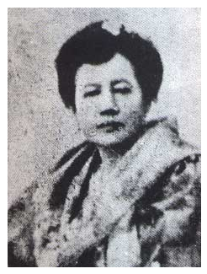 | 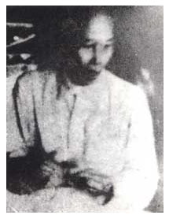 | 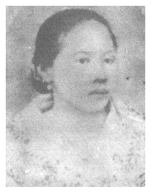
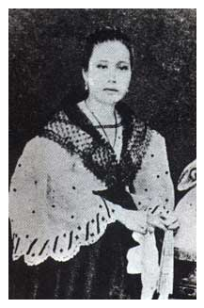 | 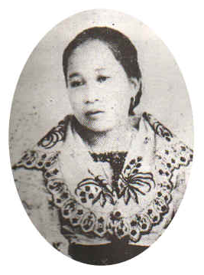 | 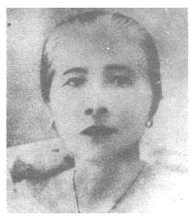
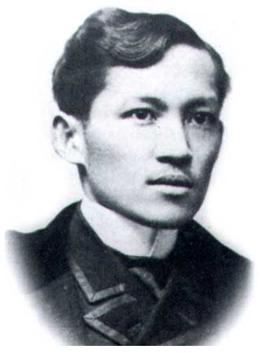 | 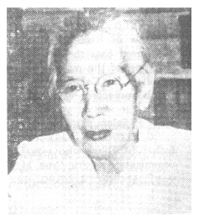 | 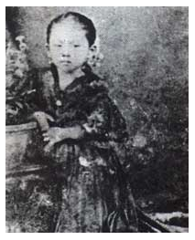
Selection
Jose Rizal belonged to a big family. He had nine sisters and one brother. His sisters were Saturnina, Narcisa, Olimpia, Lucia, Maria, Concepcion, Josefa, Trinidad and Soledad. His brother was Paciano.
- Cut and paste the first sentence in this space.
- Cut and paste the name of each of Rizal’s sisters into the following rows.
1.
2.
3.
4.
5.
6.
7.
8.
9.
- Cut and paste the name of Rizal’s only brother in this space.

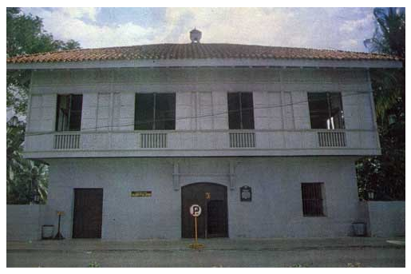
Selection
Jose Rizal’s house in Calamba has many rooms. It also has a big garden. Rizal played a lot in the garden. He played luksong tinik, shadow games, and many others. The house also has an azotea. An azotea is an open place. At night, Rizal listened to stories at the azotea and gazed at the moon and the stars.
Instruction: Cut and paste the answer to the following questions.
- Rizal’s house has many of these. Choose the word.
- What is big in Rizal’s house? Choose the word.
- What games did Rizal play in the garden? Choose the sentence.
- Aside from many rooms and a big garden, what else does his house have? Choose the word.
- What is an azotea? Choose the sentence.
6. What two things did Rizal do in the azotea? Choose the sentence.

