Instruction: Read the selection then follow the instructions.
Set 1
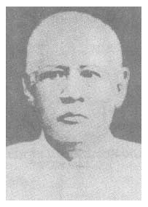 | 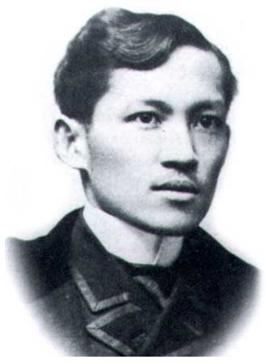 | 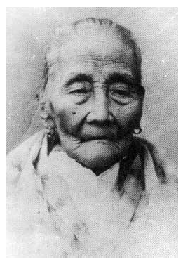
Selection
Jose Rizal was born on June 19, 1861. His real name was José Protacio Rizal Mercado y Alonzo Realonda. He was born in Calamba, Laguna. His father was Francisco Rizal Mercado. His mother was Teodora Alonso.
Instruction: Select each sentence in the paragraph and copy each one to the table below. There should be one sentence per row.
1.
2.
3.
4.
5.

