Garbage in, Garbage Out:

A Look into Some Issues on Solid Waste

by Xander Corpuz

August 19, 2005

Table of Contents

<Insert Table of Contents here>
Introduction

Everyday, Metro Manila generates six thousand tons of solid waste (Duyanen and Heasley, 2002). Each piece of paper, potato chip wrapper, and plastic bag that we, city dwellers throw into the waste bin, contributes to this number. Imagine what that would look like. That would be heaps of trash with weight amounting to six thousand cars.

Should not it be a good question to ask where all of this waste go? That amount occupies about thirty-thousand cubic meters of space (Ibid.). Is it not amazing, if not bothering, how all of that trash is swept away from our individual trash cans by large trucks and hidden from our sights?
The obvious fact remains that this amount of matter cannot just be plainly hidden from us. The waste does go somewhere. With Metro Manila’s land being occupied by more than ten million people, it is really a wonder how we are able to unload our household wastes over some place.

What is waste?

Answering such questions would need further explanations on the basics of the waste issue. First, we need to define waste. Alternatively, in layman’s terms, waste is our typical trash or garbage. However, in stricter terms, waste is “unwanted or undesired material left over after the completion of a process” (Wikipedia, 2005). Waste can be of all forms of matter – solid, liquid or gas. Our household trash or garbage is considered as solid waste.

Supposedly, not all waste is useless. Some of the waste can still be reused or recycled. These are the ones popularly collected by junk shops and scavengers - metal, paper, plastic and glass scraps. Some are bio-degradable or can be decomposed by natural means. Kitchen waste like food scraps is bio-degradable.

A report by the Japan International Cooperation Agency (in Duyanen and Heasley, 2002) states these following statistics on the percentages of the components of solid waste:

TYPE OF WASTE | PERCENT (%)
Kitchen waste | 45
Grass and wood | 7
Leather and rubber | 1
Metal | 5
Ceramic and stone | 1
Paper | 17
Textile | 4
Plastic | 16
Glass | 3
Others | 1
TOTAL | 100
Table 1: Percentage of Types of Waste (JICA Master Plan of 1998 in Duyanen and Heasley)

The ones that cannot undergo the aforementioned processes are therefore considered as net waste. Net waste is the residual waste coming from the intensive segregation that is not bio-degradable, recyclable and reusable.

Solid Waste Management

Waste management is defined as “the collection, transport, processing or disposal of waste materials, usually ones produced by human activity, in an effort to reduce their effect on human health or local amenity” (Wikipedia, 2005).

There are many possible ways of managing waste. These can be done through dumping (on dumpsites or landfills), incineration, composting and recycling.

Open dumpsites – are “disposal areas wherein the solid wastes are indiscriminately thrown or disposed of without planning and consideration for environmental and health standards” (RA 9003, 2001)

Controlled dumpsites – are “disposal sites at which solid waste is deposited accordance with the minimum prescribed standards of site operation” (RA 9003, 2001)

Sanitary landfills – are “waste disposal sites designed, constructed, operated and maintained in a manner that exerts engineering control over significant potential environmental impacts arising from the development and operation of the facility” (RA 9003, 2001)

Incineration – is the burning of waste in order to reduce its volume. This method of waste management can reduce volume by up to 90%. One of its major drawbacks is the potential release of toxic fumes from the combustion process (Environmental Literacy Council, 2005).

Composting – is “the controlled decomposition of organic matter. Rather than allowing nature to take its slow course, a composter provides an optimal environment in which decomposers can thrive” (Wikipedia, 2005). This is useful for bio-degradable material.

Recycling – is the systematic segregation and processing of non-biodegradable waste material to make these materials reusable.

Box 1: Some Methods of Waste Management

Destination unknown

To answer the question of where all of the solid waste goes, we must follow the trail of our trash. In 2002, a survey of 75 students belonging to different households showed that daily household waste was still collected by hauling trucks. Metro Manila’s local governments still opt to use dumping as the primary way of managing solid waste (Duyanen and Heasley, 2002).

According to reports, Metro Manila has been dumping its solid waste in open dumps such as Payatas (Philippine-Swedish Cooperation). As of today, there are no certified sanitary landfills that are maintained for use in Metro Manila or the whole of the Philippines, for that matter.
Existing laws, such as the Clean Air Act, prohibit other alternatives, such as incineration. The better alternatives such as composting and recycling are only done in small-scale proportions, oftentimes ushered in by private units and other pro-environment groups.

Concerns

The continued use of an open dumpsite, such as Payatas, poses these threats to public health and safety. Open dumpsites (Magalang, 2002) are said to:
Be unplanned, poorly sited and often of small capacity

Have no site preparation and no cell planning – waste deposited across large part of the site

Have Thin layers of waste – relatively rapid aerobic decomposition
Contaminate surface and groundwater
Have significant environmental impacts

The most concrete, and also devastating, example of the dangers of these open dumpsites happened in Payatas in July 2000, where an avalanche of garbage buried thousands of people living on the dumpsite due to heavy rains.

METRO MANILA | CITIES AND MUNICIPALITIES | POPULATION | WASTE GENERATION/DAY
METRO MANILA | CITIES AND MUNICIPALITIES | POPULATION | Cu. M. | Tons
METRO MANILA | Quezon City | 2223972 | 6379 | 1276
METRO MANILA | Manila | 1849858 | 5306 | 1061
METRO MANILA | Caloocan | 1143790 | 3281 | 656
METRO MANILA | Makati | 541260 | 1553 | 311
METRO MANILA | Pasig | 526615 | 1511 | 302
METRO MANILA | Valenzuela | 488707 | 1402 | 280
METRO MANILA | Las Piñas | 461789 | 1325 | 265
METRO MANILA | Panay | 456785 | 1310 | 262
METRO MANILA | Muntinlupa | 446988 | 1282 | 256
METRO MANILA | Parañaque | 437430 | 1255 | 251
METRO MANILA | Taguig | 426311 | 1223 | 245
METRO MANILA | Marikina | 399349 | 1146 | 229
METRO MANILA | Malabon | 388452 | 1114 | 223
METRO MANILA | Mandaluyong | 320692 | 920 | 184
METRO MANILA | Navotas | 256043 | 734 | 147
METRO MANILA | San Juan | 138829 | 398 | 80
METRO MANILA | Pateros | 51804 | 177 | 36
METRO MANILA | TOTAL | 10558974 | 30316 | 6063

Table 2: Waste generated by Metro Manila (MMDA in Duyanen and Heasley)

Laws and Policies (RA 9003)

“The Solid Waste Management Act,” Republic Act 9003 or simply RA 9003, was primarily passed in order to address the already alarming waste issues of the country. Its passing as a law was also hastened by the tragedy that struck Payatas. This law makes open dumpsites illegal. It also prompts the government to manage waste through Sanitary Landfills and promote the recycling, re-using, composting and the use of bio-degradable material.

Sanitary Landfills

Solid Waste Management is the concept of effectively handling our solid waste in order to minimize the non-recyclable and non-reusable Out of the different ways of dealing with trash, Sanitary Landfills are said to be one of the safest methods as it takes many necessary precautions so as not to create unfavorable impacts to the environment. The figure below shows the different layers of a landfill. One can see how the “cells” or layers of garbage are layered. The other layers below these protect the surrounding land from contamination 1 (Freudenrich, 2005).
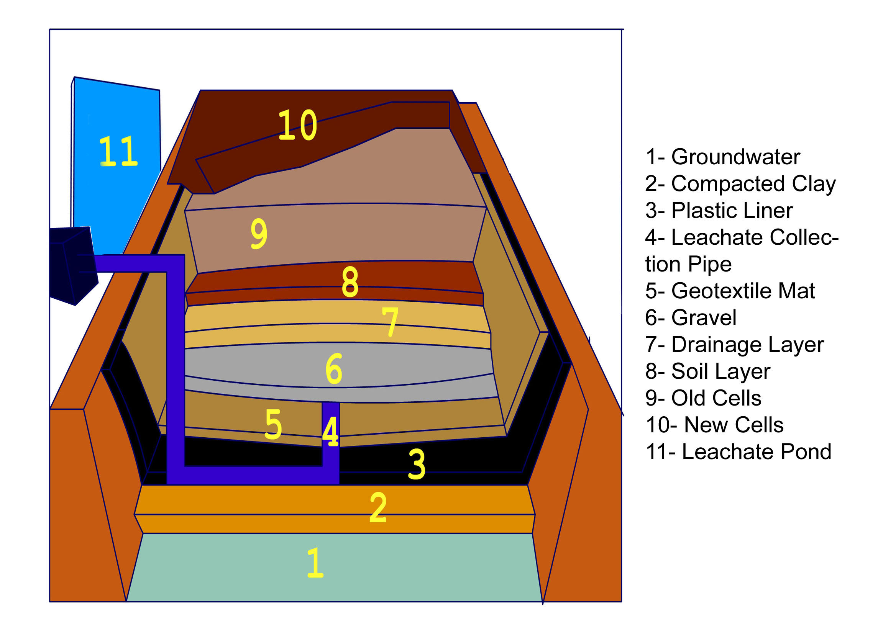
Figure 1: The Layers of a Landfill

(Footnote) 1 Sanitary landfills, as different from open dumpsite, use meticulous engineering and technological implementation in order to neutralize the threats of waste. In Figure 1, one can see that landfills take necessary precautions so as not to harm the groundwater and the surrounding soil. Using mats and drainage systems ensure that toxins from the waste are prevented from escaping the landfill.

Dealing with the issue

As the situation indicates, the Philippines needs to act upon the issues of waste. As we continue to delay on urgent ways to address the issue, the tons of waste that we generate continue to pile up as well. We should start to be more active in protecting our environment.
Experts say that the best way to deal with waste is to deal with waste from the source. This means that the problem should be dealt with on the level of those who generate waste – the people.

Here are some recommendations:
The government should promote the development of solid waste management programs as stated by law.
The everyday consumers should learn to segregate solid waste so as to facilitate and aid in the proper disposal of non-recyclable and non-reusable material.
Educate the masses on the dangers of unmanaged waste and the benefits of proper solid waste management.

Conclusion

We, as citizens, should be aware of the issues surrounding our environment. A topic such as solid waste should be given attention. We are part of the whole process. We contribute to the tons of waste generated everyday. Each piece of candy wrapper, potato chip bag, and piece of paper that we throw straight to our trash bins makes us part of the problem.

We should start acting now. The measures that are recommended above are simple enough to follow. Unless we start acting, we will eventually find ourselves living amidst heaps of our own waste.
Bibliography

Duyanen, Joselito and Murray Heasley. (April 2002). A Matter of Fact: The disposal aspects of 3 Solid Waste Management Projects in Luzon. Philippines: CDMP.

Environmental Literacy Council. (February 9, 2005) Incineration. Retrieved August 10, 2005 from http://www.enviroliteracy.org/article.php/60.html

Freudenrich, Craig. (2005) How Landfills Work. Retrieved August 11, 2005 from http://people.howstuffworks.com/landfill.htm.

Magalang, Albert. (2002). Technical Guidelines for Municipal Solid Waste Disposal. Philippines: Presidential Task Force on Waste Management.

Pagano, Angela. (2000). "Promised Land" garbage landslide kills at least 200 in the Philippines. Retrieved August 19, 2005 from http://www.wsws.org/articles/2000/jul2000/phil-j21_prn.shtml.

Philippine-Swedish Cooperation on Solid Waste Management in Metro Manila, Philippines. (2005) The Payatas Dumpsite. Retrieved August 19, 2005 from http://www.conexor.se/philippines/dilg/dilg_payatas_1.htm.

Republic Act 9003. (January 2001). Retrieved August 11, 2005 from http://www.lawphil.net/statutes/repacts/ra2001/ra_9003_2001.html.

Wikipedia (2005). Waste Management. Retrieved August 12, 2005 from http://en.wikipedia.org/wiki/Waste_management.

