Images

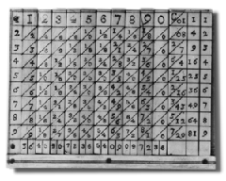
Napier’s Bones
Source: Maxfield & Montrose Interactive, Inc. <http://www.maxmon.com>

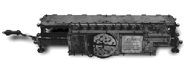
Stepped Reckoner
Source: Maxfield & Montrose Interactive, Inc. <http://www.maxmon.com>

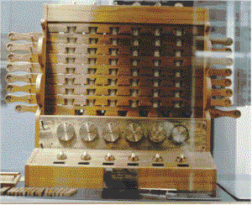
Calculating Clock
Source: http://www.xnumber.com

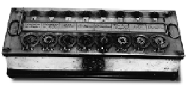
Pascaline
Source: Maxfield & Montrose Interactive, Inc. <http://www.maxmon.com>

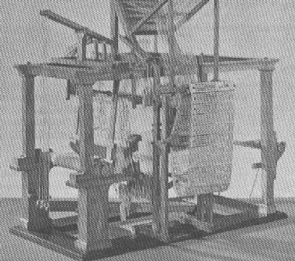
Jacquard’s Loom
Source: http://www.columbia.edu/acis/history

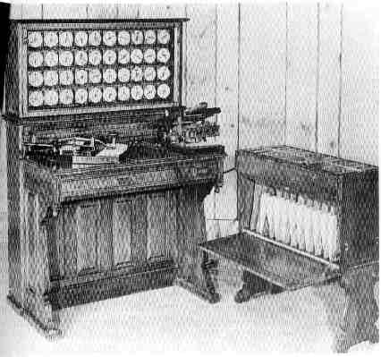
Hollerith’s Tabulating Machine
Source: http://www.brainerd.net
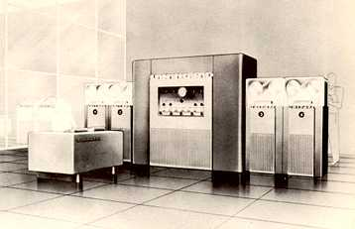
UNIVAC
Source: http://www.digicamhistory.com

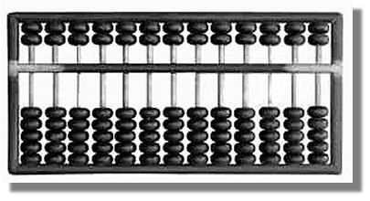
Abacus

